**Louisville Office of Research and Innovation**

**Written by: Cardinal Strategic Development Team**

Queena Lin

Isaac Mills

Hasan Mohammad

Trey Sledge

Durian Spagnuolo

Dean Stitt



**Elaboration Deliverables**

**Table of Contents**

System Requirements…………………………………………….3

Use Case Diagram………………………………………………….5

Trace Matrix………………………………………………….13

Use Cases……………………………………………….15

Sequence Diagrams…………………………………………...41

Class Diagrams……………………………………………….70

Database Design……………………………………………….74

Navigation System……………………………………….75

Screen Layout……………………………………………...76

Physical Architecture Design…………………………….77

Design Procedures………………………………………...78

Gantt Chart……………………………………………….79

Prototype……………………………………………….80

**System Requirements**

A requirement is simply a statement of what the system must do or what characteristic it must have. Requirements can be either functional or nonfunctional in nature. A functional requirement relates directly to a process a system has to perform or information it needs to contain Functional requirements flow directly into the creation of functional, structural, and behavioral models that represent the functionality of the evolving system. Nonfunctional requirements refer to behavioral properties that the system must have, such as performance and usability. The ability to access the system using a Web browser is considered a nonfunctional requirement. Nonfunctional requirements can influence the rest of analysis. Nonfunctional requirements are used primarily in design when decisions are made about the user interface, the hardware and software, and the system’s underlying physical architecture.

**Functional:**

1. The system will have applications for Industry Partners.
2. The system will have a(n) system for processing/Accepting grants.
3. The system will have a system for users to manage awards.
4. The system will have a system for donations.
5. The system will have a(n) system for researchers to manage projects (iRIS).
6. The system will have a(n) Social media for R&I to interact with the community.
7. The system will have a link to the newsletter via the University of Louisville magazine.
8. The system will allow Administrators to track performance.
9. The system will have a(n) area for current invitations R&I is working on.
10. The system will have a(n) Centers and Institutes page for navigation.
11. The system will have individual pages for each Stakeholder (Student, researcher, Industry, Admin, Community).
12. The system will have support for industry (industry request form).
13. The system will have event opportunities for the local community to engage.
14. The system will have scholarship opportunities for undergraduate students.
15. The system will have a student (undergraduate/Graduate research proposal form)
16. The system will have Licensing Collaboration Forms
17. The system will have Startup Partnership/Collaboration Forms
18. The system will have accessible forms for Graduate students for funding opportunities (internal and external).
19. The system will have accessible forms for Undergraduate students to find funding opportunities (internal and external).
20. The system will allow administrators to track current Projects
21. The system will allow administrators to maintain industry and community contacts list
22. The system will allow for collaborative efforts within the University of Louisville’s different centers and institutes
23. The system will have a sign-up form for the community.
24. The system will integrate current security measures provided by the University of Louisville
25. The system will have good news and funding newsletters Forms
26. The system will have a redesign landing page
27. The system will have Twitter news widget
28. The system will have a legal portal
29. The system will maintain current lead flows

**Non-Functional:**

1. The system will be secured by the University of Louisville’s firewall
2. The system will be user-friendly
3. The system will have a near-perfect uptime
4. The system will use Plone as the Content Management System
5. The system will use PeopleSoft as the Payment Management System
6. The system will use Microsoft SQL Server 2016 as a Database Management System
7. The system will have back-up capabilities
8. The system will have desktop capabilities
9. The system will have mobile capabilities (access from any device)
10. The system will follow the universities guidelines
11. The system will incorporate security guidelines and policies

**Use Case Diagrams**

**Create newsletter, delete newsletter, edit newsletter**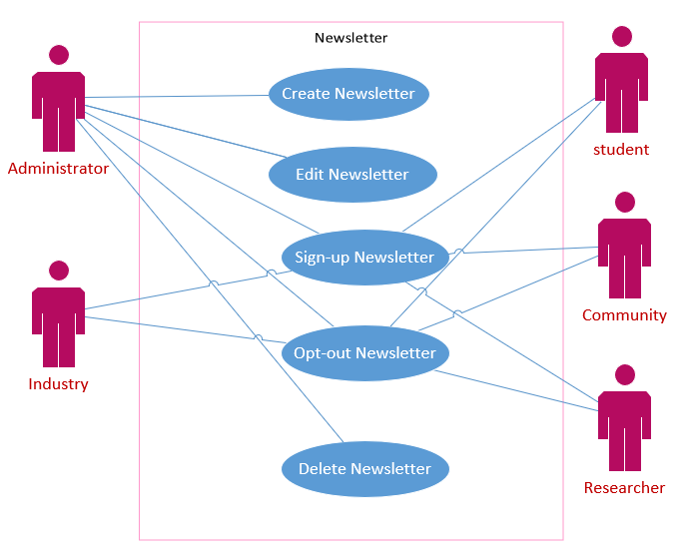

This use case diagram shows that all of the stakeholders such as administrator, industry, student, researcher, and community member. Only the administrator will be able to create, edit, and delete newsletters while the rest of the stakeholders are able to sign-up or opt-out of the newsletter with a mobile number or email address.

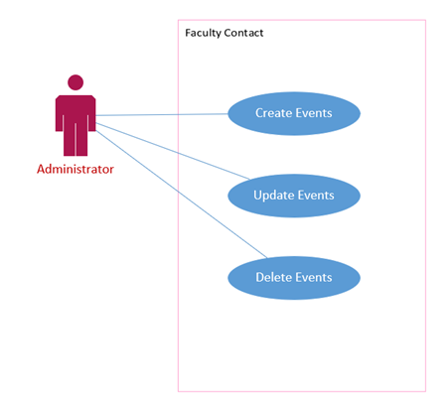

**Create event, edit events, delete events, store events**

This diagram shows that the primary actor of the use case is the administrator which they are able to create, edit, and delete events. The administrator receives an application from the other users and then approves their request for creating events.

**Create attendee, delete attendee, edit attendee**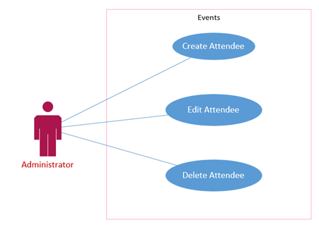

This use case shows that all the stakeholders are able to create, edit, and delete attendee lists. They will submit requests to participate in an event and then their names get submitted into the attendee list. All the users will be able to edit information about the event or delete the event. Finally, all the users will receive a confirmation email every time a change is made.

**Create, edit, delete contact list**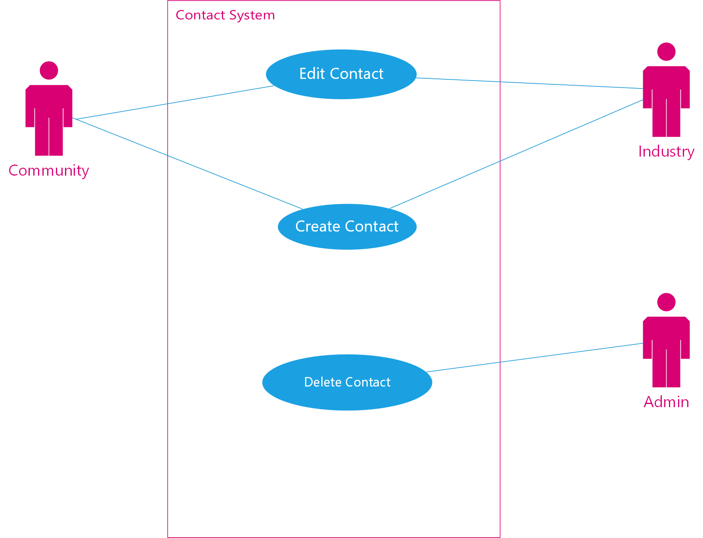

Diagram for managing contacts. We need a centralized list to make it convenient for industry/community members to network and collaborate (for the ones that want to participate). Administrators will be responsible for approving and deleting the contacts. The user will be responsible for entering and editing their information.

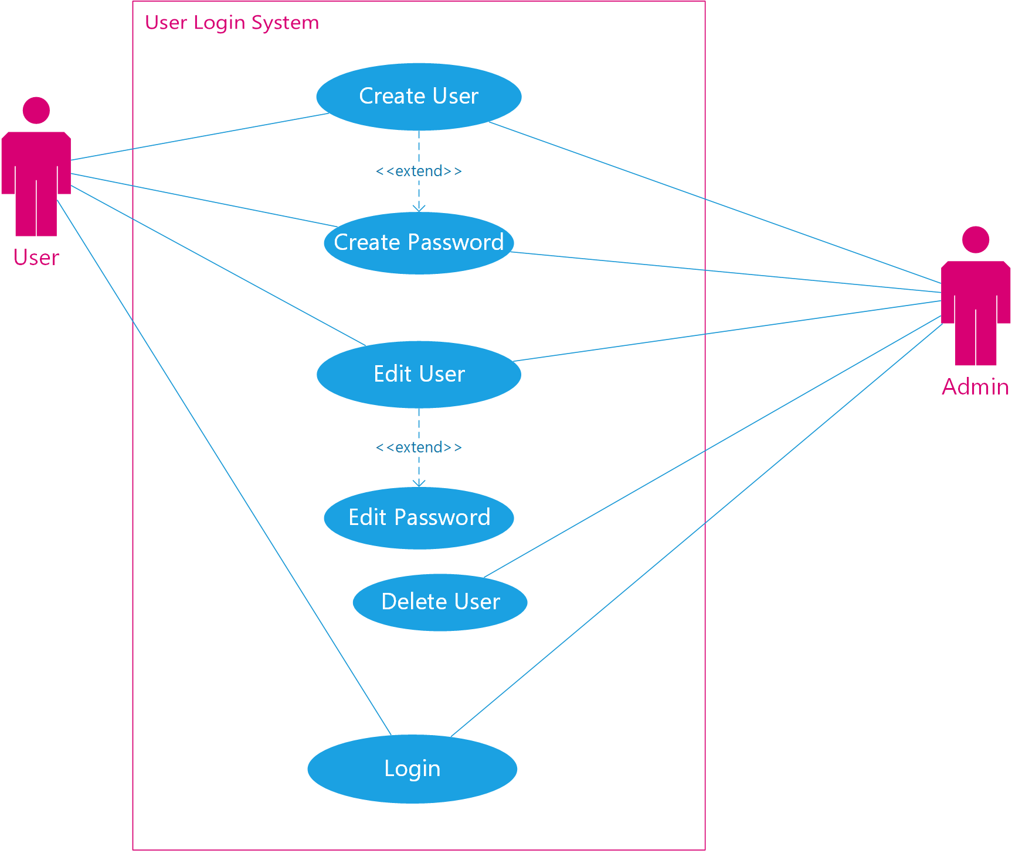

**Create, edit, delete users, create password, edit password, delete password, login**

Diagram for creating a new user. Returning users can keep track of projects, forms and other information easily. Creating an account simply requires a unique username and secure password. A user can edit their account at any time. They can change their email associated with the account, add information about themselves or business/organization. The user can request to delete their account if they wish to terminate.

**Create project, edit project, delete project**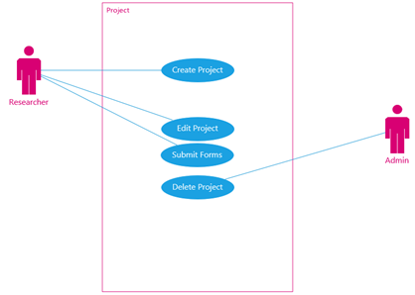

This diagram shows that the researcher will have the ability to create a new project they wish to work on, edit an existing project they are a part of and file any forms needed to start or continue the project. The diagram also shows that an admin will be the only person able to delete current and previous projects. This is to avoid any loss of information if a researcher decides to delete an entire project.

**Create reports, edit report, delete report**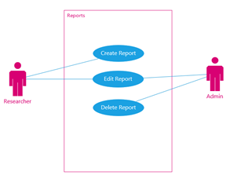

This diagram shows that when creating a report over a current project the researcher is able to create the report and edit it and an admin can edit the reports and is the only one able to delete them; this is so that a researcher can delete all of the reports they have sent off.

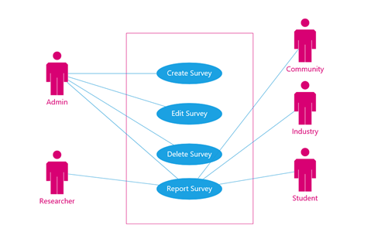

**Create survey, delete survey, edit survey, report survey**

This diagram shows that when creating a survey, the Admin is able to create the report, edit it and delete them; this is so that all other users can report the survey without being able to modify it.

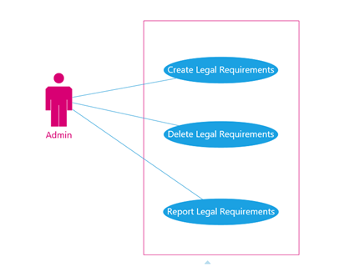

**Create, edit, delete legal guideline**

This diagram shows that when creating a legal requirement, the Admin is able to create the requirement, edit it and delete them when necessary.

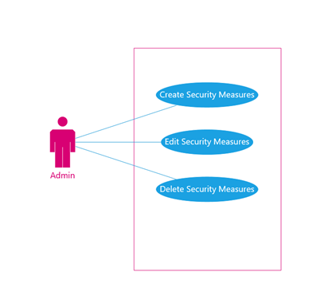

**Create, edit, delete security measures**

This diagram shows that when creating a security measure, the Admin is able to create the measure, edit it and delete them as needed for rollback of the system.

**Create, edit, delete event registrations**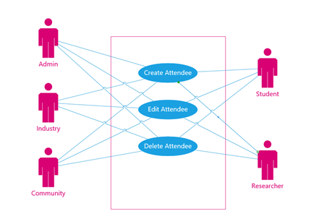

This diagram shows that when creating an attendee all users will be able to create the attendee, edit it and delete them as necessary for mistakes.

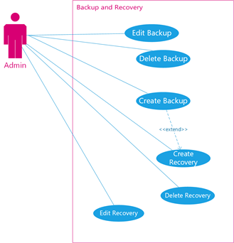

**Create, edit, delete recovery/backup**

This use case diagram depicts how backups and recovery will be conducted within the website. Users with administrators’ privilege will be able to create backups, edit attributes of the backup such as intervals or schedule time. The Admin will also be able to perform backup maintenance with the ability to delete previously created backup files. Creations of Backup files allow the Admin to create recovery points (which store the current state of the data system) and allow the website to recover data in the event of a disaster or data loss.

**Create form, edits form, deletes form**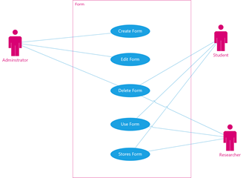

This use case diagram depicts how a User with Admin privileges will be to create, edit and delete forms no matter what the situation calls for. Whether it be creating newsletter or event signup, collaboration form for industry or applications for funding. It also depicts how other stakeholders will be able to fill out forms, submit them or store them so they can edit said forms if they have time constraints as well as keep track of their interactions with the website.

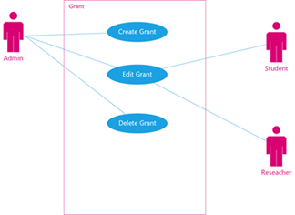

**Create grant, delete grant, edit grant**

This use case diagram depicts how a user with Admin privileges will be to create, edit and delete an object called grants. This object will store metadata that will allow researchers and students who have been awarded grants the ability to track and manage their grants from a secure web page within the website.

**Create a study, edit a study, delete a study**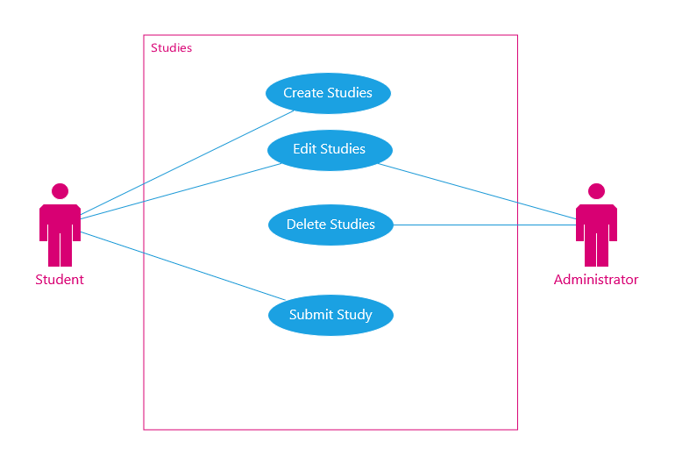

This diagram shows that a student has the ability to create a new study and edit the study and submit the study and an admin is the only person with the ability to delete the study but can also edit them if the information is provided but is not on the study.

**Create study renewal, edit study renewal, delete study renewal**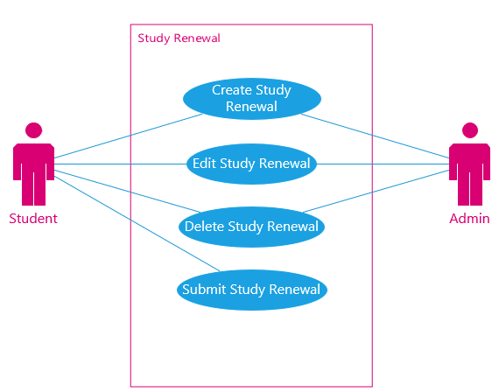

A student has the ability to create a study renewal for when they wish to continue a study, they can also edit the study renewal and delete the study renewal if they do not wish to continue with the study. An admin can create study renewals, edit, and delete them at the request of a student/researcher.

**Trace Matrix**

A trace matrix is a document, in this case in the form of a table, used to assist in determining the completeness of a relationship by correlating any two baselined documents using a many-to-many relationship comparison. It is a tool to ensure that requirements are not lost during various stages of the system’s development. This matrix is a Requirements Traceability Matrix, it will be used to check if the current project requirements are being met and ensure none are lost through the development of the website from start to finish. At the current stage of the development of the website, the matrix will compare the system requirements to the use case document. The matrix is split into two parts to make it easier to view. We also added a table of the system requirements and their associated use cases to make the interpretation of trace matrix easier to understand.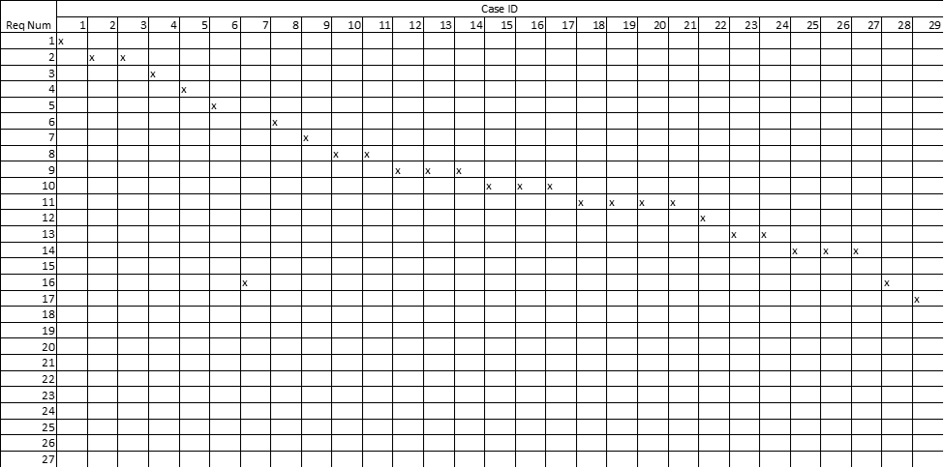

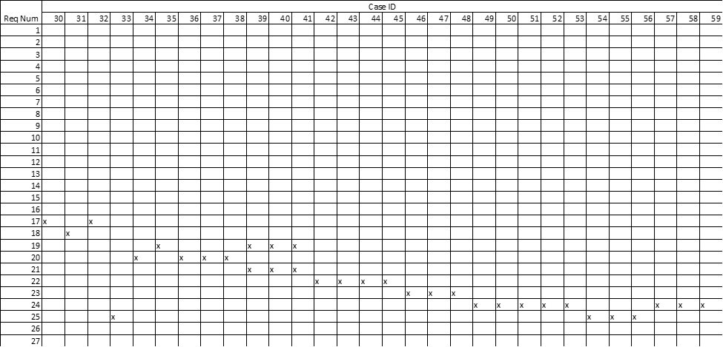

|  |  |  |
| --- | --- | --- |
| Req num | Requirement Description | Use CaseID |
| 1 | The system will have applications for industry partners. | 1 |
| 2 | The system will have a(n) system for processing/accepting grants. | 2,3 |
| 3 | The system will have a system forward donation to appropriate sites. | 4 |
| 4 | The system will have a(n) system for researchers to manage projects (iris). | 5 |
| 5 | The system will have a(n) social media for R&I to interact with the community. | 6 |
| 6 | The system will allow administrators to track performance. | 8 |
| 7 | The system will have an area for current invitations R&I is working on. | 9 |
| 8 | The system will create/edit/delete individual pages for each stakeholder (student, researcher, industry, admin, community). | 10,11 |
| 9 | The system will have support for industry (industry request form). | 12 |
| 10 | The system will create/edit/delete event opportunities. | 13,14 |
| 11 | The system will create student (undergraduate/graduate research proposal form) | 15 |
| 12 | The system will create licensing collaboration forms | 16,17 |
| 13 | The system will create startup partnership/collaboration forms | 20,21 |
| 14 | The system will have accessible forms for graduate students for funding opportunities (internal and external). | 22 |
| 15 | The system will allow administrators to maintain industry and community contacts list | 24 |
| 16 | The system will allow for collaborative efforts within the university of Louisville’s different centers and institutes | 25,26,27 |
| 17 | The system will integrate current security measures provided by university of Louisville | 39,40,41 |
| 18 | The system will provide newsletters that vary in content and display daily. | 7,28 |
| 19 | The system will have improved navigation with new landing pages. | 29,30,32 |
| 20 | The system will have a portal available for legal affairs. | 31 |
| 21 | The system will have events that will be available for editing/deleting. | 39,40,41 |
| 22 | The system will have the ability to change your password. | 36,37,38 |
| 23 | The system will have the ability for tracking projects. | 33,39,40,41 |
| 24 | The system will have surveys that can be sent and used for reporting. | 42,43,44,45 |
| 25 | The system will have legal guidelines that will need to be met. | 50,51,52 |
| 26 | The system will have security requirements that will be enabled. | 57,58,59 |
| 27 | The system will allow for users to rsvp for events and make changes. | 33,54,55,56 |

**Research & Innovation Center**

**Use Case Specification**

**Version 1.0**

**Revision History**

|  |  |  |  |
| --- | --- | --- | --- |
| **Date** | **Version** | **Description** | **Author** |
| 18/03/2020 | 1.0 | Initial Input | CDSG |
|  |  |  |  |
|  |  |  |  |
|  |  |  |  |

**Use Case Specification: <Create Newsletter>**

1. **Use-Case Name**

Create Newsletter

* 1. **Brief Description**

 This use case creates the content of the newsletter. Its information is provided by the various stakeholders

1. **Flow of Events**
   1. **Basic Flow**

* The user connects to the internet
* The user is register to the University as an administrator
* The user login to the account
* The system verifies that both username and password match with the contents in the

database

* The user is now logged into the system
* The user receives information from the researcher, students, community, and industry members
* The user enters related information
* The user publishes content into the newsletter
* Use case end
  1. **Alternative Flows**
     + 1. < An Alternative Subflow >

None

* + 1. < Second Alternative Flow >

None

1. **Special Requirements**
   1. **< First Special Requirement >**

None

1. **Pre-conditions**
   1. **< Pre-condition One >**

User is an administrator

1. **Post-conditions**
   1. **< Post-condition One >**

A newsletter page is created

1. **Extension Points**
   1. **<Name of Extension Point>**

None

**Use Case Specification: Edit Newsletter**

1. **Use-Case Name**

Edit Newsletter

* 1. **Brief Description**

The users make updated information on the contents of the newsletter.

1. **Flow of Events**
   1. **Basic Flow**

* The user connects to the internet
* The user is register to the University as an administrator
* The user login to the account
* The system verifies that both username and password match with the contents in the

database

* The user is now logged into the system
* The user receives information from the researcher, students, community, and industry members
* The user enters new information
* The user saves the information
* The user publishes new content into the newsletter
* Use case ends
  1. **Alternative Flows**
     + 1. < An Alternative Subflow >

None

* + 1. < Second Alternative Flow >

None

1. **Special Requirements**
   1. **< First Special Requirement >**

None

1. **Pre-conditions**
   1. **< Pre-condition One >**

User is an administrator

1. **Post-conditions**
   1. **< Post-condition One >**

A newsletter is revised

1. **Extension Points**
   1. **<Name of Extension Point>**

None

**Use Case Specification: <Delete Newsletter>**

1. **Use-Case Name**

Delete Newsletter

* 1. **Brief Description**

 The users delete the newsletter.

1. **Flow of Events**
   1. **Basic Flow**

* The user connects to the internet
* The user is register to the University as an administrator
* The user login to the account
* The system verifies that both username and password match with the contents in the

database

* The user is now logged into the system
* The user deletes newsletter
* The newsletter is deleted from the landing page
* Use case ends
  1. **Alternative Flows**
     + 1. < An Alternative Subflow >

None

* + 1. < Second Alternative Flow >

None

1. **Special Requirements**
   1. **< First Special Requirement >**

None

1. **Pre-conditions**
   1. **< Pre-condition One >**

User is an administrator

1. **Post-conditions**
   1. **< Post-condition One >**

A newsletter is deleted

1. **Extension Points**
   1. **<Name of Extension Point>**

None

**Use Case Specification: <Create Newsletter Sign-up>**

1. **Use-Case Name**

Create Newsletter Sign-up

* 1. **Brief Description**

 This use case will allow the users to sign up for newsletters related to the Research & Innovation Center department. Any type of user is applied to this use case. This is information for the user to be updated about the events and news that is taking place

1. **Flow of Events**
   1. **Basic Flow**

* The user enters home landing page
* The user clicks on subscribe
* The user selects mobile or email as a subscription information
* The user submits the application
* The user’s request gets approve
* The user receives an email receipt
* The administrator sends out weekly or daily newsletter
* The users receive the weekend newsletter
* Use case ends
  1. **Alternative Flows**
     + 1. < An Alternative Subflow >

None

* + 1. < Second Alternative Flow >

None

1. **Special Requirements**
   1. **< First Special Requirement >**

None

1. **Pre-conditions**
   1. **< Pre-condition One >**

User must have an email or phone number

1. **Post-conditions**
   1. **< Post-condition One >**

The users receive updates of the newsletter from the Research Office of Innovation

1. **Extension Points**
   1. **<Name of Extension Point>**

None

**Use Case Specification: <Opt-out Newsletter >**

1. **Use-Case Name**

Opt-out Newsletter

* 1. **Brief Description**

Description: This allows the users to change and edit information about the events that they create

1. **Flow of Events**
   1. **Basic Flow**

* The user login to their email or phone
* The user clicks on unsubscribe
* The user enters mobile number or email
* The user submits the application
* The user’s request gets approve
* The user receives an email receipt
* The users are opt-out of the newsletter
* Use case ends
  1. **Alternative Flows**
     + 1. < An Alternative Subflow >

None

* + 1. < Second Alternative Flow >

None

1. **Special Requirements**
   1. **< First Special Requirement >**

None

1. **Pre-conditions**
   1. **< Pre-condition One >**

User is subscribed with the newsletter

1. **Post-conditions**
   1. **< Post-condition One >**

The users no longer receive updates of the newsletter from the Research Office of Innovation

1. **Extension Points**
   1. **<Name of Extension Point>**

None

**Use Case Specification: <Create Events>**

* 1. **Brief Description**
* This enables the users to create events.

1. **Flow of Events**
   1. **Basic Flow**

* User enter username
* User enter password
* User enter login
* User enter event name
* User enter date
* User enter time
* User enter room or location of events
* A user submits the form
* User’s request gets approve
* The user receives an email receipt
* Use case ends
  1. **Alternative Flows**
     1. < First Alternative Flow >
* The request for the creation of an event is denied.
  + - 1. < An Alternative Subflow >
* none
  + 1. < Second Alternative Flow >
* none

1. **Special Requirements**
   1. **< First Special Requirement >**

None

1. **Pre-conditions**

* User contains some type of connection with UofL
  1. **< Pre-condition One >**

1. **Post-conditions**

* The user is able to schedule an event.
  1. **< Post-condition One >**

1. **Extension Points**

* none
  1. **<Name of Extension Point>**
* none

**Use Case Specification: <Edit Attendee >**

1. **Use-Case Name**

Edit Attendee

* 1. **Brief Description**

This use case edits a list of attendees that is participating to specific events.

1. **Flow of Events**
   1. **Basic Flow**

* The user clicks into corresponding landing page
* The user enters email address
* The user enter password
* The user select login
* The user’s request to cancel the participation to an event
* The user edits information
* The user saves new changes
* The user receives an email about the changes made
* Use case ends
  1. **Alternative Flows**
     + 1. < An Alternative Subflow >

None

* + 1. < Second Alternative Flow >

None

1. **Special Requirements**
   1. **< First Special Requirement >**

None

1. **Pre-conditions**
   1. **< Pre-condition One >**

None

1. **Post-conditions**
   1. **< Post-condition One >**

The user edits information in the attendee list

1. **Extension Points**
   1. **<Name of Extension Point>**

None

**Use Case Specification: <Delete Event>**

1. **Use-Case Name**

Delete Event

* 1. **Brief Description**

  This allows the users to delete or cancel information of the events that they create

1. **Flow of Events**
   1. **Basic Flow**

* User enter username
* User enter password
* User enter login
* User select “delete event”
* User’s request gets approve
* Use case ends
  1. **Alternative Flows**
     + 1. < An Alternative Subflow >

None

* + 1. < Second Alternative Flow >

None

1. **Special Requirements**
   1. **< First Special Requirement >**

None

1. **Pre-conditions**
   1. **< Pre-condition One >**

User had created an event

1. **Post-conditions**
   1. **< Post-condition One >**

Users delete an event

1. **Extension Points**
   1. **<Name of Extension Point>**

None

**Use Case Specification: <Create Attendee >**

1. **Use-Case Name**

Create Attendee

* 1. **Brief Description**

This use case creates a list of attendees that are participating to specific events.

1. **Flow of Events**
   1. **Basic Flow**

* The user clicks into a corresponding landing page
* The user register to participate for specific event
* The User enter first name
* The user enters last name
* The user enters email address
* The user submits the application
* The user’s name is submitted to the administrator
* The user’s request gets approve
* The user receives a confirmation receipt
* The administrator received a list of attendees
* Use case ends
  1. **Alternative Flows**
     + 1. < An Alternative Subflow >

None

* + 1. < Second Alternative Flow >

None

1. **Special Requirements**
   1. **< First Special Requirement >**

None

Pre-conditions

* 1. **< Pre-condition One >**

None

1. **Post-conditions**
   1. **< Post-condition One >**

The user is enrolled in the attendee list

1. **Extension Points**
   1. **<Name of Extension Point>**

None

**Use Case Specification: <Edit Attendee >**

1. **Use-Case Name**

Edit Attendee

* 1. **Brief Description**

This use case edits a list of attendees that is participating to specific events.

1. **Flow of Events**
   1. **Basic Flow**

* The user clicks into corresponding landing page
* The user enters email address
* The user enter password
* The user select login
* The user’s request to cancel the participation to an event
* The user edits information
* The user saves new changes
* The user receives an email about the changes made
* Use case ends
  1. **Alternative Flows**
     + 1. < An Alternative Subflow >

None

* + 1. < Second Alternative Flow >

None

1. **Special Requirements**
   1. **< First Special Requirement >**

None

1. **Pre-conditions**
   1. **< Pre-condition One >**

None

1. **Post-conditions**
   1. **< Post-condition One >**

The user edits information in the attendee list

1. **Extension Points**
   1. **<Name of Extension Point>**

None

**Use Case Specification: <Delete Attendee >**

1. **Use-Case Name**

Edit Attendee

* 1. **Brief Description**

This use case edits a list of attendees that is participating to specific events.

1. **Flow of Events**
   1. **Basic Flow**

* The user clicks into corresponding landing page
* The user is login as the administrator
* The user’s delete an attendee’s information
* The attendee receives a confirmation email
* Use case ends
  1. **Alternative Flows**
     + 1. < An Alternative Subflow >

None

* + 1. < Second Alternative Flow >

None

1. **Special Requirements**
   1. **< First Special Requirement >**

None

1. **Pre-conditions**
   1. **< Pre-condition One >**

The attendee is in the attendee list

1. **Post-conditions**
   1. **< Post-condition One >**

The user deletes an attendee in the list

1. **Extension Points**
   1. **<Name of Extension Point>**

None

**Use Case Specification: Contact List**

1. **Use-Case Name**

Create Contact

* 1. **Brief Description**

This use case will create a central repository of industry and community members’ contact information. This is important for convenience; it will make forming partnerships with other members much easier. Industry and community members do not have to participate, it is optional. Participating users must, at minimum, enter their full name and e-mail address; business name, phone number and other information is optional.

1. **Flow of Events**
   1. **Basic Flow**

1. User clicks on the Industry & Community tab.

2. User enters their first name.

3. User enters their last name.

4. User enters e-mail address.

5. User enters business/organization name [optional].

6. User enters 10+ digit phone number [optional].

7. User submits information.

* 1. **Alternative Flows**
     1. The user enters a null value in a required field

Some fields require an entry. Furthermore, first and last names require a strict character input (non-numeric). A null value will return an error.

2.2.2The user enters an invalid string of numbers in the phone number field.

The phone number field is optional. However, if the user does choose to provide the information, they must enter a valid 10-digit phone number. This field will allow for a maximum of 11 numbers (United States country code +1). A non-numeric or number outside of the allowed range will return an error.

**Use Case Specification: Edit Contact**

1. **Use-Case Name**

Edit Contact

* 1. **Brief Description**

This use case shows how a contact can be edited or updated once it has been created. If a user changes their phone number or e-mail it should be easy for them to edit their displayed information. Also, if a user decides they want to add a business or organization name to their contact they can do so.

1. **Flow of Events**
   1. **Basic Flow**
2. User clicks on the Industry & Community tab.
3. User clicks on the edit contact button.
4. User updates their information.

**2.2 Alternative Flows**

2.2.1 The user requests their contact be deleted.

To have a contact deleted it must first go through the administrator.

1. **Special Requirements**
   1. **Internet Connection**
2. **Pre-conditions**
   1. **User must be logged-in to verify they are the holder of that contact.**

1. **Extension Points**
   1. **<Name of Extension Point>**

**Use Case Specification: Delete Contact**

1. **Use-Case Name**

Delete Contact

* 1. **Brief Description**

This use case shows how an administrator can delete an industry contact (upon request or error).

1. **Flow of Events**
   1. **Basic Flow**
2. User [administrator] clicks on contact list file.
3. User clicks on manage file.
4. User deletes record.
5. **Special Requirements**
   1. **Internet Connection**
6. **Pre-conditions**
   1. **User must confirm there are no duplicate records.**
7. **Post-conditions**
   1. **The deleted record will not appear in the file.**
8. **Extension Points**
   1. **<Name of Extension Point>**

**Use Case Specification: Create Password**

1. **Use-Case Name**

Create Password

* 1. **Brief Description**

Part of becoming a registered user is creating a secure password.

1. **Flow of Events**
   1. **Basic Flow**
2. User clicks the sign-up button.
3. User enters their first name.
4. User enters their last name.
5. User enters e-mail.
6. User enters their phone number.
7. User enters password.
8. User re-enters password.
9. User selects a security question.
10. User enters an answer to a security question.
11. User submits information.
    1. **Alternative Flows**
       1. Password is invalid.

An error will be returned for two reasons.

1. Password does not meet length and structure requirements. Passwords must be at least 7 digits and must contain at least one number.
2. The user’s first entry and confirmation entry do not match for creating the password.
3. **Special Requirements**
   1. **Internet Connection**
4. **Extension Points**
   1. **Email confirmation**

After the user submits valid information, the account is created. A confirmation email is sent to the user’s email entered.

**Use Case Specification: Change Password**

1. **Use-Case Name**

Change Password

* 1. **Brief Description**

Part of becoming a registered user is creating a secure password.

1. **Flow of Events**
   1. **Basic Flow**
2. User clicks the log-in.
3. User enters username.
4. User enters password.
5. User submits credentials.
6. User accesses page.
7. User clicks the settings (gear) button.
8. User clicks “change password” option.
9. User enters current password.
10. User enters a new password.
11. User re-enters new password.
12. User receives confirmation email.
    1. **Alternative Flows**
       1. Password is invalid. Can happen when the user logs in, when they are prompted to enter their current password before changing, OR when they are confirming their new password.

An error will be returned for two reasons.

1. Password does not meet length and structure requirements. Passwords must be at least 7 digits and must contain at least one number.
2. The user’s first entry and confirmation entry do not match for creating the password.
3. **Special Requirements**
   1. **Internet Connection**
4. **Extension Points**
   1. **Email confirmation**

After the user submits valid information, the password is changed. A confirmation email is sent to the user’s email entered.

**Use Case Specification: Create User**

1. **Use-Case Name**

Create User

* 1. **Brief Description**

When a user wants to create their own log-in they must go through a registration process. Creating a user means you have access to a more personalized web page. Being a user means you can use features that non-users cannot.

1. **Flow of Events**
   1. **Basic Flow**
2. User clicks the sign-up button.
3. User enters their first name.
4. User enters their last name.
5. User enters e-mail.
6. User enters their phone number.
7. User enters username.
8. User selects a security question.
9. User enters an answer to a security question.
10. User submits information.
    1. **Alternative Flows**
       1. Username is already in use.

When the user submits their information, an error will be returned if the username entered is already in use. The system will check with the database management system and it will confirm or deny.

* + 1. Invalid entry

Input fields have requirements. Null values are not accepted. Usernames must be a minimum length.

1. **Special Requirements**
   1. **Internet Connection**
2. **Extension Points**
   1. **Email confirmation**

After the user submits valid information, the account is created. A confirmation email is sent to the user’s email entered.

**Use Case Specification: Delete User**

1. **Use-Case Name**

Delete User

* 1. **Brief Description**

If a user decides they want to terminate their account, they can do so without an administrator. This use case will delete the record from the database.

1. **Flow of Events**
   1. **Basic Flow**
2. User clicks the log-in button.
3. User enters their username.
4. User enters their password.
5. Users submits credentials
6. User clicks the settings (gear) button.
7. User clicks “delete my account”.
8. User enters password.
9. User submits the password.

**Use case ends**

* 1. **Alternative Flows**
     1. Username is already in use.

When the user submits their information, an error will be returned if the username entered is already in use. The system will check with the database management system and it will confirm or deny.

* + 1. Invalid entry

Input fields have requirements. Null values are not accepted. Usernames must be a minimum length.

1. **Special Requirements**
   1. **Internet Connection**
2. **Extension Points**
   1. **Email confirmation**

After the user submits valid information, the account is created. A confirmation email is sent to the user’s email entered.

**Use Case Specification: Log-In**

1. **Use-Case Name**

Log-In

* 1. **Brief Description**

To access the system as an authorized user, the user must log-in with their credentials. Once they log-in, their personalized page will appear.

1. **Flow of Events**
   1. **Basic Flow**
2. User clicks the log-in button.
3. User enters username.
4. User enters password.
5. User submits credentials.
   1. **Alternative Flows**
      1. User enters wrong password or username

If the username and password combination do not match the record in the database, an error will be returned.

* + 1. User forgot their password.

In the event the user forgets their password they will follow these steps:

1. User clicks “Forgot password?” button.
2. User follows instructions to reset password, resulting in an extension.
3. **Special Requirements**
   1. **Internet Connection**
4. **Pre-conditions**
   1. **< Pre-condition One >**
5. **Post-conditions**
   1. **< Post-condition One >**
6. **Extension Points**
   1. **E-mail Extension**

A user with a forgotten password will have to access their email offsite to reset their password.

**Use Case Specification: <Create Project>**

**Brief Description**

A research will create a new project that they want to work on

**Flow of Events**

**Basic Flow**

* User enters iRIS
* User enters Username
* User enters Password
* User login
* User selects form
* User enters Information into the Form
* User submits form
* User project gets approved
* User get confirmation of project approved
* Use case ends

**Alternative Flows**

*< First Alternative Flow >*

* User project is denied
* User receive confirmation of project denied

< An Alternative Subflow >

* None

*< Second Alternative Flow >*

* None

**Special Requirements**

**< First Special Requirement >**

**Pre-conditions**

* User must be a researcher at UofL

**< Pre-condition One >**

**Post-conditions**

* UofL Receives Info about the project

**< Post-condition One >**

**Extension Points**

**<Name of Extension Point>**

**Use-Case Name <Edit Project>**

**1.1 Brief Description**

A Research will have the ability to add on to or change information on a project they are currently working on

**2. Flow of Events**

**Basic Flow**

* User enters iRIS
* User enters Username
* User enters Password
* User login
* User selects projects
* User selects the project they wish to edit
* User edits the project
* User saves the edits they made
* Use case ends

**3. Alternative Flows**

*< First Alternative Flow >*

* none

< An Alternative Subflow >

* none

*< Second Alternative Flow >*

* none

**Special Requirements**

**< First Special Requirement >**

**Pre-conditions**

* User must be currently working on a project at UofL

**< Pre-condition One >**

**Post-conditions**

* The edits to the project will be saved on the database

**< Post-condition One >**

**Extension Points**

**<Name of Extension Point>**

**Use-Case Name <Delete Project>**

**Brief Description**

An admin can delete a project if the project is no longer needed

**Flow of Events**

**Basic Flow**

* Admin enters iRIS
* Admin enter Username
* Admin enter Password
* Admin login
* Admin searches for the project
* Admin deletes the project
* Confirmation is sent to the admin
* Admin confirms
* deletion request is sent to a higher up
* Deletion request approved
* Project is deleted
* Use case ends

**Alternative Flows**

*< First Alternative Flow >*

* request is denied

< An Alternative Subflow >

*< Second Alternative Flow >*

**Special Requirements**

**< First Special Requirement >**

**Pre-conditions**

* Project must currently be in the database

**< Pre-condition One >**

**Post-conditions**

* The project and information are deleted from iRIS (maybe saved somewhere?)

**< Post-condition One >**

**Extension Points**

**<Name of Extension Point>**

**Use-Case Name < Create Report >**

**Brief Description**

A Research is tasked with creating a report of the current stage of development they are in on the project they are working on

**Flow of Events**

**Basic Flow**

* User enters iRIS
* User enters Username
* User enters Password
* User login
* User clicks on Reports
* User enters information into due reports
* User submits reports
* Use case ends

**Alternative Flows**

*< First Alternative Flow >*

* none

< An Alternative Subflow >

* none

*< Second Alternative Flow >*

* none

**Special Requirements**

**< First Special Requirement >**

**Pre-conditions**

* Must be a researcher that is currently working on a project at UofL

**< Pre-condition One >**

**Post-conditions**

* Reports are sent to a higher up to see if the project is currently on track and worth the time and money.

**< Post-condition One >**

**Extension Points**

**<Name of Extension Point>**

**Use-Case Name <Edit Reports>**

**Brief Description**

A research might have to edit a current report because of an error

**Flow of Events**

**Basic Flow**

* User enters iRIS
* User enters Username
* User enters Password
* User login
* User clicks on Reports
* User goes to Submitted Reports
* User clicks on Report
* User updates Report
* Updated report is sent
* Use case ends

**Alternative Flows**

*< First Alternative Flow >*

* none

< An Alternative Subflow >

* none

*< Second Alternative Flow >*

* none

**Special Requirements**

**< First Special Requirement >**

**Pre-conditions**

* Researcher must have a report already in the system

**< Pre-condition One >**

**Post-conditions**

* a previous report is sent with an updated version to avoid loss of information

**< Post-condition One >**

**Extension Points**

**<Name of Extension Point>**

**Sequence Diagram**

**<Main Flow>**

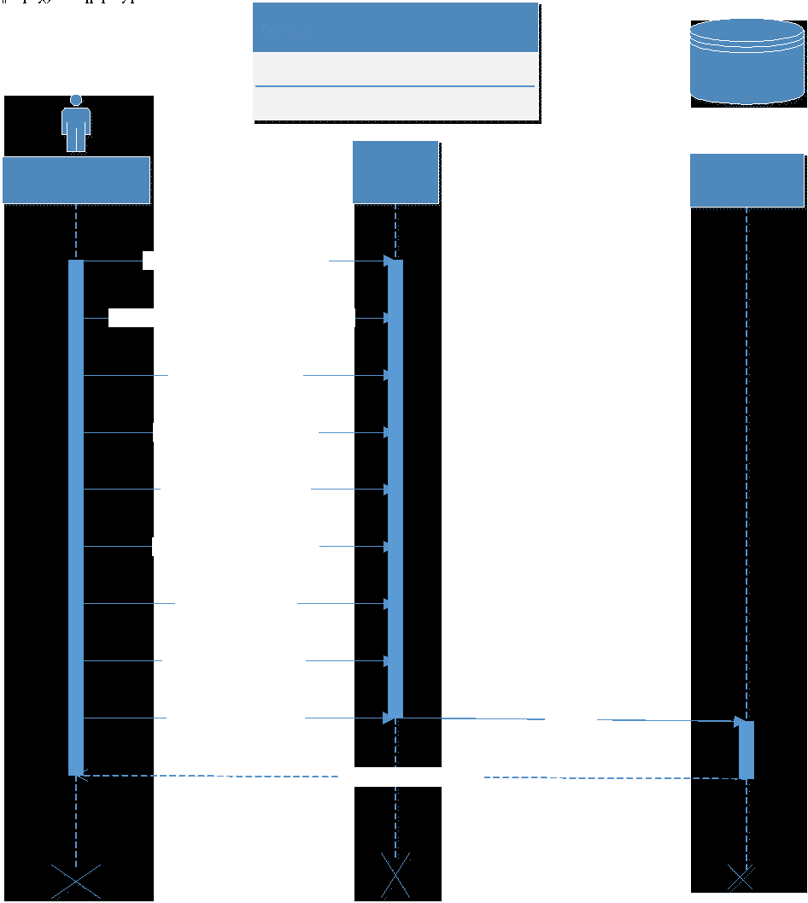

1. The Administrator Clicks Create Backup Button
2. The System Displays A Window Form.
3. The Administrator Enters Backup Name
4. The Administrator Selects Backup Start Date
5. The Administrator Selects Backup Interval
6. The Administrator Selects Data To Be Stored
7. The Administrator Selects Destination
8. System Validates User’s Input
9. The Administrator Clicks Create Backup
10. System Creates New Backup Record.

**Sequence Diagram**

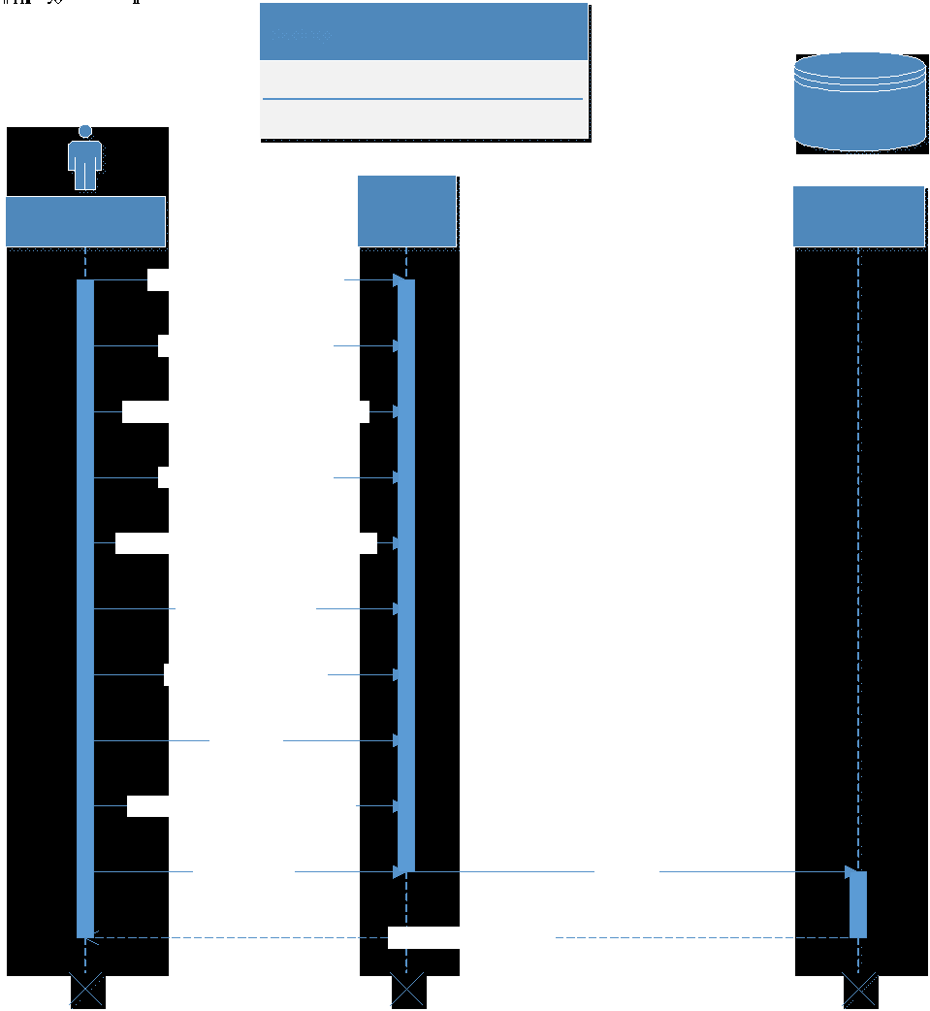

**<Main Flow>**

1. The Administrator Clicks Edit Backup Button
2. The System Displays A Window Form.
3. The Administrator Selects The Backup To Be Edited.
4. The System Displays A Window Form.
5. The Administrator Clicks On The Attribute To Be Edit
6. The Administrator Edits The Attribute.
7. The System Validates User’s Input
8. The Administrator Clicks Ok
9. The Administrator Repeats Process Until Satisfied
10. The Administrator Submits Edits
11. System Updates Record

**Sequence Diagram**

**<Main Flow>**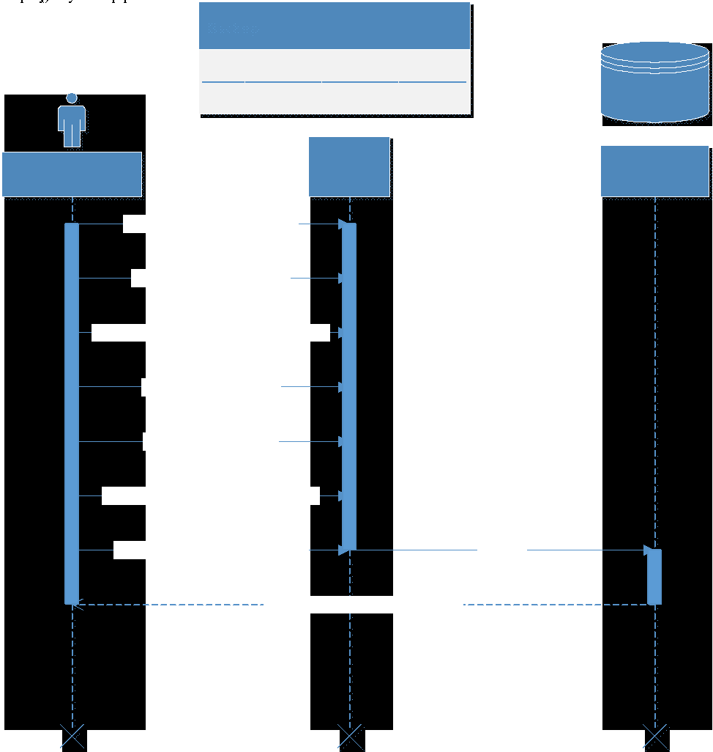

1. The Administrator Clicks Delete Backup Button.
2. The System Displays A Window Form.
3. The Administrator Selects The Backup File To Be Deleted.
4. The System Validates The Deletion.
5. The Administrator Clicks The OK Button.
6. The System Confirms The File Is To Be Deleted.
7. The Administrator Submits The File To Be Deleted.
8. The System Successfully Deletes The Record.

**Sequence Diagram**

**<Main Flow>**

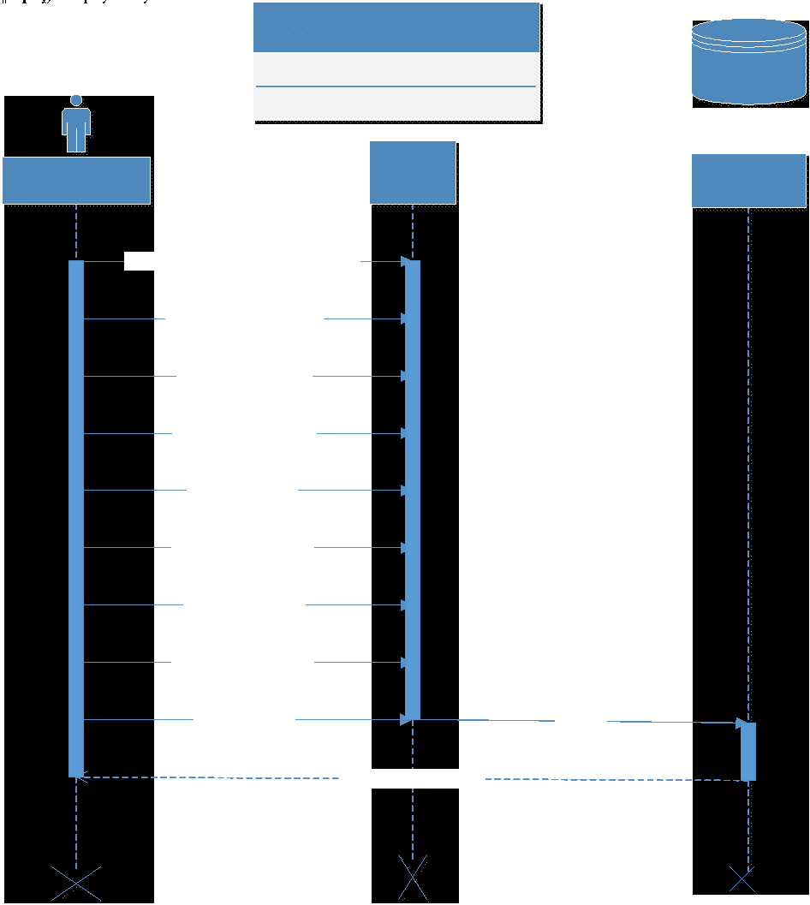

1. The Administrator Clicks Create Recovery Point Button.
2. The System Displays A Windows Form.
3. The Administrator Select Backup Media.
4. The Administrator Selects Recovery Date.
5. The Administrator Selects The Time.
6. The System Validates User’s Input.
7. The Administrator Clicks Ok Button.
8. The Administrator Submits Record.
9. The System Creates A New Recovery Record.

**Sequence Diagram**

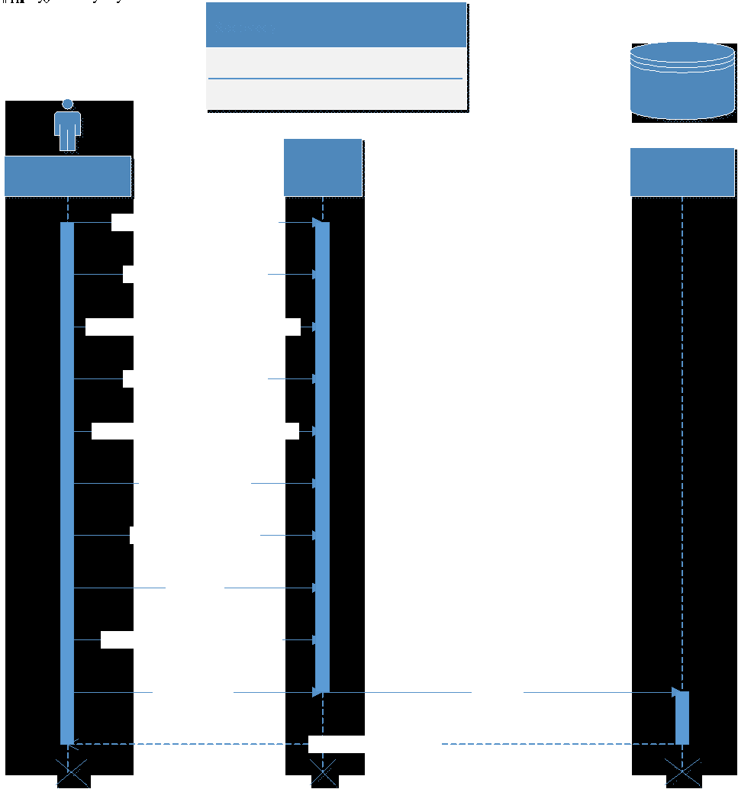

**<Main Flow>**

1. The Administrator Clicks Edit Recovery Button.
2. The System Displays Window Form.
3. The Administrator Selects Recovery Point To Be Edited.
4. The System Displays Window Form.
5. The Administrator Clicks On The Attribute To Be Edit.
6. The Administrator Edits The Attribute.
7. The Administrator Clicks OK Button.
8. The Administrator Repeats Process Until Satisfied
9. The System Validates User’s Input
10. The Administrator Clicks Ok Button
11. The Administrator Submits Record
12. The System Updates Recovery Record

**Sequence Diagram**

**<Main Flow>**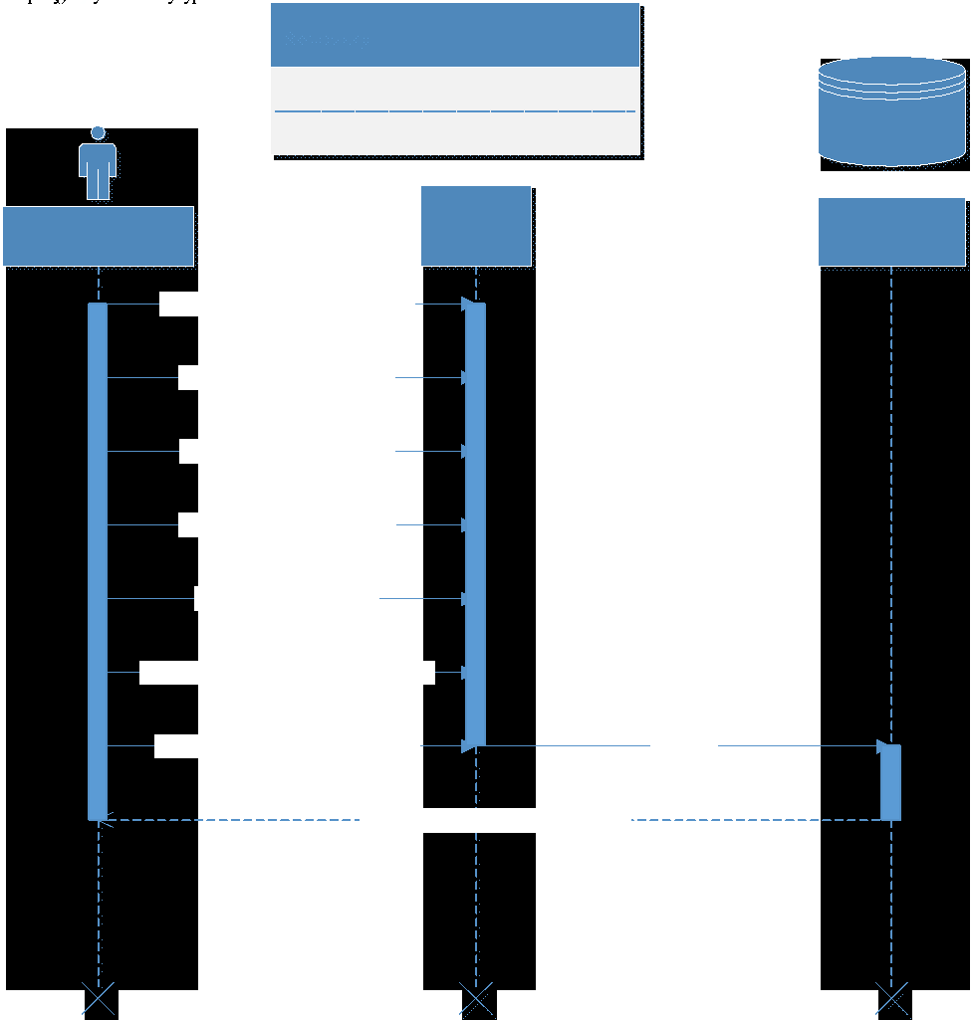

1. The Administrator Clicks Delete Recovery Button.
2. The System Displays A Window Form.
3. The Administrator Selects The Recovery File To Be Deleted.
4. The System Validates User’s Input.
5. The Administrator Clicks The OK Button.
6. The System Confirms The File Is To Be Deleted.
7. The Administrator Submits The File To Be Deleted.
8. The System Successfully Deletes The Record.

**Sequence Diagram**

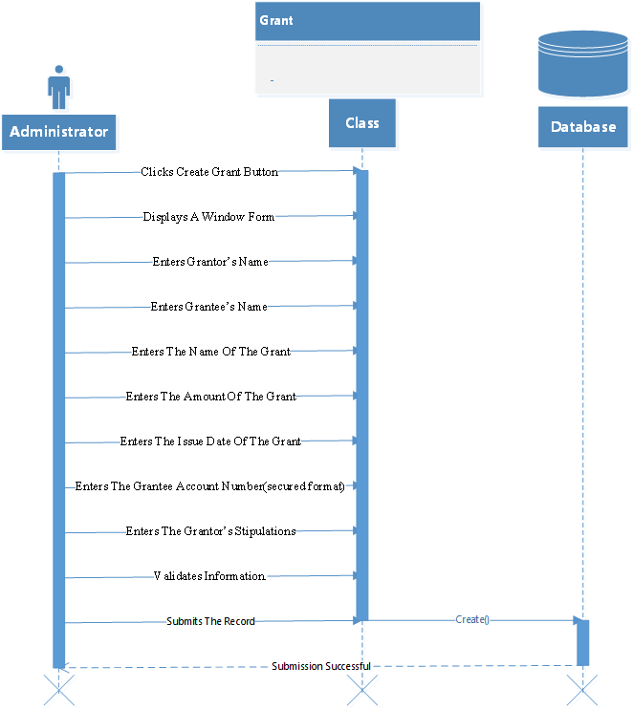

**<Main Flow>**

1. The Administrator Clicks Create Grant Button.
2. The System Displays A Window Form.
3. The Administrator Enters Grantor’s Name.
4. The Administrator Enters Grantee’s Name.
5. The Administrator Enters The Name Of The Grant.
6. The Administrator Enters The Amount Of The Grant.
7. The Administrator Enters The Issue Date Of The Grant.
8. The Administrator Enters The Grantee Account Number (secured format).
9. The Administrator Enters The Grantor’s Stipulations.
10. The System Validates Information.
11. The Administrator Submits The Record.
12. The System Creates A New Grant Record In The Database.

**Sequence Diagram**

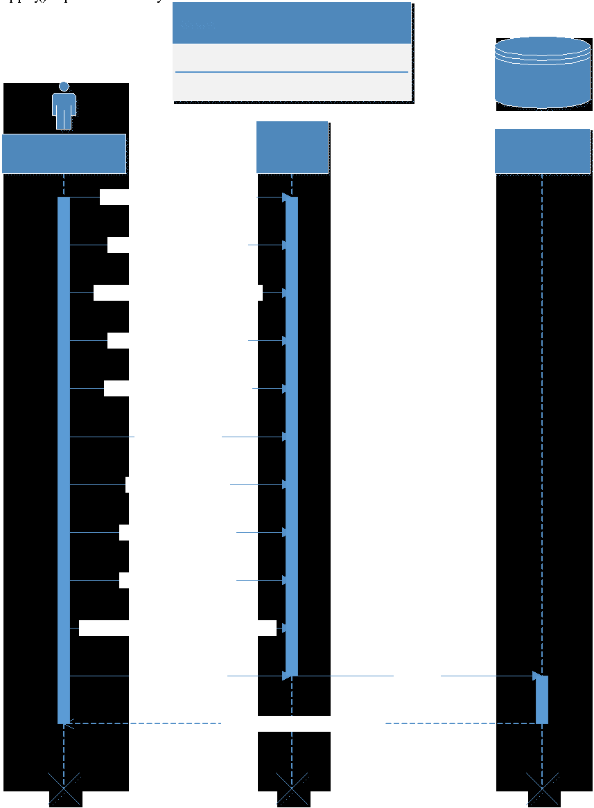

**<Main Flow>**

1. The Administrator Clicks The Edit Grant Button.
2. The System Displays A Windows Form.
3. The Administrator Selects The Grant To Be Edited.
4. The System Displays A Windows Form.
5. The Administrator Selects The Field To Edited.
6. The Name Of The Grant.
7. The Amount Of The Grant.
8. The Issue Date Of The Grant.
9. The Grantee Account Number (secured format).
10. The Grantor’s Stipulations.
11. The Administrator Alters The Field.
12. The System Validates The Edits.
13. The Administrator Clicks The Ok Button.
14. The System Confirms The Edits Are To Be Made.
15. The Administrator Submits The Edits
16. The System Updates The Grant

**Sequence Diagram**

**<Main Flow>**

1. The Administrator Clicks The Delete Grant Button.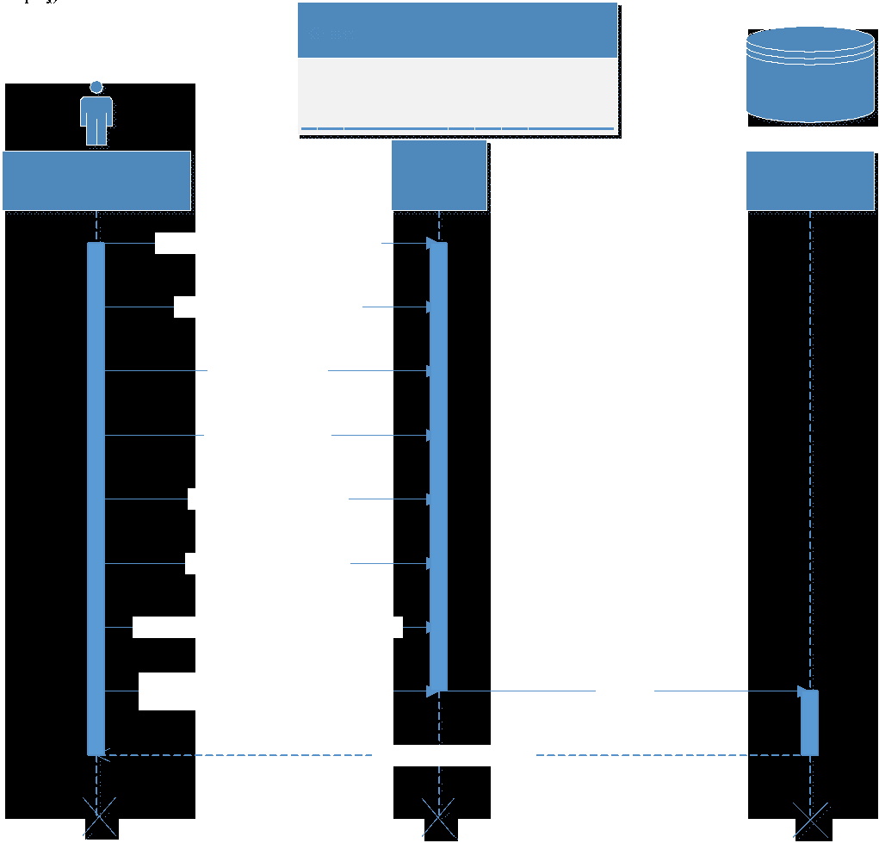
2. System Displays A Window Form.
3. The Administrator Selects The User.
4. The Administrator Selects The Grant
5. The Administrator Clicks The OK Button
6. System Validates The Deletion.
7. System Confirms The Grant Is To Be Deleted
8. Administrator Submits The Grant To Be Deleted
9. System Updates The Database.

**Sequence Diagram**

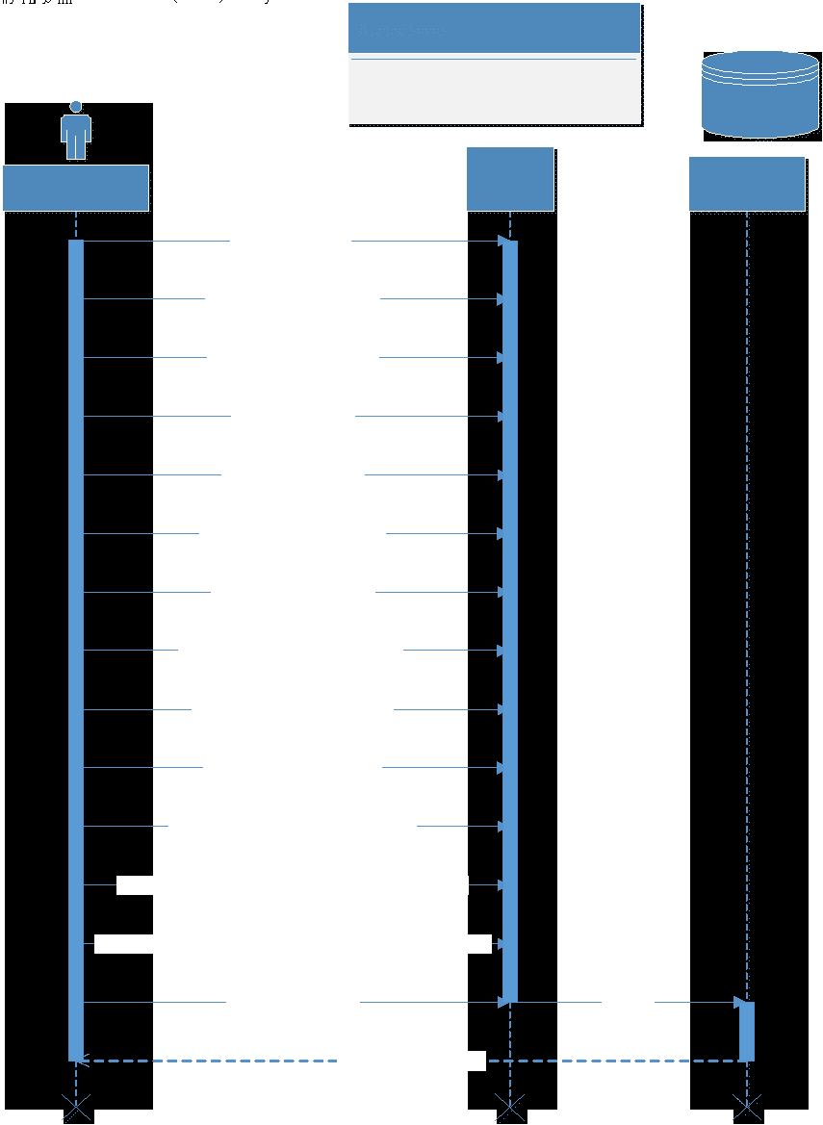

**<Main Flow>**

1. The Administrator Selects Forms Tab
2. The Administrator Clicks Create Form Button.
3. The System Displays A Window Form.
4. The Administrator Enters Form Name.
5. The Administrator Enters Form Deadline.
6. The Administrator Enters Form Award Amount.
7. The Administrator Enters Applicant’s Name.
8. The Administrator Selects Applicant Address ( format)
9. The Administrator Enters Applicant’s Department.
10. The Administrator Enters Applicant’s Position.
11. The Administrator Selects Applicant’s Project’s Proposal.
12. The Administrator Selects Applicant’s Proposal Clearance Form Number.
13. The System Validates Information Entered By The Administrator.
14. The Administrator Submits The Record.
15. The System Creates A New Form Record In The Database.

**Sequence Diagram**

**<Main Flow>**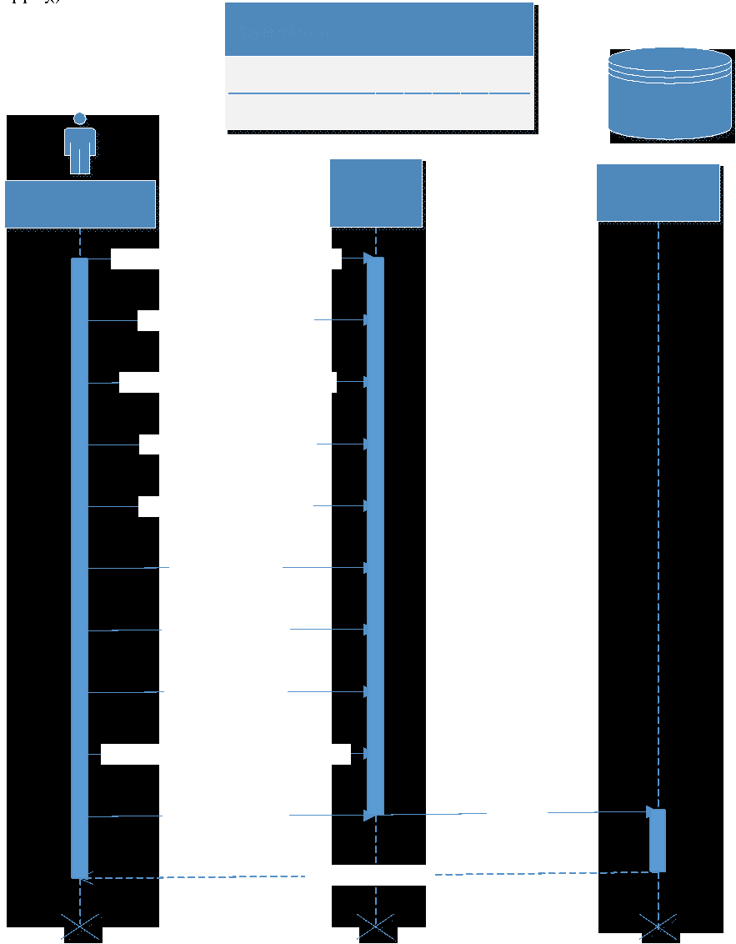

1. The Administrator Selects The Edit Form Button.
2. The System Displays A Window Form.
3. The Administrator Selects The Form To Be Edited
4. The System Displays A Window Form.
5. The Administrator Selects The Field To Edit.
6. Form Name.
7. Form Deadline.
8. Form Award Amount.
9. Applicant’s Name.
10. Applicant Address (format)
11. Applicant’s Department.
12. Applicant’s Position.
13. Applicant’s Project’s Proposal.
14. Applicant’s Proposal Clearance Form Number.
15. The Administrator Alters The Field.
16. The System Validates The Edits.
17. The Administrator Clicks OK.
18. The System Confirms the Edits Are To Be Made.
19. The Administrator Submits The Edits.
20. The System Updates The Database Record.

**Sequence Diagram**

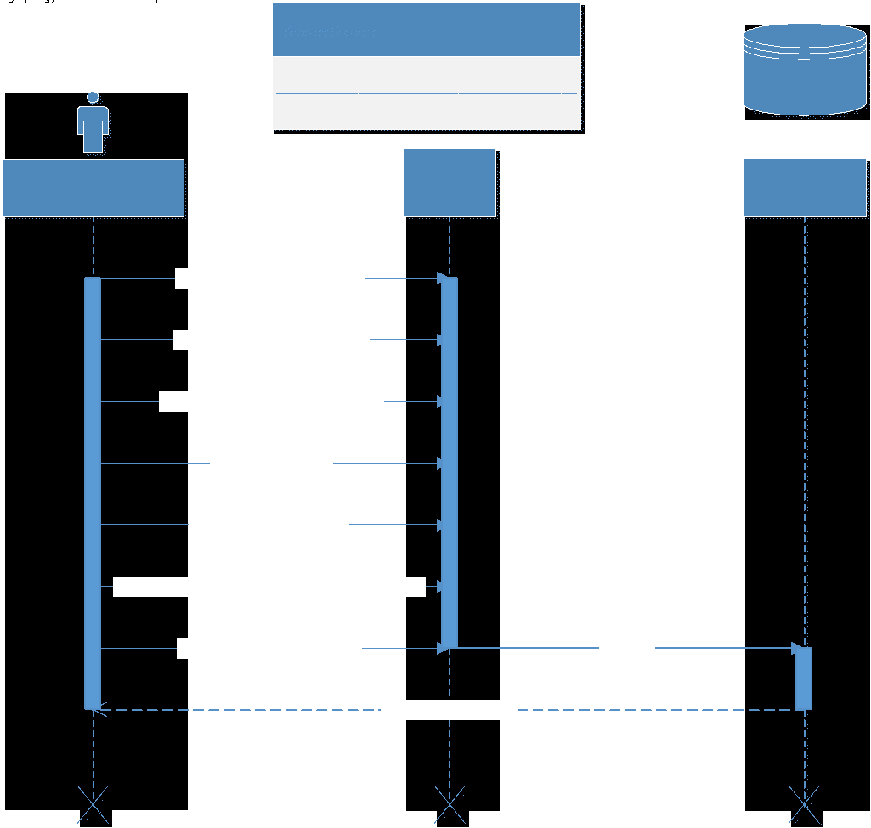

**<Main flow>**

1. The Administrator Selects Delete Form Button.
2. The System Displays A Window Form
3. The Administrator Selects The Form To Be Deleted
4. The Administrator Clicks OK Button
5. The System Validates The Deletion
6. The System Confirms The Form Is To Be Deleted
7. The Administrator Submits Deletions Request.
8. System Deletes The Form Record

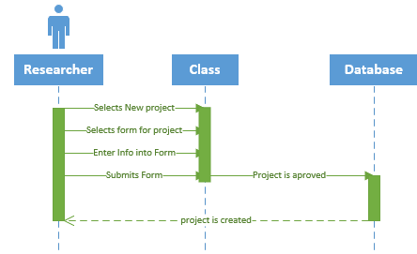

**Main Flow**

● User enters iRIS

● User enters Username

● User enters Password

● User login

● User selects New project.

● User selects form

● User enters Information into the Form

● User submits form

● User project gets approved

● User get confirmation of project approved

● Use case ends

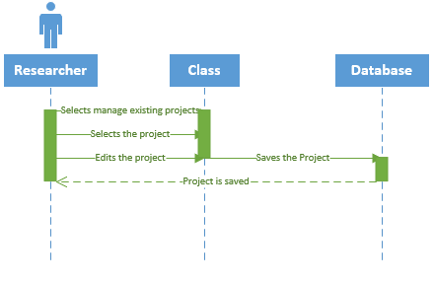

**Main Flow**

* User enters iRIS
* User enters Username
* User enters Password
* User login
* User selects manage existing projects
* User selects the project they wish to edit
* User edits the project
* User saves the edits they made
* Use case ends

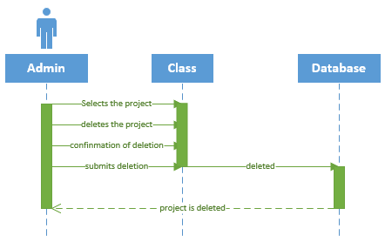

**Main Flow**

* Admin enters iRIS
* Admin enter Username
* Admin enter Password
* Admin login
* Admin searches for the project
* Admin deletes the project
* Confirmation is sent to the admin
* Admin confirms
* deletion request is sent to a higher up
* Deletion request approved
* Project is deleted
* Use case ends

**Main Flow**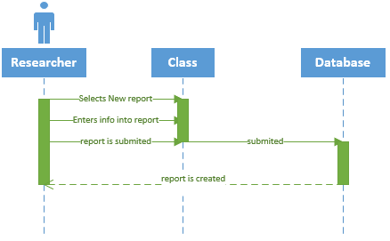

* User enters iRIS
* User enters Username
* User enters Password
* User login
* User clicks on start a new Reports
* User enters information into due reports
* User submits reports
* Use case ends

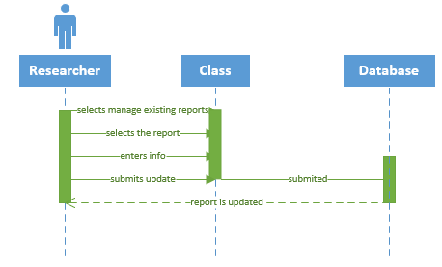

**Main Flow**

* User enters iRIS
* User enters Username
* User enters Password
* User login
* User clicks on manage existing Reports
* User goes to Submitted Reports
* User clicks on Report
* User updates Report
* Updated report is sent
* Use case ends

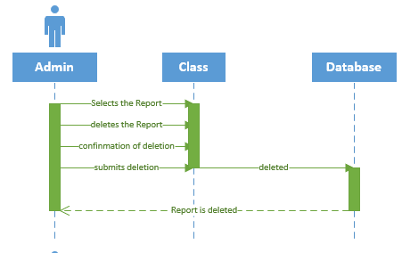

**Main Flow**

* Admin enter System
* Admin enters Username
* Admin enters Password
* Admin login
* Admin searches for the report
* Admin deletes report

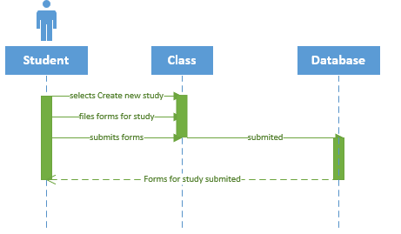

**Main Flow**

* User enters iRIS
* User enters Username
* User enters Password
* User login
* User clicks Create a new Study
* User files Forms
* User submits Forms
* User receive confirmation of approval
* Use case ends

**Main Flow**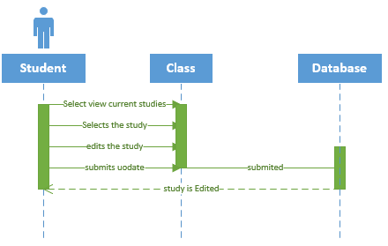

* User enters iRIS
* User enters Username
* User enters Password
* User login
* User clicks view Current Studies
* User edits Study
* Use Case ends

**Main Flow**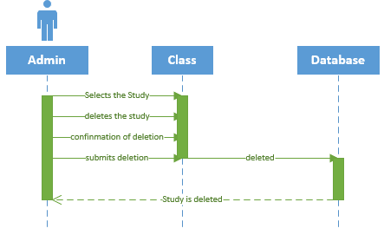

* Admin enters system
* Admin enters Username
* Admin enters password
* Admin searches for the Study
* Admin deletes Study
* Use case end

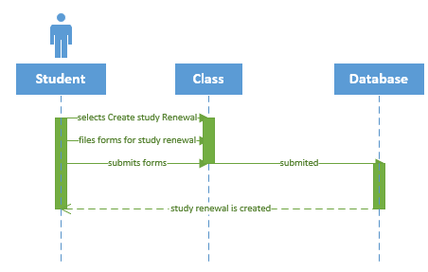

**Main Flow**

* User enters iRIS
* User enters Username
* User enters Password
* User login
* User clicks Study Renewal
* User creates a Study Renewal
* User enters Information
* User submits Study Renewal
* User request is approved
* User is notified of approval

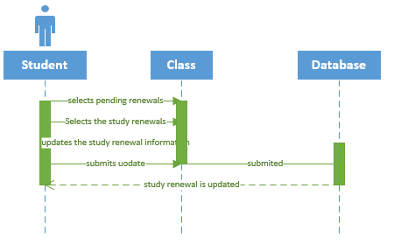

**Main Flow**

* User enters iRIS
* User enters Username
* User enters Password
* User login
* User clicks Study Renewal
* User Select Pending Renewals
* User updates the information they provided
* Use Case ends

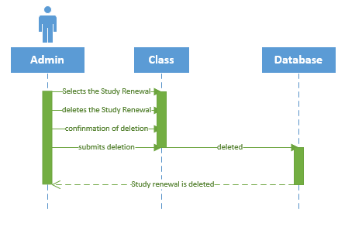

**Main Flow**

* Admin enters System
* Admin Enters Username
* Admin Enters Password
* Admin login
* Admin searches for Study Renewal
* Admin Deletes Study Renewal
* Use case ends

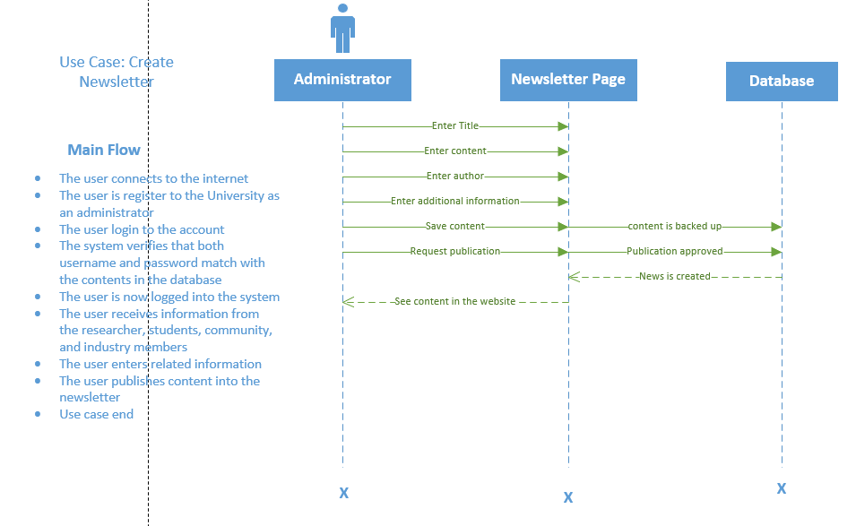

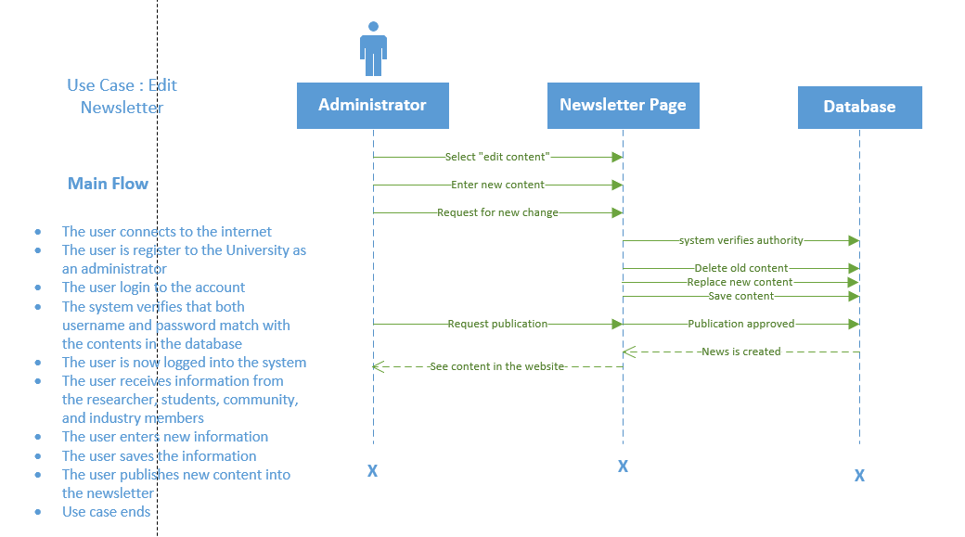

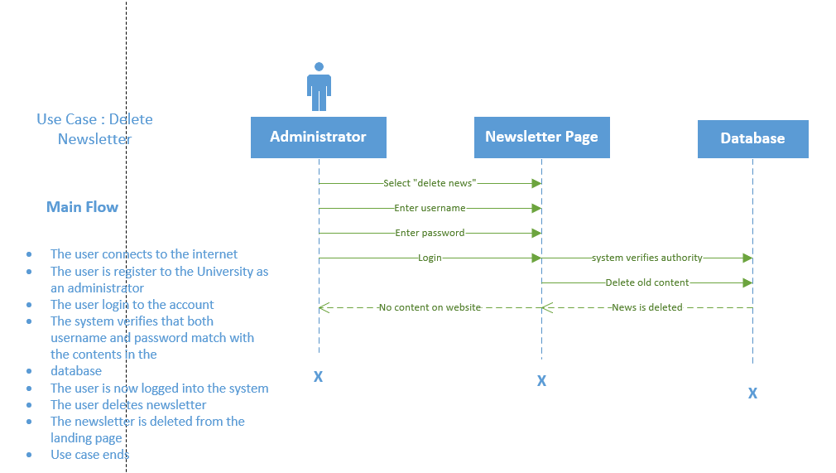

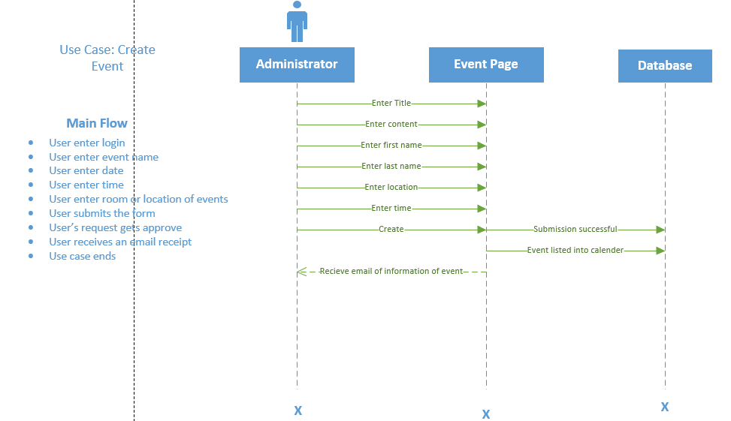

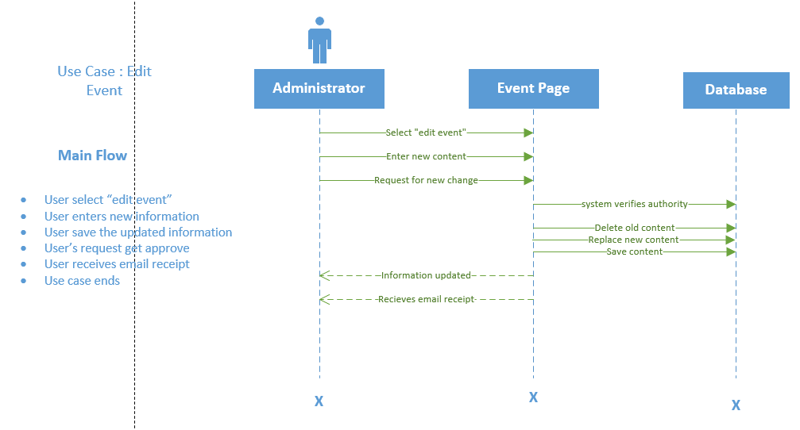

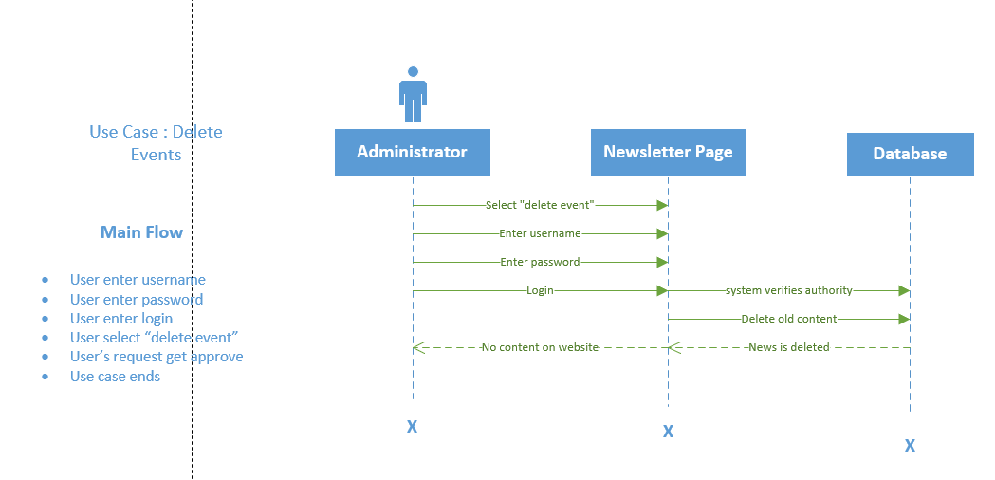

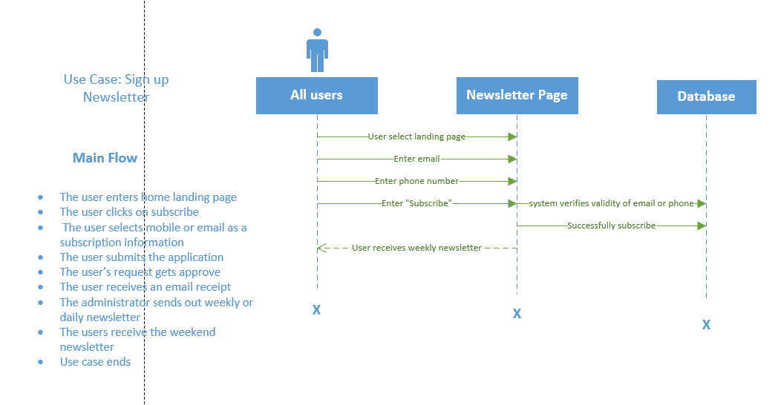

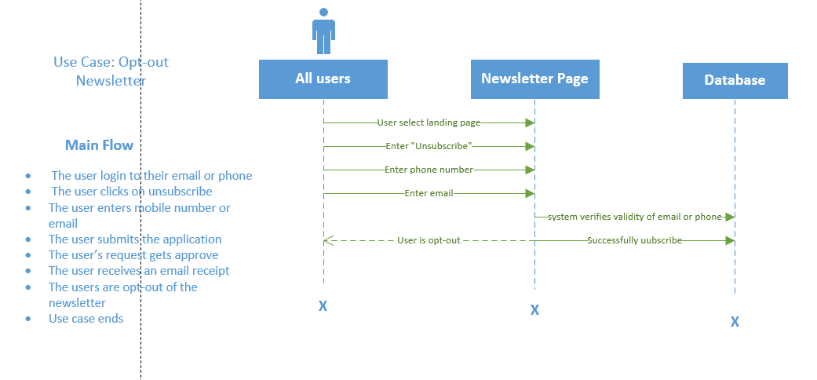

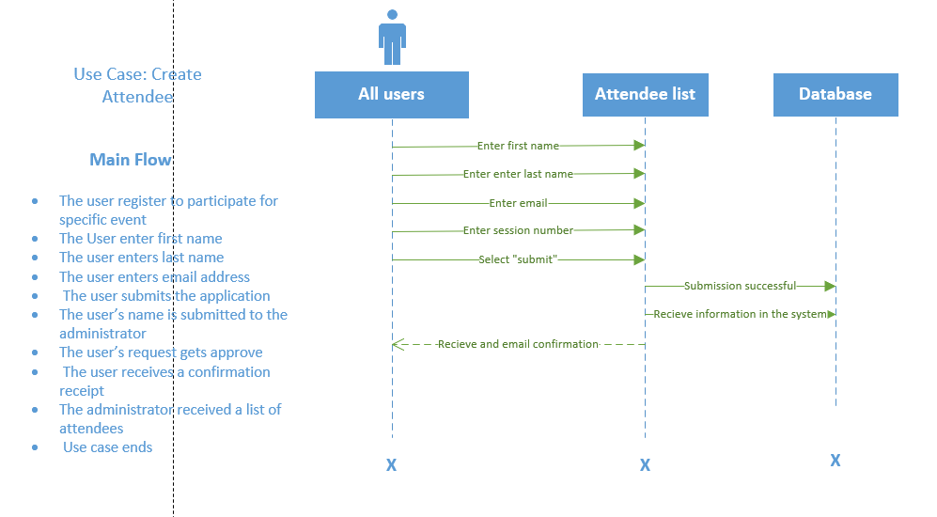

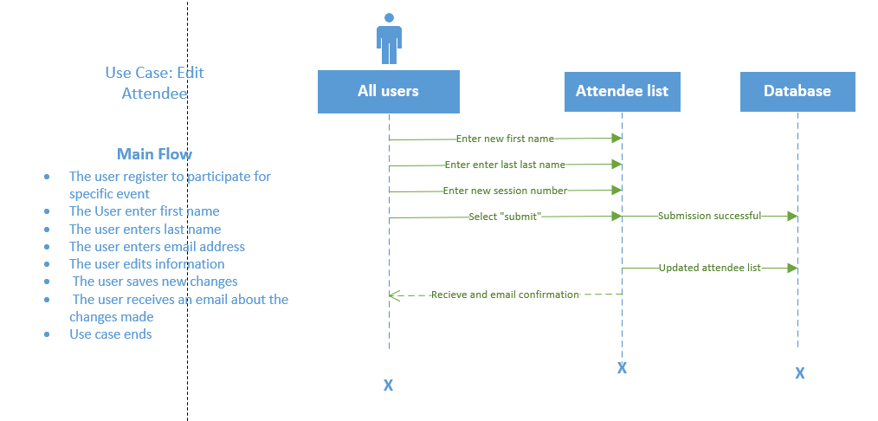

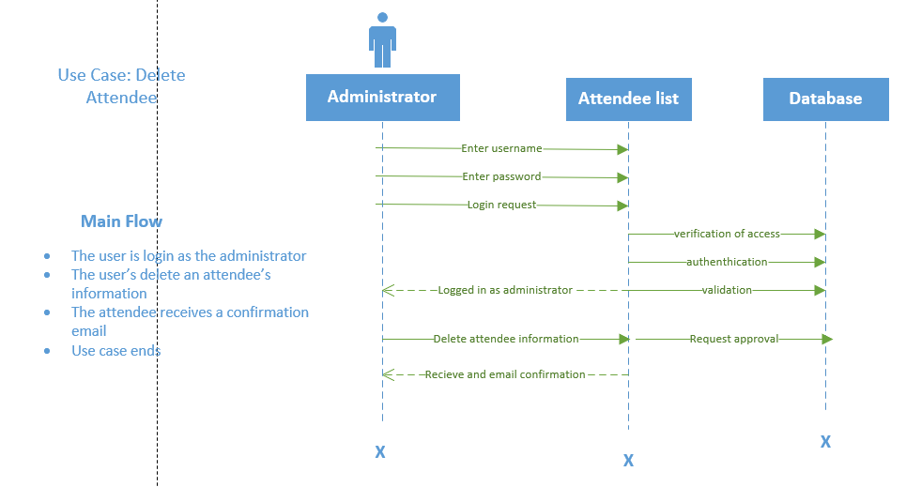

**Main Flow:**

1. The user clicks create textbox. 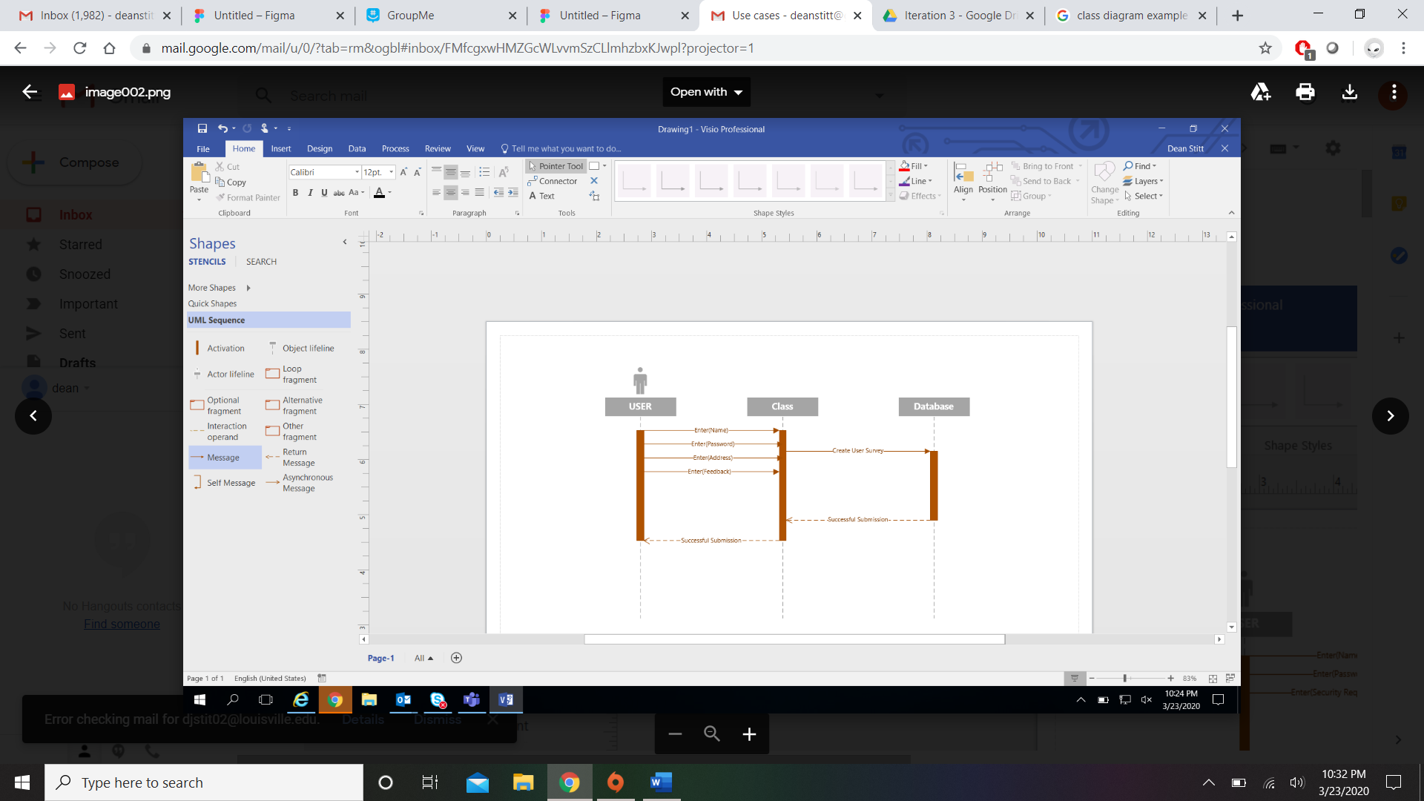

2. The user enters their first name.

3. The user enters their last name.

4. The user enters their phone number.

5. The user enters their feedback.

6. The user enters a password.

7. The user validates their password.

8. The user submits the survey.

9. The system creates a new survey in the database.

**Main Flow:**

1. The user clicks create textbox. 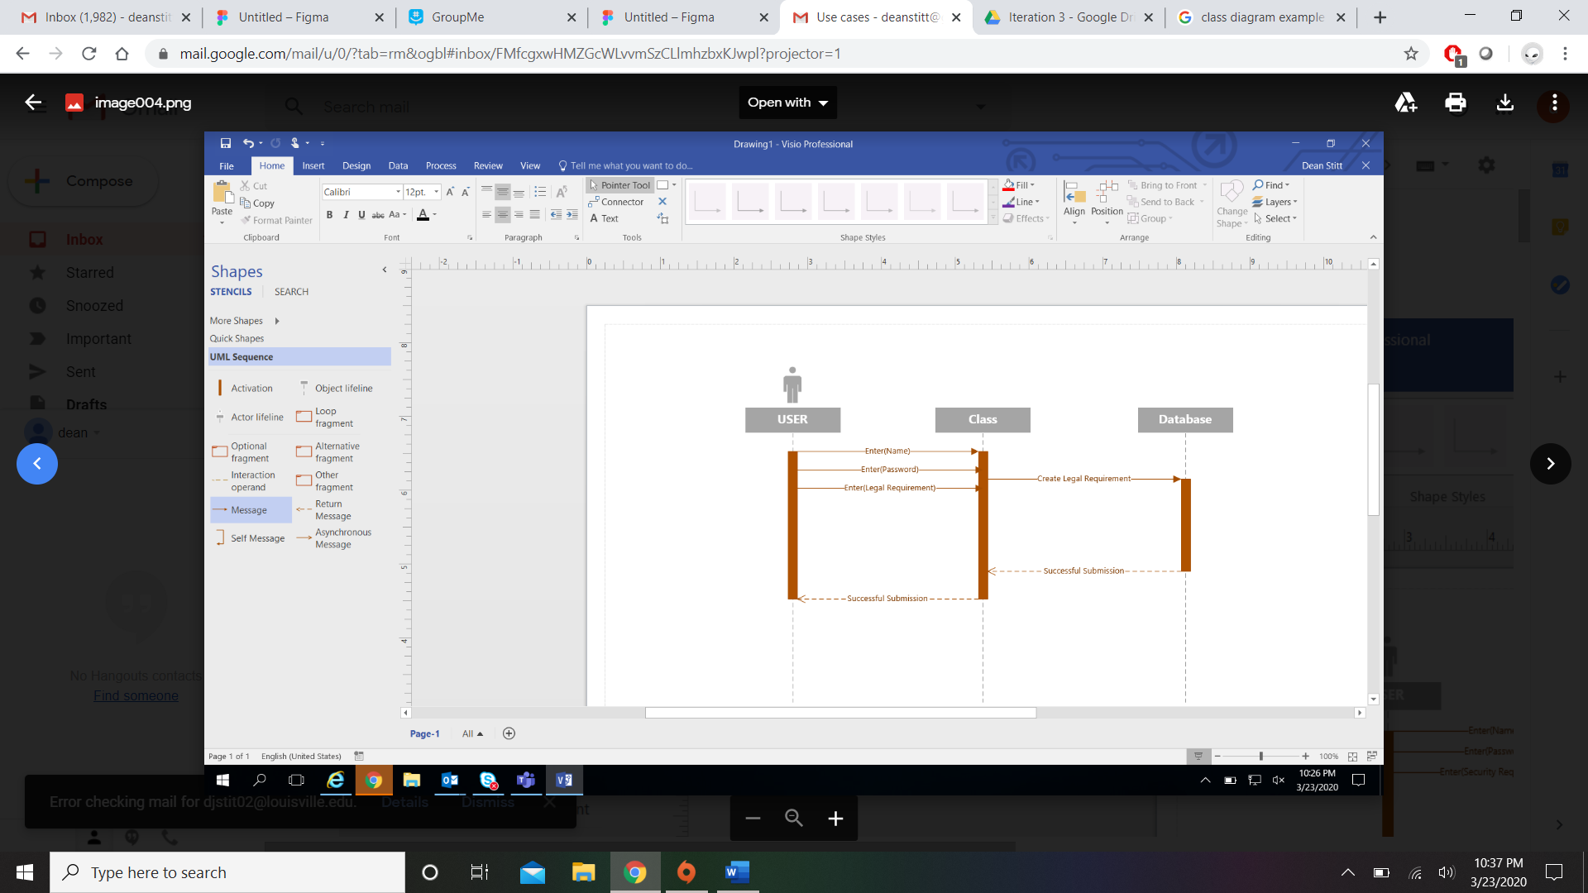

2. The user enters their first name.

3. The user enters their last name.

4. The user enters their legal requirement.

5. The user enters a password.

6. The user validates their password.

7. The user submits the legal requirement.

8. The system creates a new legal requirement in the database.

**Main Flow:**

1. The user clicks create textbox. 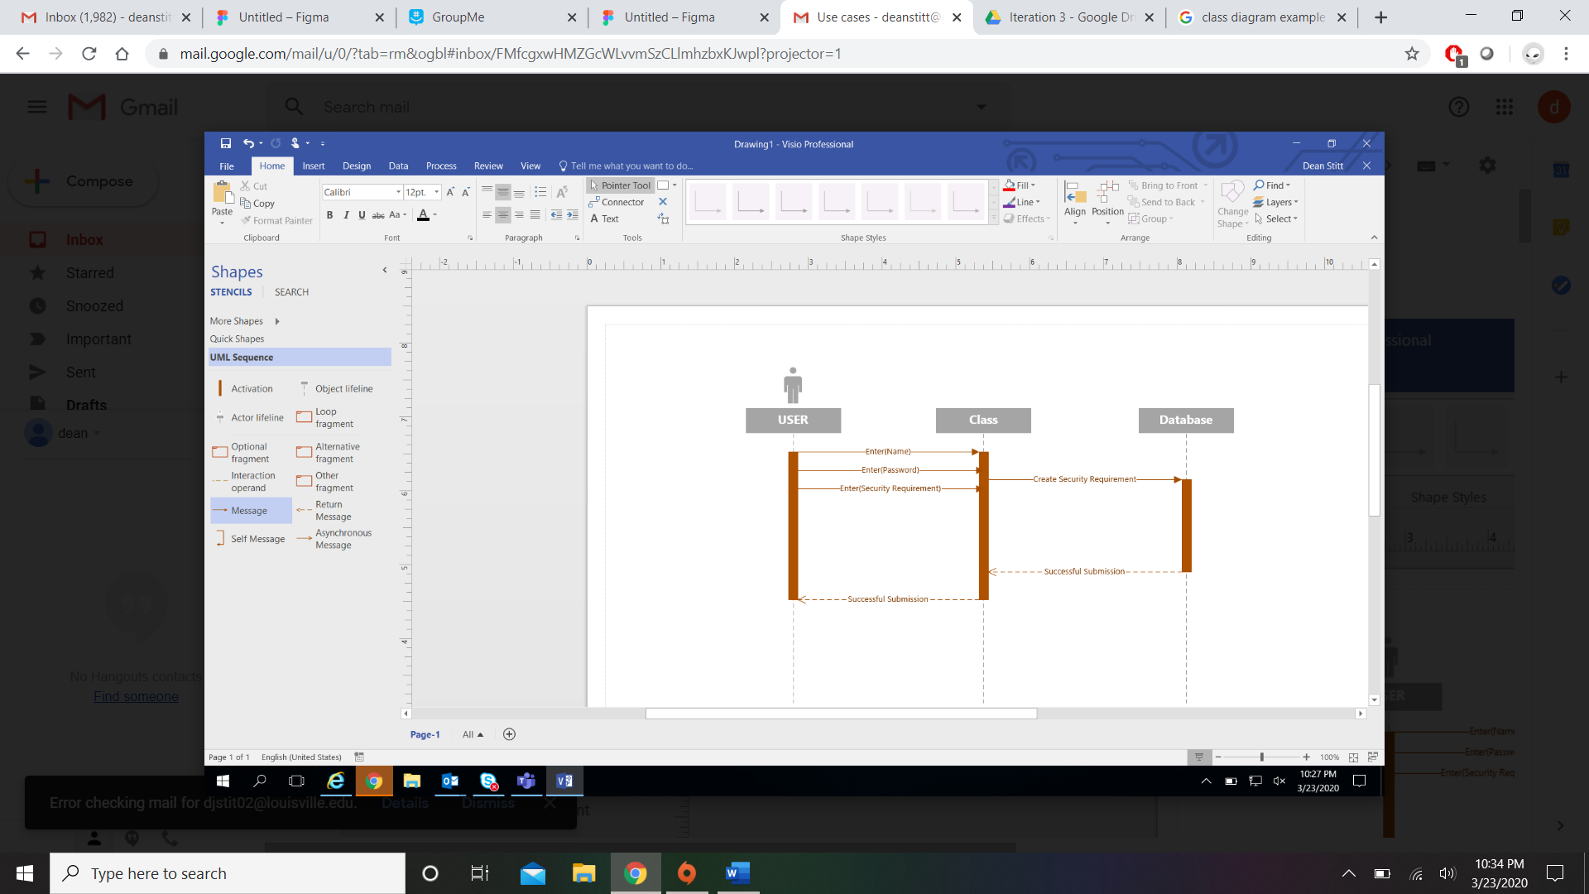

2. The user enters their first name.

3. The user enters their last name.

4. The user enters their Security requirement.

5. The user enters a password.

6. The user validates their password.

7. The user submits the security requirement.

8. The system creates a new security requirement in the database.

**Main Flow:**

1. The user clicks create textbox. 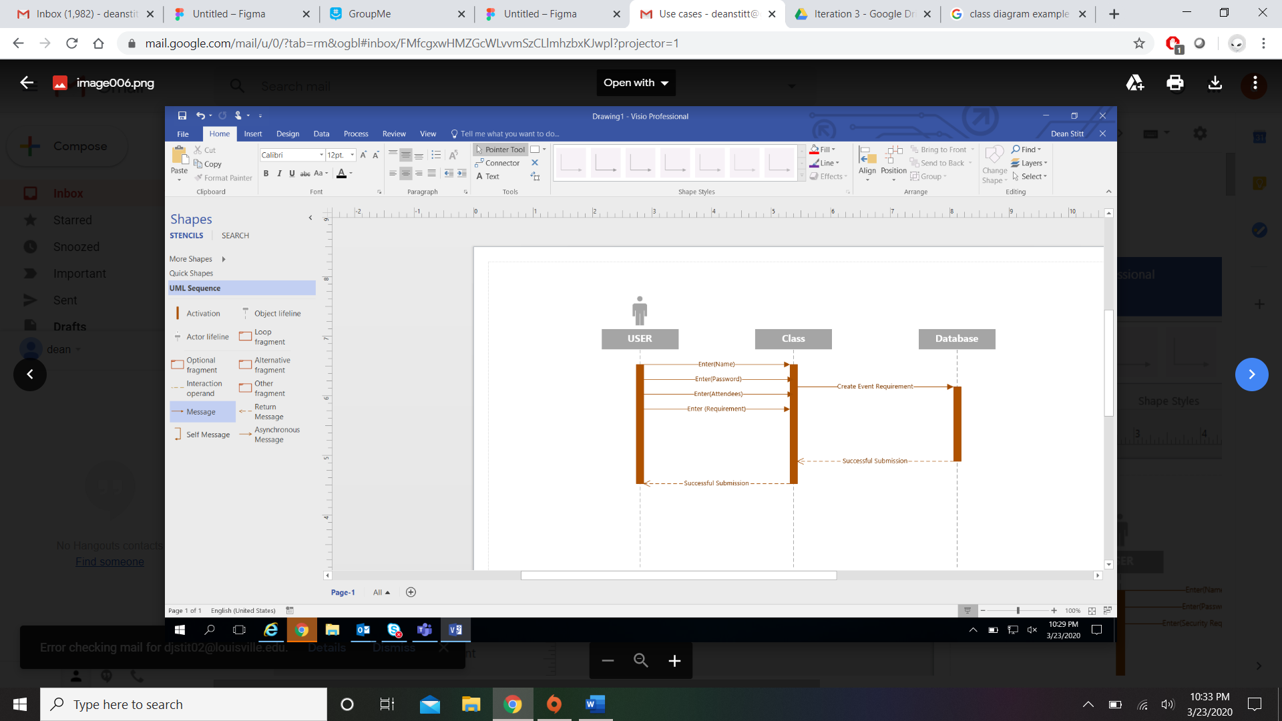
2. The user enters their first name.
3. The user enters their last name.
4. The user enters their attendee.
5. The user enters Requirements.
6. The user enters a password.
7. The user validates their password.
8. The user submits the event requirement.

1. The system creates a new event requirement in the database.

**Main Flow:**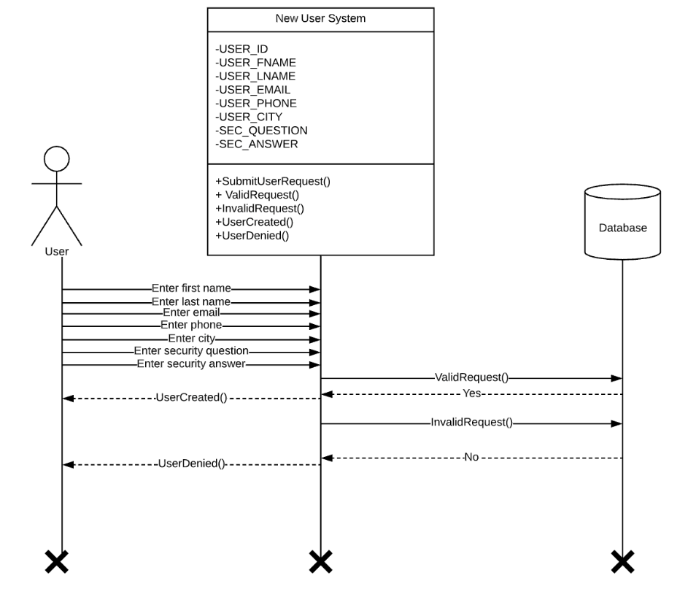

1. User clicks the sign-up button.
2. User enters their first name.
3. User enters their last name.
4. User enters e-mail.
5. User enters their phone number.
6. User enters username.
7. User selects a security question.
8. User enters an answer to a security question.
9. User submits information.

**Main Flow:**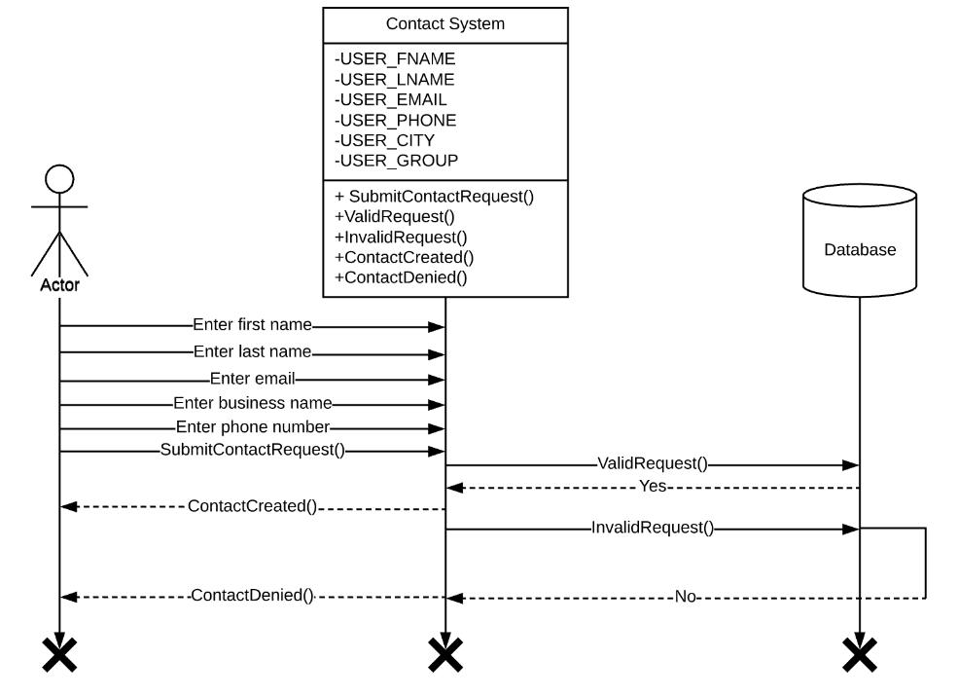

* + - 1. User clicks on the Industry & Community tab.
      2. User enters their first name.
      3. User enters their last name.
      4. User enters e-mail address.
      5. User enters business/organization name [optional].
      6. User enters 10+ digit phone number [optional].
      7. User submits information.

**Main Flow:**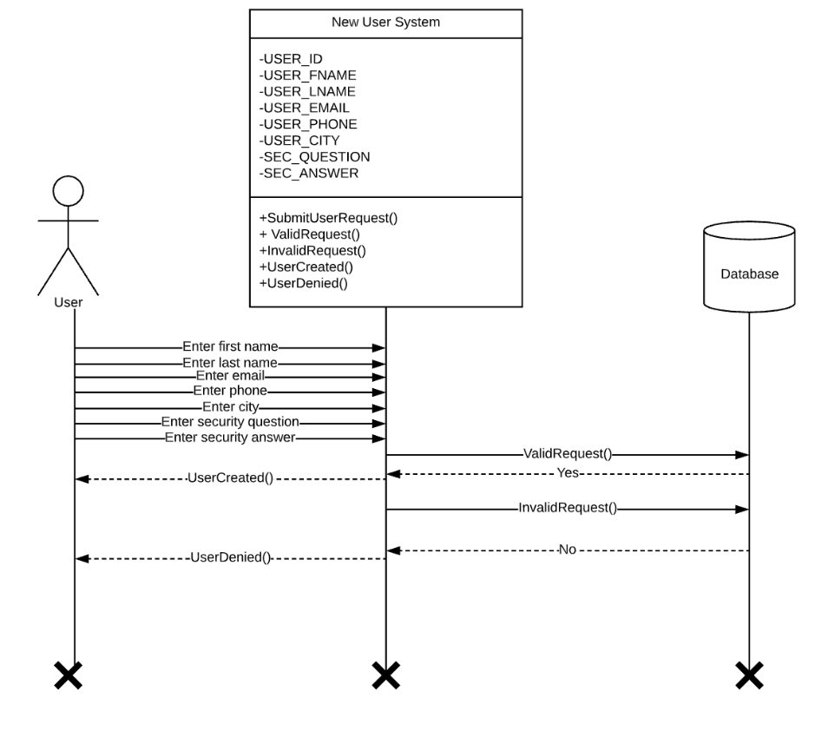

1. User clicks the sign-up button.
2. User enters their first name.
3. User enters their last name.
4. User enters e-mail.
5. User enters their phone number.
6. User enters password.
7. User re-enters password.
8. User selects a security question.
9. User enters an answer to a security question.
10. User submits information

**Main Flow:**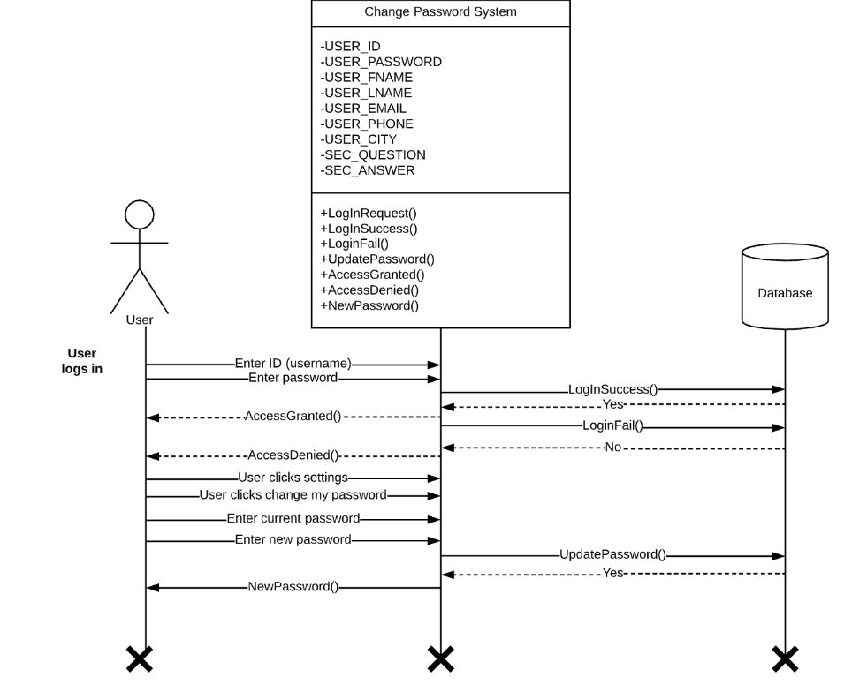

1. User clicks the log-in.
2. User enters username.
3. User enters password.
4. User submits credentials.
5. User accesses page.
6. User clicks the settings (gear) button.
7. User clicks “change password” option.
8. User enters current password.
9. User enters a new password.
10. User re-enters new password.
11. User receives confirmation email.

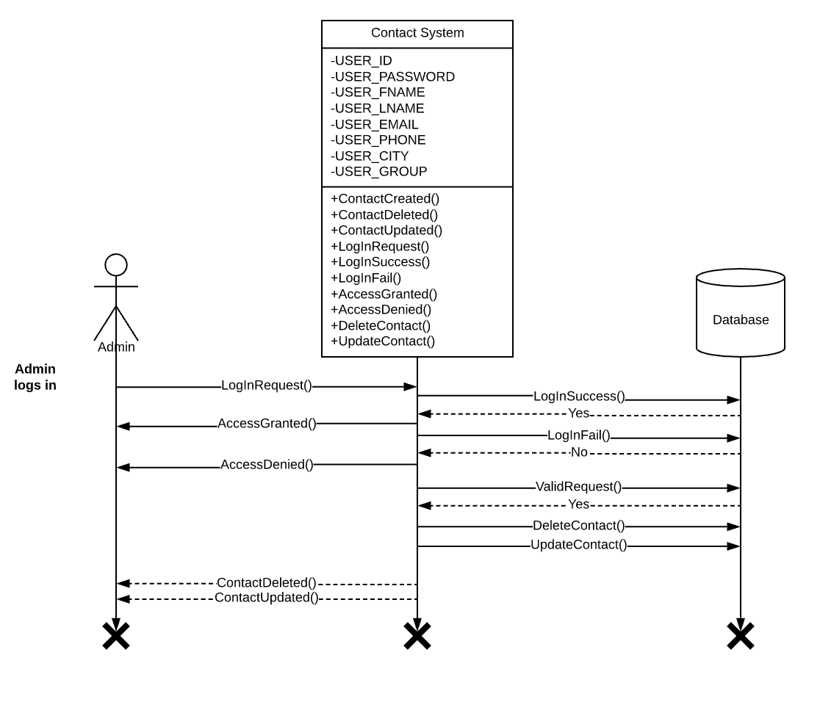

**Main Flow:**

1. User [administrator] clicks on contact list file.
2. User clicks on manage file.
3. User deletes record.

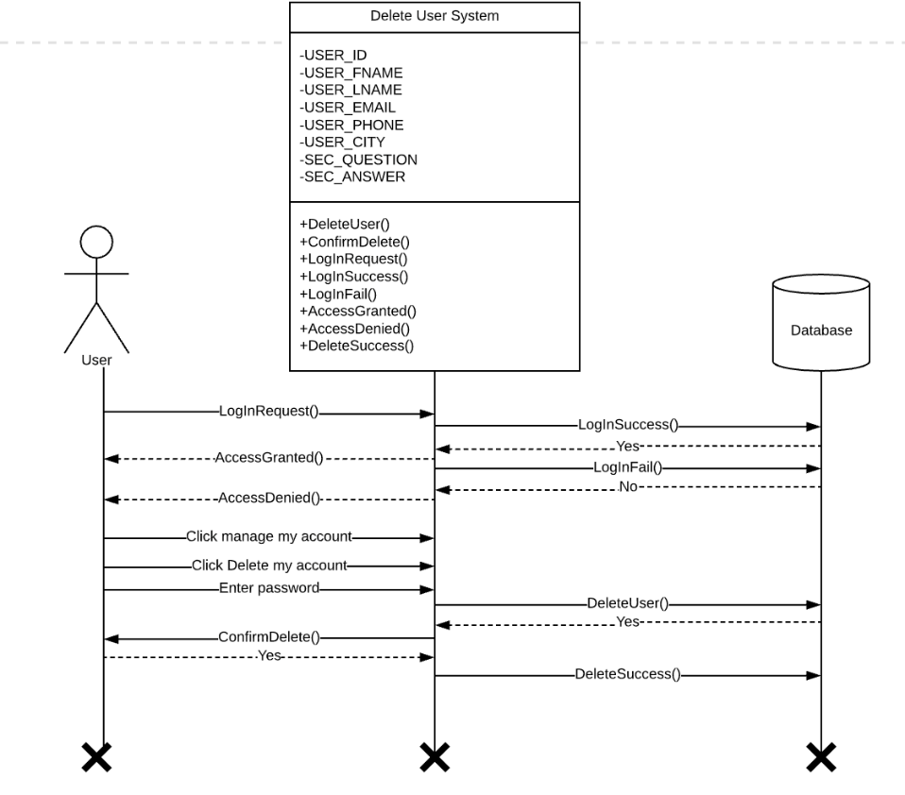

**Main Flow:**

1. User clicks the log-in button.
2. User enters their username.
3. User enters their password.
4. Users submits credentials
5. User clicks the settings (gear) button.
6. User clicks “delete my account”.
7. User enters password.
8. User submits the password.

**Use case ends**

**Main Flow:**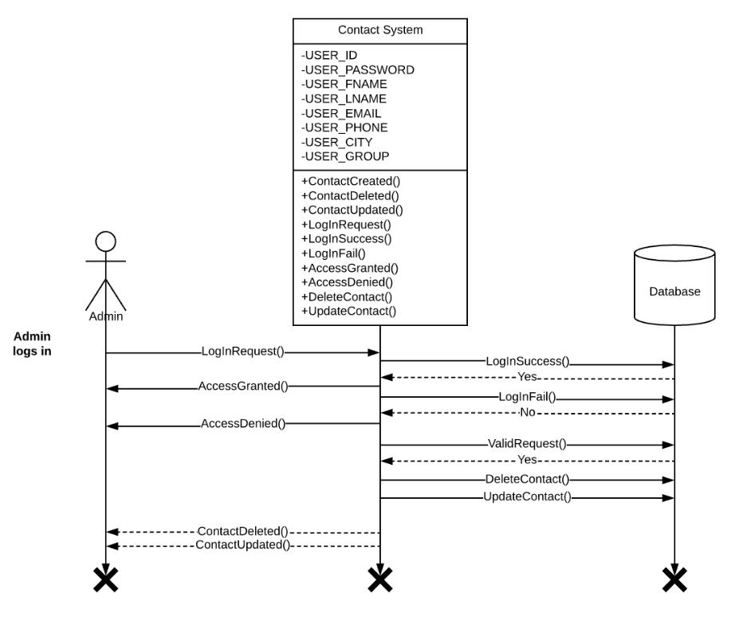

1. User clicks on the Industry & Community tab.
2. User clicks on the edit contact button.
3. User updates their information.

**Main Flow:**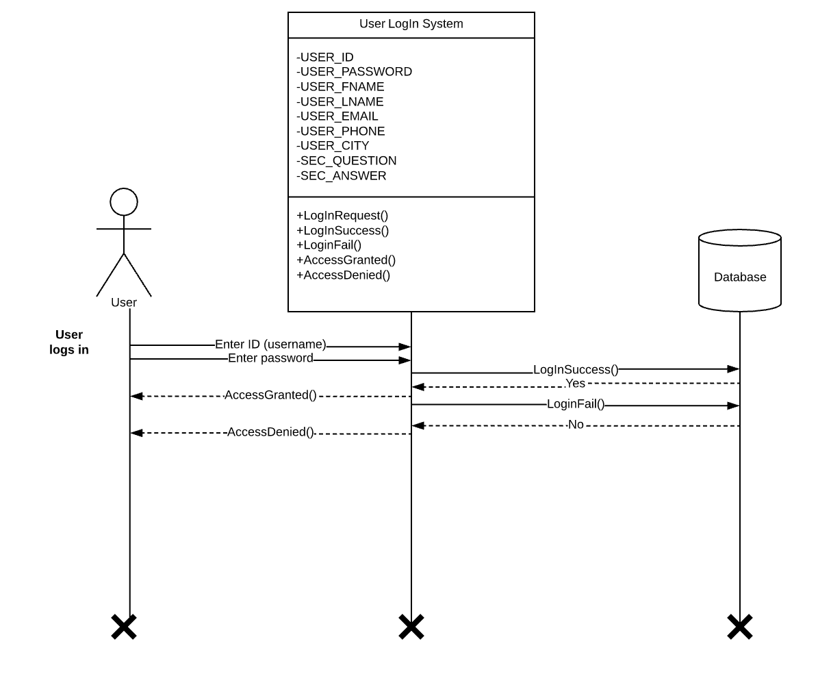

1. User clicks the log-in button.
2. User enters username.
3. User enters password.
4. User submits credentials

**Class Diagram**

This class diagram shows the relationship between different classes for the necessary entity for the operation of the Research & Innovation Center. The above shows both the entity relation in terms of one case and many cases. For instance, users may register for events and need to create an attendee for the event. This dependency is shown above and details the methods that will need to be created to ensure the user requirements are met. Attributes are shown to give the developer the names of variables that will be required to meet the needs of the prototype and finished product.

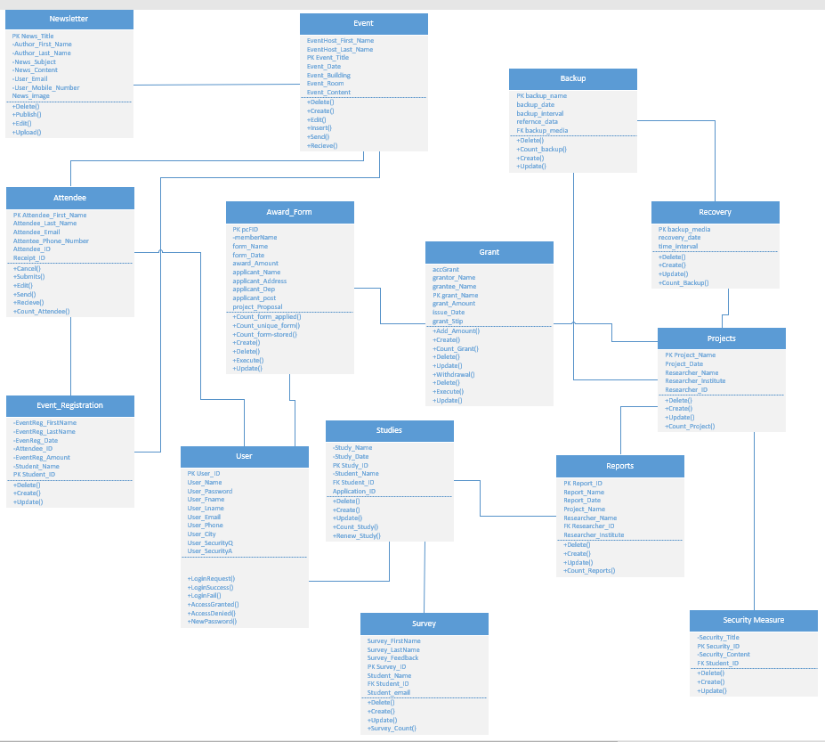

|  |  |
| --- | --- |
| Class - Newsletters | |
| Responsibility   * Know who published the letter * Know who edited the letter * Know who uploaded new letters * Allow users to read letter * Allow the user to sign-up for weekly newsletter * Allow the user to opt-out of the weekly newsletter | Collaborator   * Event |

|  |  |
| --- | --- |
| Class - Attendee | |
| Responsibility   * Allow user to cancel * Allow user to edit attendee * Allow user to submit attendee * Allow users to send and receive information * Know the count of the attendees | Collaborator   * Event * Event Registration |

|  |  |
| --- | --- |
| Class - Event_Registation | |
| Responsibility   * Allow user to create registration * Allow user to delete registration * Allow user to update registration | Collaborator   * Event * Attendee |

|  |  |
| --- | --- |
| Class - Survey | |
| Responsibility   * Allow the user to create a form * Allow the user to edit form * Allow the user to delete form * Ask questions related to particular studies * The user is expected to provide feedback | Collaborator   * studies |

|  |  |
| --- | --- |
| Class - Event | |
| Responsibility   * Description of the event location, session ID, date, and host * The user creates an event * The user edits an event * The user deletes an event | Collaborator   * Event Registration * Attendee |

|  |  |
| --- | --- |
| Class – Award_Form | |
| Responsibility   * Display information on related grants or reward * The applicant provides name, address, and ID * The user can create an award form * The user can edit an award form * The user can delete an award form | Collaborator   * Grant * Study * Project |

|  |  |
| --- | --- |
| Class - Studies | |
| Responsibility   * Provide a description of information of particular study that the user applied for * Connect the user information with the related study * Provide excesses link to regarding the studies * The user can create a study * The user can edit a study * The user can delete a study * The user can renew or extend the study period | Collaborator   * Grant * Study * Project |

|  |  |
| --- | --- |
| Class - Backup | |
| Responsibility   * The user can create backup information * The user can edit backup information * The user can delete backup information * Provide an alternative if a particular system fails to operate | Collaborator   * Recovery * Project |

|  |  |
| --- | --- |
| Class - Recovery | |
| Responsibility   * The user can create recovery * The user can edit recovery * The user can delete recovery * Restores the system to its original state after a system failure | Collaborator   * Back-up * Project |

|  |  |
| --- | --- |
| Class - Projects | |
| Responsibility   * The user creates a project * The user edits a project * The user deletes a project * Provide a time limit for the user to accomplish within the time * Provide information of the project * Connect the project with the researcher | Collaborator   * Study * Grant * Back up * Report |

|  |  |
| --- | --- |
| Class - Reports | |
| Responsibility   * The user creates the report * The user edits the report   The user deletes the report   * provides progress information on the research project * the report is back up with statistics and charts | Collaborator   * Project * Study * Grant |

|  |  |
| --- | --- |
| Class - Security Measure | |
| Responsibility   * Provide a description of the security measure of different department * The administrator creates the security measure * The administrator edits the security measure * The administrator deletes the security measure | Collaborator   * Projects |

|  |  |
| --- | --- |
| Class - User | |
| Responsibility   * The user creates account * The user login success * The user login alternative path, login fail * The user creates username * The user creates password | Collaborator   * Projects |

**Database Design**

**Fundamentals**

To avoid partial dependencies, we had to remove a lot of the composite keys. Instinctively, we added User_ID as a primary attribute in almost every table. However, we quickly learned that most attributes were not dependent on User_ID. Primary keys such as PCF_ID, Event_ID, Study_ID, Proj_ID, Report_ID, and Grant_ID serve as the only determinants in their respective tables. To reach that point, we had to create additional tables. For example, the Reports table derived from the Projects table. Once the database was in 2NF, we removed all transitive dependencies.

**Data Types & Sizes**

The data types and sizes were chosen based on system requirements. The User ID and Username will allow for IDs and usernames of *up to* 15 characters. However, a password or email may be up to 64 characters. Any attribute being stored with a date will use the date data type.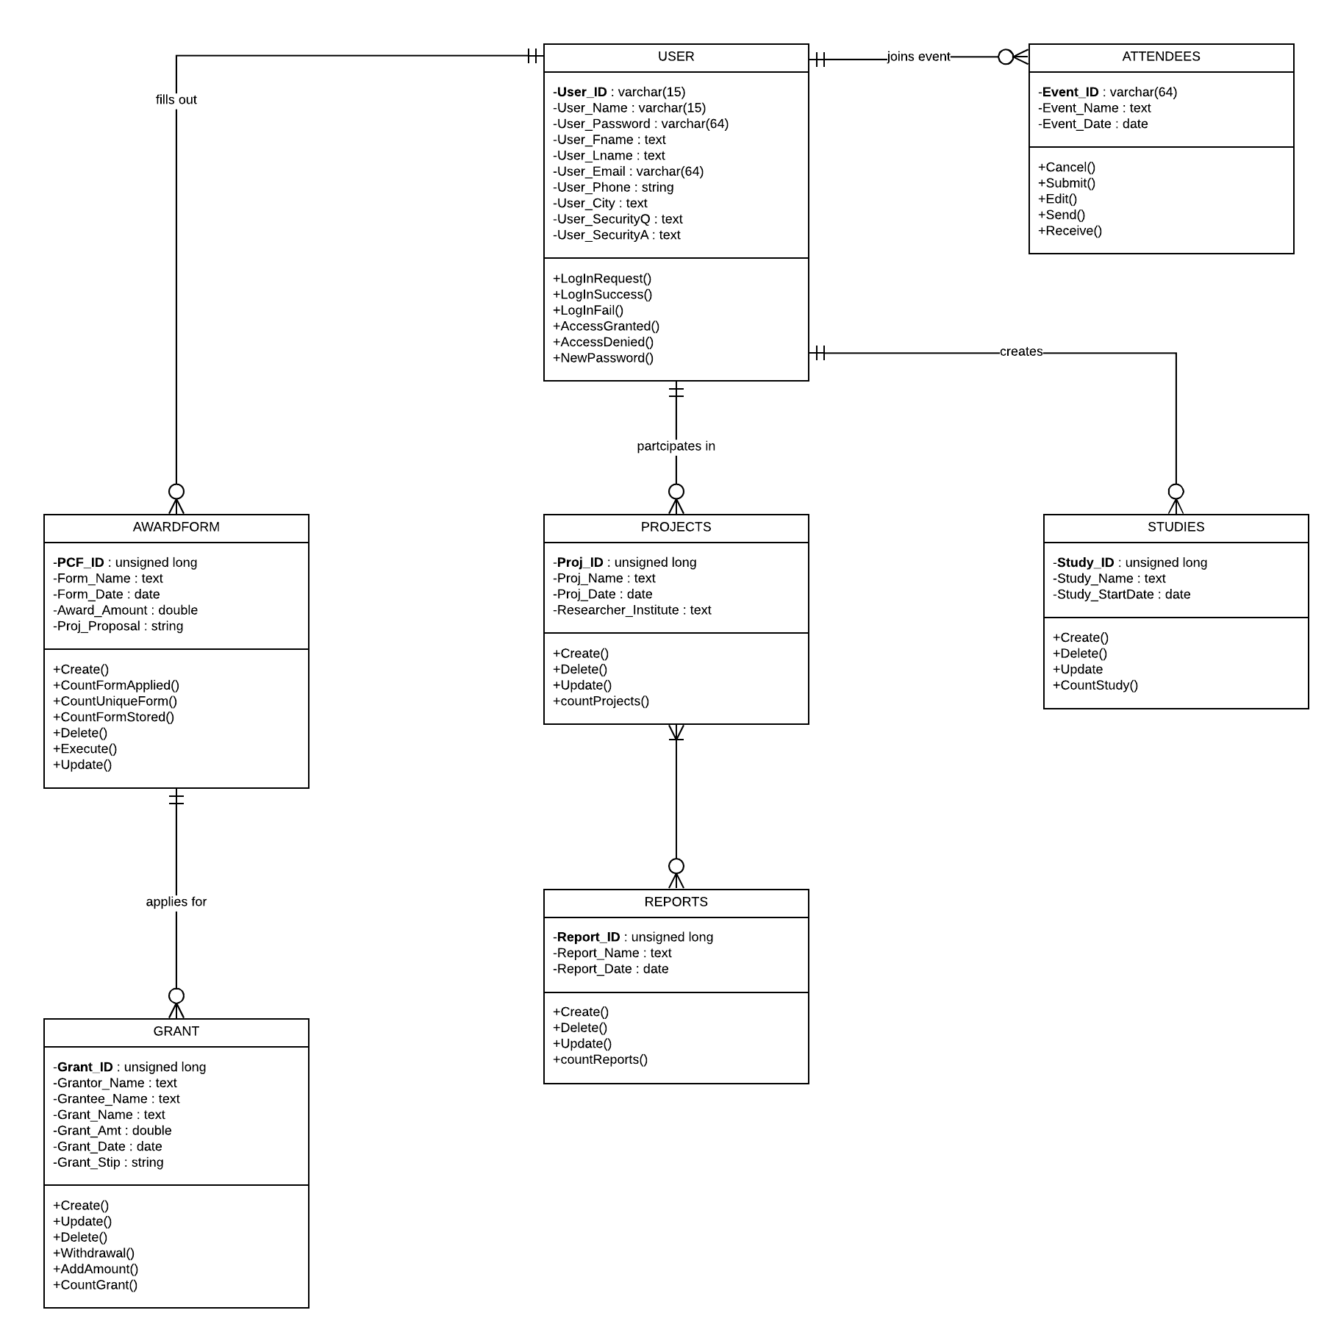

**Window Navigation**

A windows navigation diagram (WND) that defines the basic structure of the interface. is used

to show how all the screens, forms, and reports used by the system are related and how the user moves from one to another.In a WND, each state where the user interface might be located is represented as a box. A box typically corresponds to a user interface component, such as a window, form, button, or report. Transitions are modeled as either a single-headed or double-headed arrow. A single headed arrow indicates that a return to the calling state is not required, whereas a double headed arrow represents a required return. The arrows are labeled with the action that causes the user interface to move from one state to another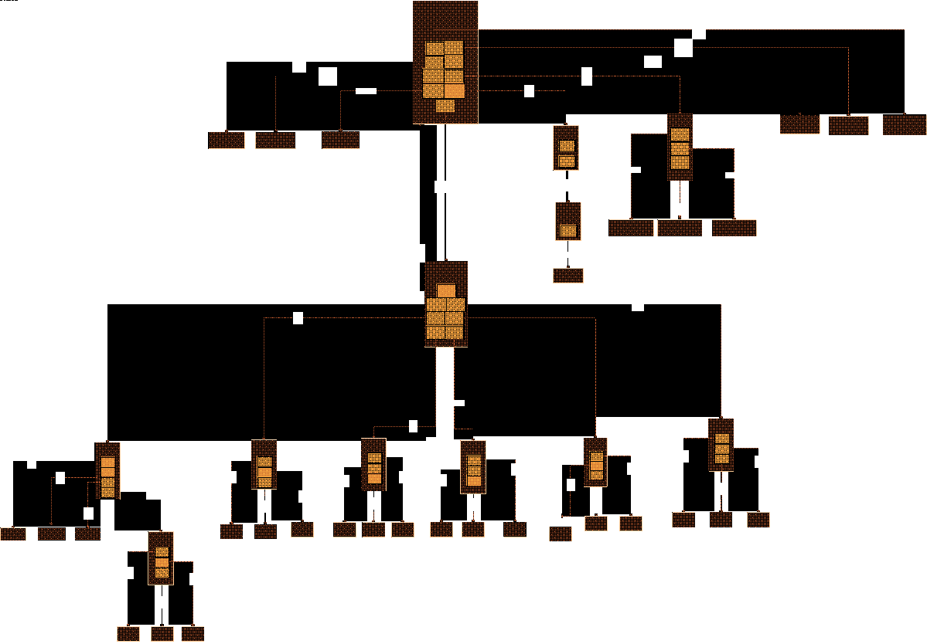

**Screen Layout**

This Screen Layout Shows The main home page and every destination that the user can make from the main homepage. The screen layout shows each and every use case that is needed for the website to function as its own prototype. Use cases such as the login page, sign in page, Newsletter sign up, and every other use case are all realized into their own prototypes to show how they could look like, what the user will see and what they will need to enter into the text boxes to complete the main flow of the use cases we built in assignment 3. The screen layout is very important to show a basic map of the website and to show each and every use case as its own prototype.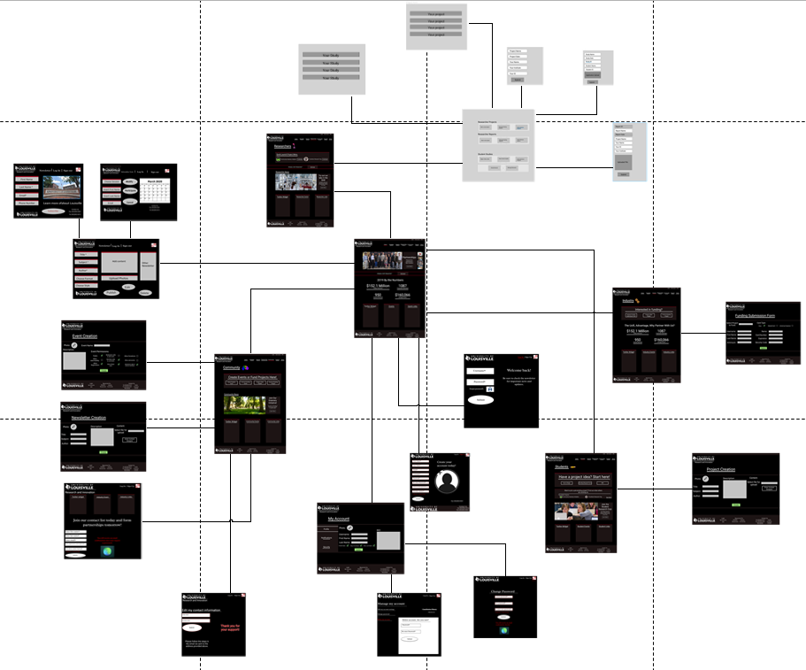

**Architectural Considerations**

**Brief:**

The major architectural components of any system are the software and the hardware. The major software components of the system are identified and then allocated to the various hardware components on which the system will operate. All software systems can be divided into four basic functions. These four functions (data storage, data access logic, application logic, and presentation logic) are the basic building blocks of any application. In our design Microsoft SQL Server 2016 will act as a Database Management System and Plone will act as Content Management System. The three primary hardware components of a system are client computers, servers, and the network that connects them. Client computers are the input/output devices employed by the user and are usually desktop, laptop computers, handheld devices, cell phones, special-purpose terminals, and so on. Servers are typically larger computers that are used to store software and hardware that can be accessed by anyone who has permission. Servers can come in several types: mainframes, minicomputers, and microcomputers. In our case, we will be using the servers already in use by the website. The network that connects the computers can vary in speed from a slow cell phone or modem connection that must be dialed, to medium-speed always-on frame relay networks, to fast always-on broadband connections such as cable. Lastly, security must be considered. Given the University of Louisville guidelines and policies, our design will integrate security and firewall suites provided by the University

**Narration:**

This brief outline of the systems our group plans to implement in our design. PeopleSoft is the University of Louisville payment management system and is required by university policy to be implemented as the website’s payment management system. SQL server will manage internet servers and act as the database management system. Plone is the university’s content management system, this system controls all the content both incoming and outgoing. According to University policy, it is the required content management system for all university websites.The firewall and security suite provided by the university will be used to protect all pertinent servers. As it is confidential, we have termed it UofL Security Suite and Firewall. The cloud computing service used by the university is Cardbox and will be integrated into our design.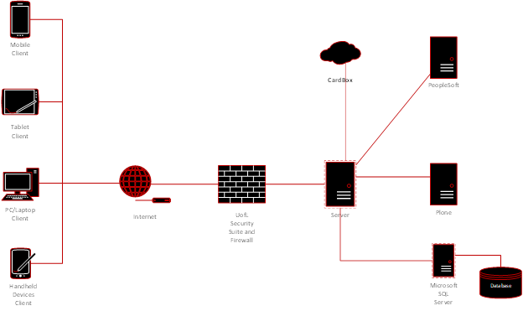

**Design Procedures for Security and Non-Functional Requirements**

* + - 1. System value estimates
* The data of this department is valuable, but it is not critical to the overall operation.
* We estimate the total value of the system’s hardware to be $5,000.
* We estimated the total value of the system data by using the PV of the project. Our realistic expectation over a 5-year period values the project at approximately $2.47 million. In a system outage, this equates to a loss of revenue of $56 per hour.
* User data is not used as a strategic asset (will not be sold or exchanged for monetization). The value of user data is derived from the data in use and the expected future value of the data.
* All data will be backed up using the University’s existing data center (in a separate geographical location in case of a random event).
  + - 1. Access control requirements
* Only administrators (authorized UofL faculty) can make changes (read, write, and execute privileges).
* Student faculty working in the department will have read and create access, but they cannot change or delete data.
* The University’s firewall will offer a layer of protection from unauthorized users attempting to access the system.
  + - 1. Encryption and authentication requirements
* Administrators logging in from outside of the office requires *additional* authentication.
* Users will have to log-in using their unique username and password combination to have full access to the system’s features. Log-in is required to view grant information, interact with other users, and make personalized requests.
* Data for grant and award information will be encrypted from the user’s computer to the website. Personal information including credit card information will be encrypted as well. This data is valued the highest and we will do our part to keep it protected from intentional acts.
  + - 1. Virus control requirements
* Preserving user data is a high priority, all imported and uploaded documents will be checked for viruses.
* If an external document (e.g. grant downloaded offline) is uploaded, it will first pass through a virus scanner (University’s antivirus software).

**Gantt Chart**

**Narrative:**

In the final iteration of this system analysis and design, we set a strict work schedule. Most of our work was cut out for us after completing Iteration V, however, we knew prototypes and physical architectural design could be time-consuming. Our official deadline is April 27th, but we used the Gantt chart to create an April 23rd deadline. This gave us a grace period in between our deadline and the official in case of any complications. Our team worked diligently and effectively to meet each task's requirements in the appropriate time frame. At this stage of the project, there was very little if any dependency between tasks. Tasks could be completed independent of each other; this means there was no overlap. Edits, compilation, and submission are these only tasks that required the previous completion of others.

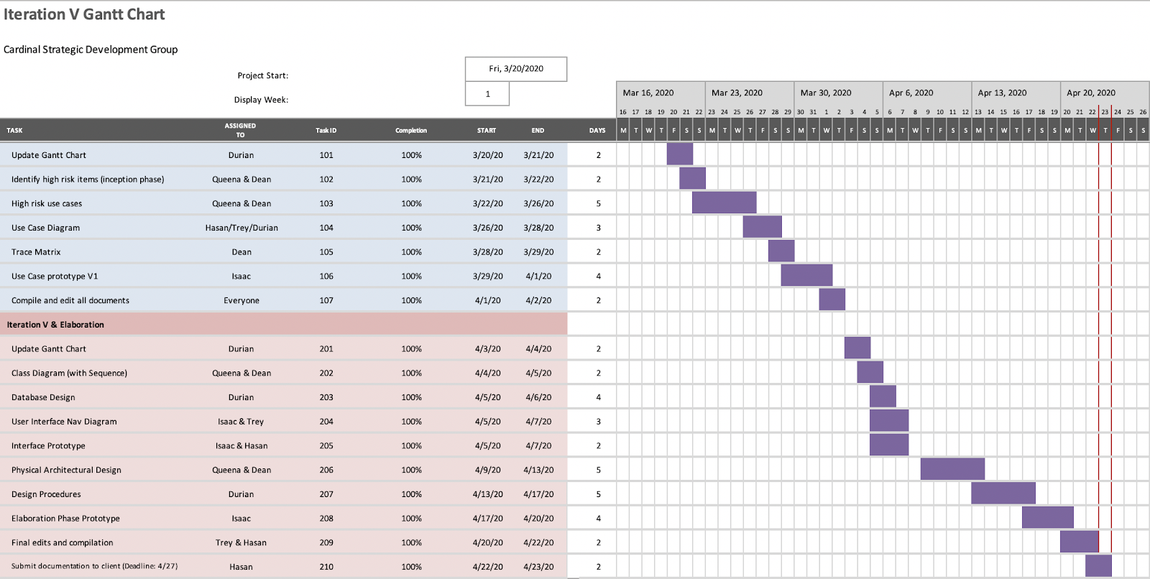

**Prototypes**

**Backup/Recovery**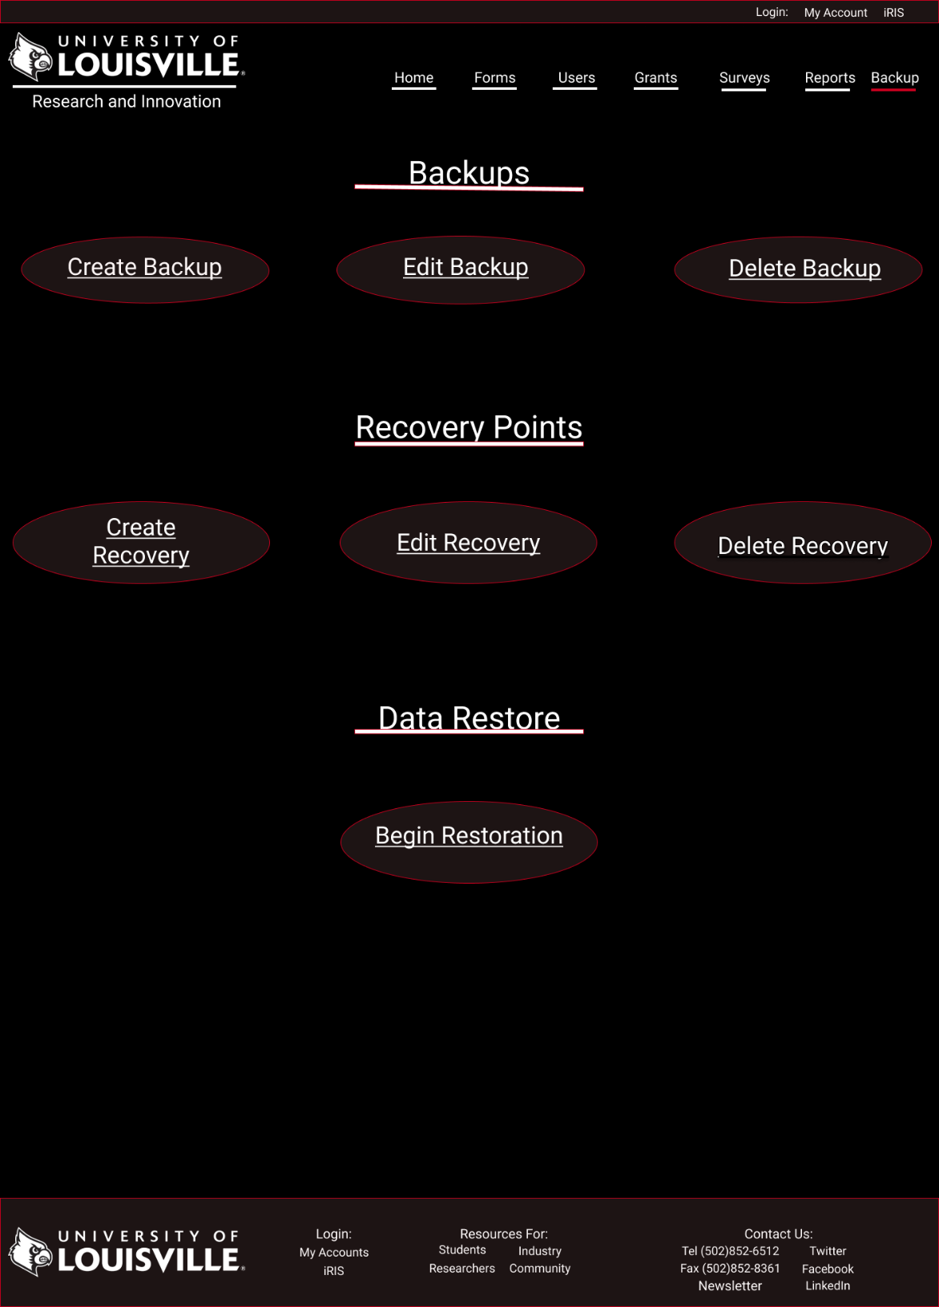

This prototype displays the backup and recovery management page. It is only accessible to administrator. Designed to allow for ease of access and speed. The admin will be able to access the is page by clicking on the backup tab at the top of the page. The page will give the admin the ability to create, edit or delete backup and recovery files. It will also allow the admin to initiate data restoration from the page. In effort to add another layer of security the admin will have to reenter their login and password in order in access any of windows forms associated with the links displayed. The design incorporates dark and clean theme inline overall innovative look.

**Prototypes**

**Grant**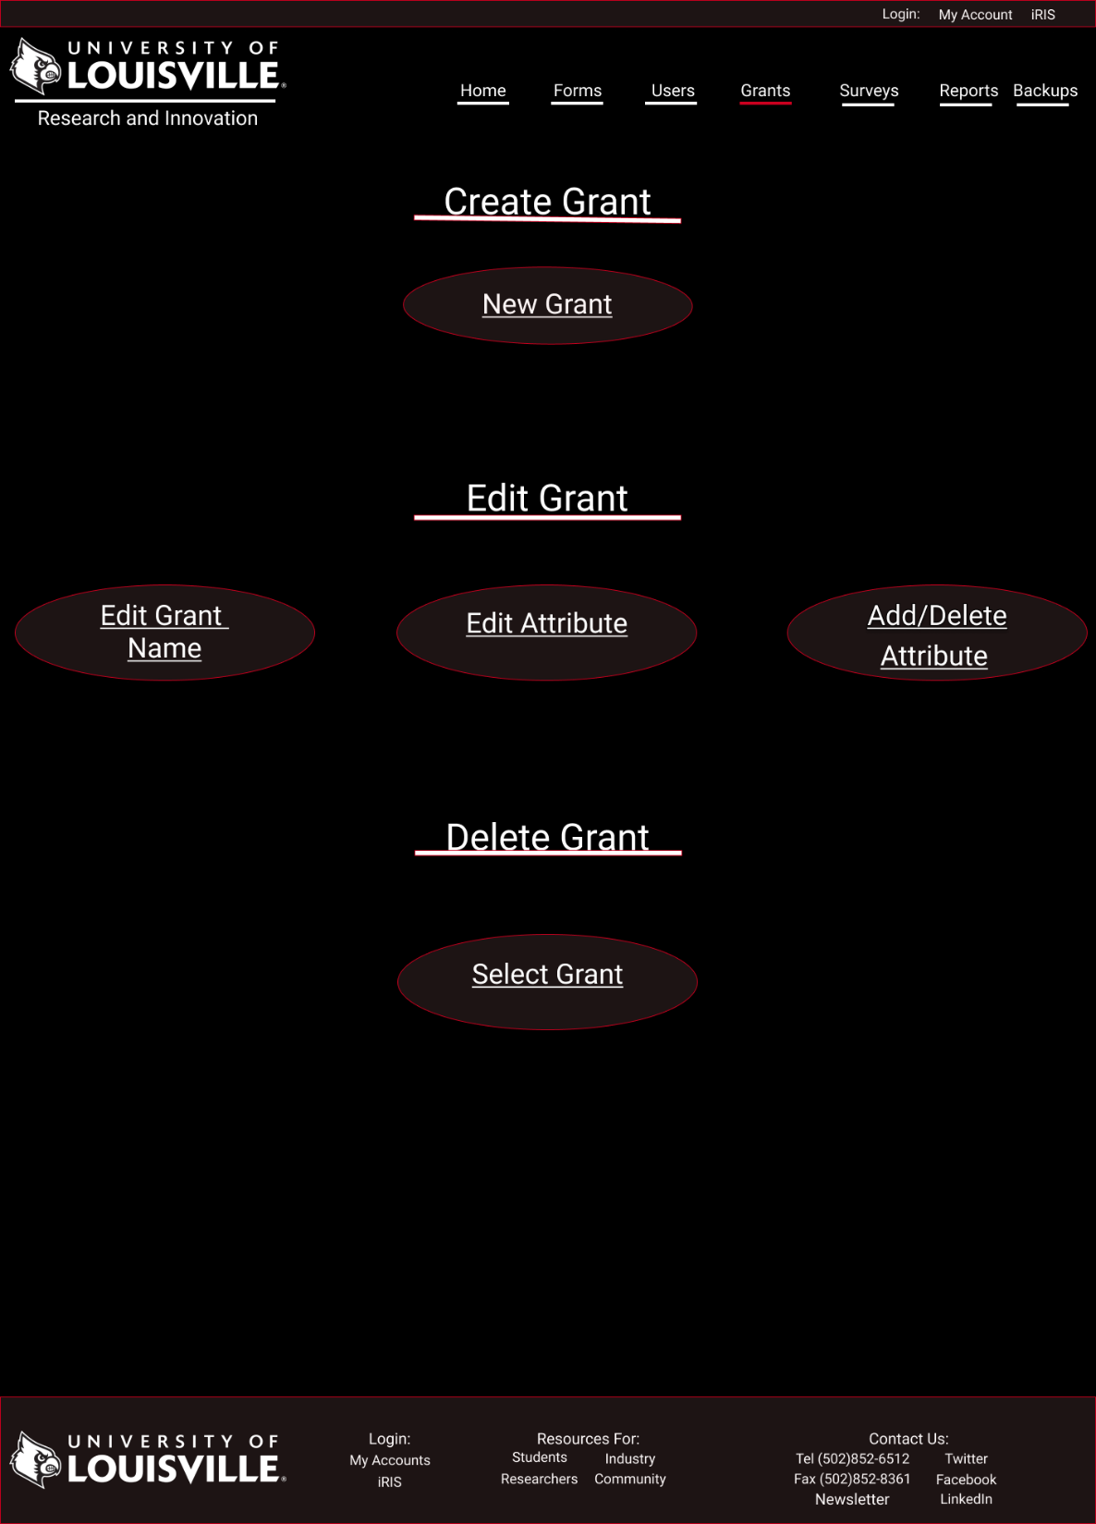

This prototype displays grant management page. It is only accessible to administrator. Designed to allow for ease of access and speed. The admin will be able to access the is page by clicking on the grant tab at the top of the page. The page will give the admin the ability to create, edit or delete grant objects. In an effort to add another layer of security the admin will have to re enter their login and password in order to access any of the windows forms associated with the links displayed. The design incorporates dark and clean themes inline overall innovative look.

**Prototypes**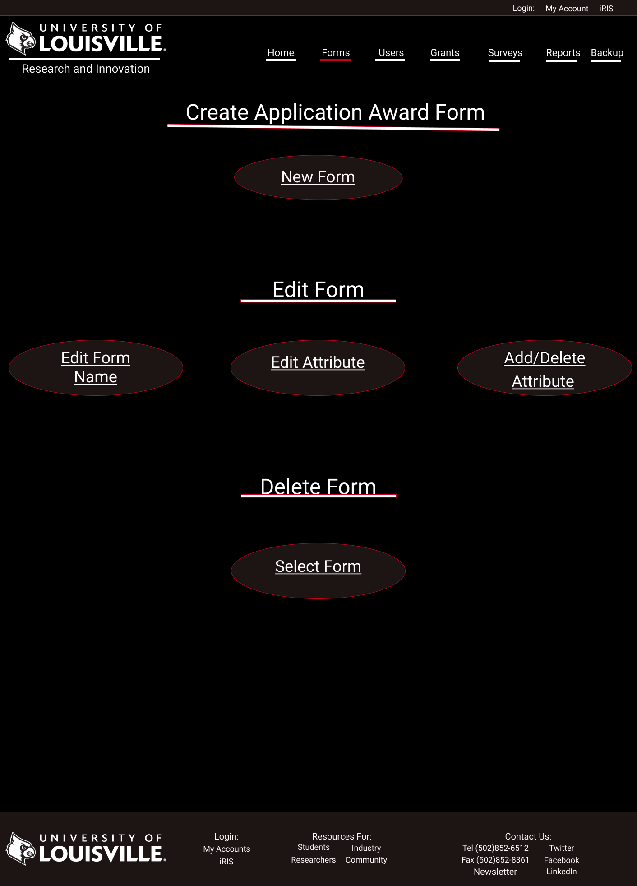

**Application Award Form**

This prototype displays application award form page. It is only accessible to administrator. Designed to allow for ease of access and speed. The admin will be able to access the is page by clicking on the forms tab at the top of the page and selecting link associated with awards form page on main form landing page. It will also be accessible via submenu when mouse hovers over the form tab. The page will give the admin the ability to create, edit or delete award application forms objects. In effort to add another layer of security the admin will have to reenter their login and password in order in access any of windows forms associated with the links displayed. The design incorporates dark and clean theme inline overall innovative look.

**Prototype**

**Front Page**

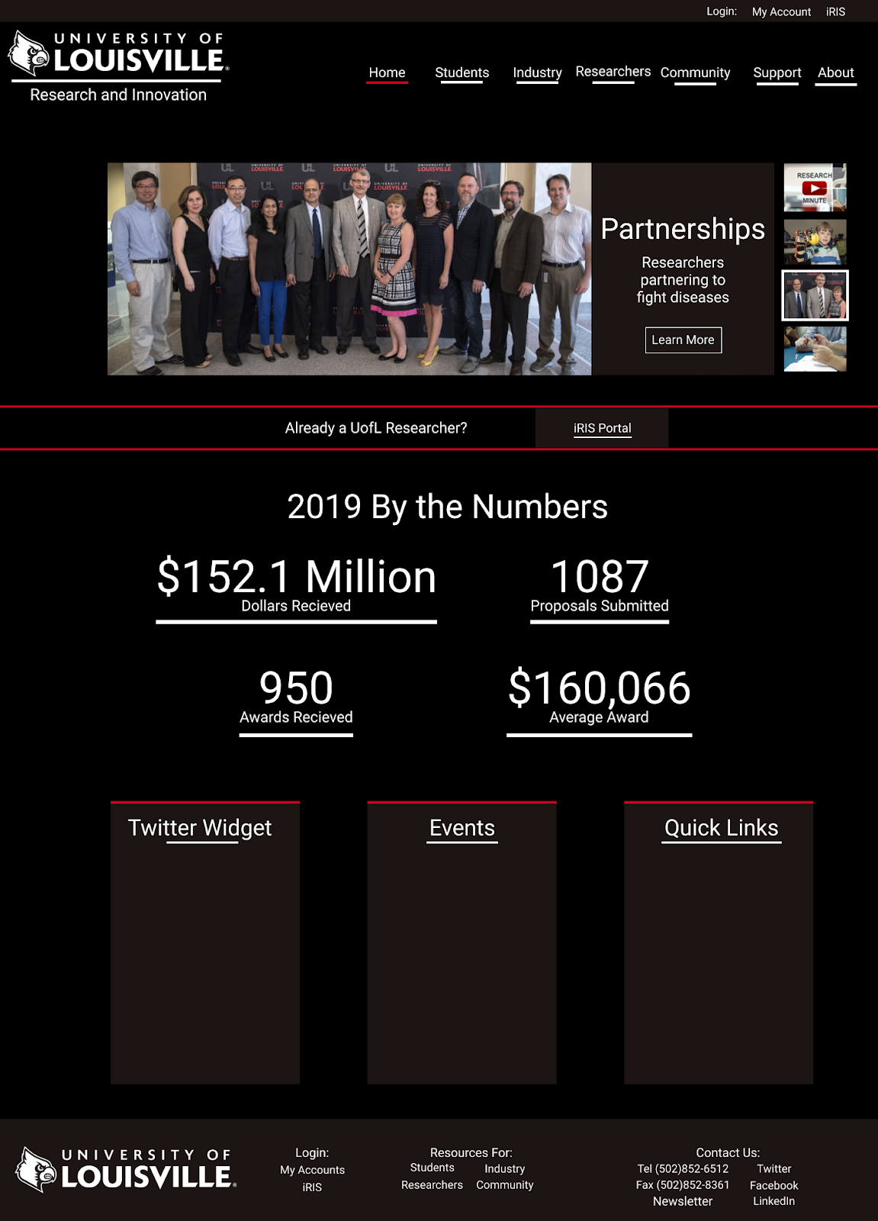

Upon arriving at the front page in the top left the UofL logo and the text Research and innovation are displayed. A login, My Account and iRIS portal link are included at the very top. A simple NAV cluster is also included with a highlighted red bar indicating which page the user is on. Below this we have a slideshow of news images and text. The most important news will go here. Moving below this we have another small link to the iRIS portal which may be removed once it is phased out entirely. Below the portal link there is a section for statistics which will showcase UofL’s achievements in the latest year of research. This will serve as marketing to draw visitors in and make them more likely to work with us with funding. Below this we have 3 sections for a twitter news widget, events and quick links. This area can also be replaced with a plethora of other content ideas if need be, this is just an example of things that could potentially go here. Finally, in the footer of the doc we have the UofL logo, login links, resource links and contact us information. This footer will remain standard on all pages of the site.

**Prototype**

**Industry**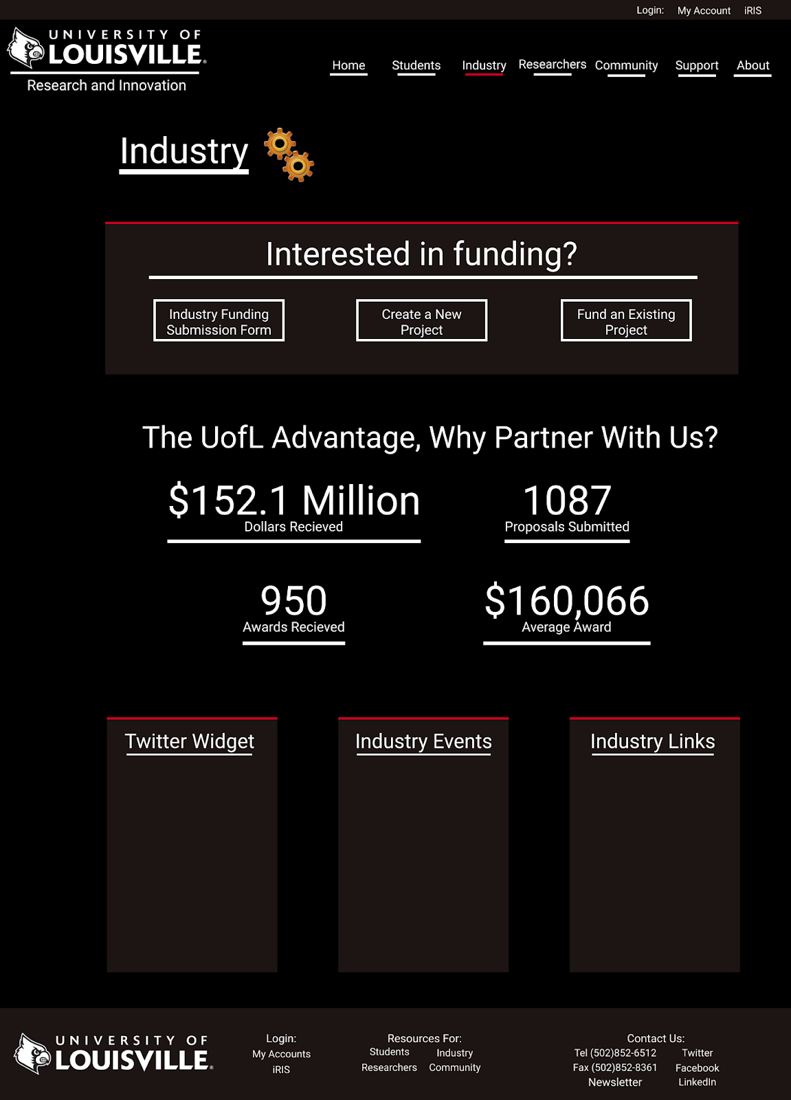

Upon arriving at the industry page, you are met with a distinctive icon indicating which page you are on. Industry members are then guided to the large text interesting in funding, where they can then choose from the submission form, creating a new project, or funding an existing project. After these visitors are drawn to a variety of statistics which will showcase UofL’s past successes with industry. We have placed statistics from the front page as placeholders. From there the all-important twitter news widget will go at the bottom as well as any industry related events or important links.

**Prototype**

**Student**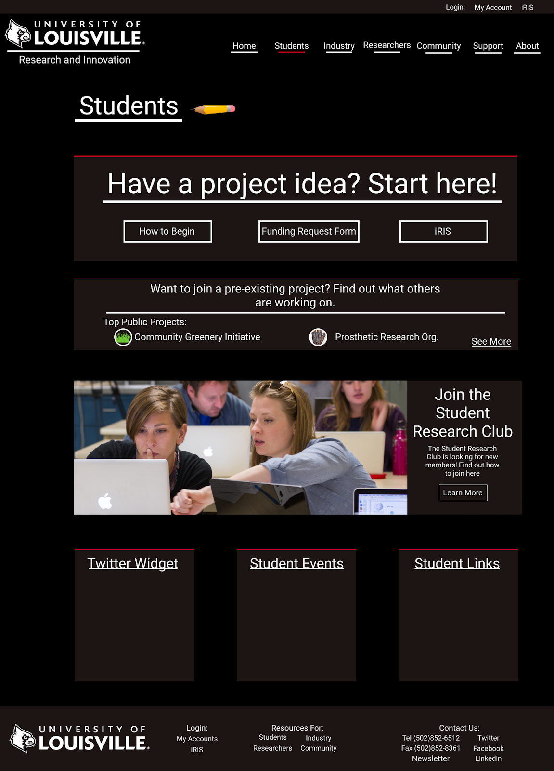

Upon arriving at the student’s page, you are met with a distinctive icon indicating which page you are on. Students will be immediately greeted with large text guiding students who wish to create a project to the correct places, a tutorial on how to begin, a submission form, and the link to the iRIS portal. Students are also able to see what the most popular projects or events other students are working on which can be hosted by any student, researcher, community or industry leader. Moving below that we have included a student news section with the demo content, “Join the student research club.” The news section contains an image, a text description and a learn more button for those who are interested. Also included on the page would be the all-important twitter widget providing a live feed of news and any other content, links, and events could fit into the additional blocks.

**Prototype**

**Community**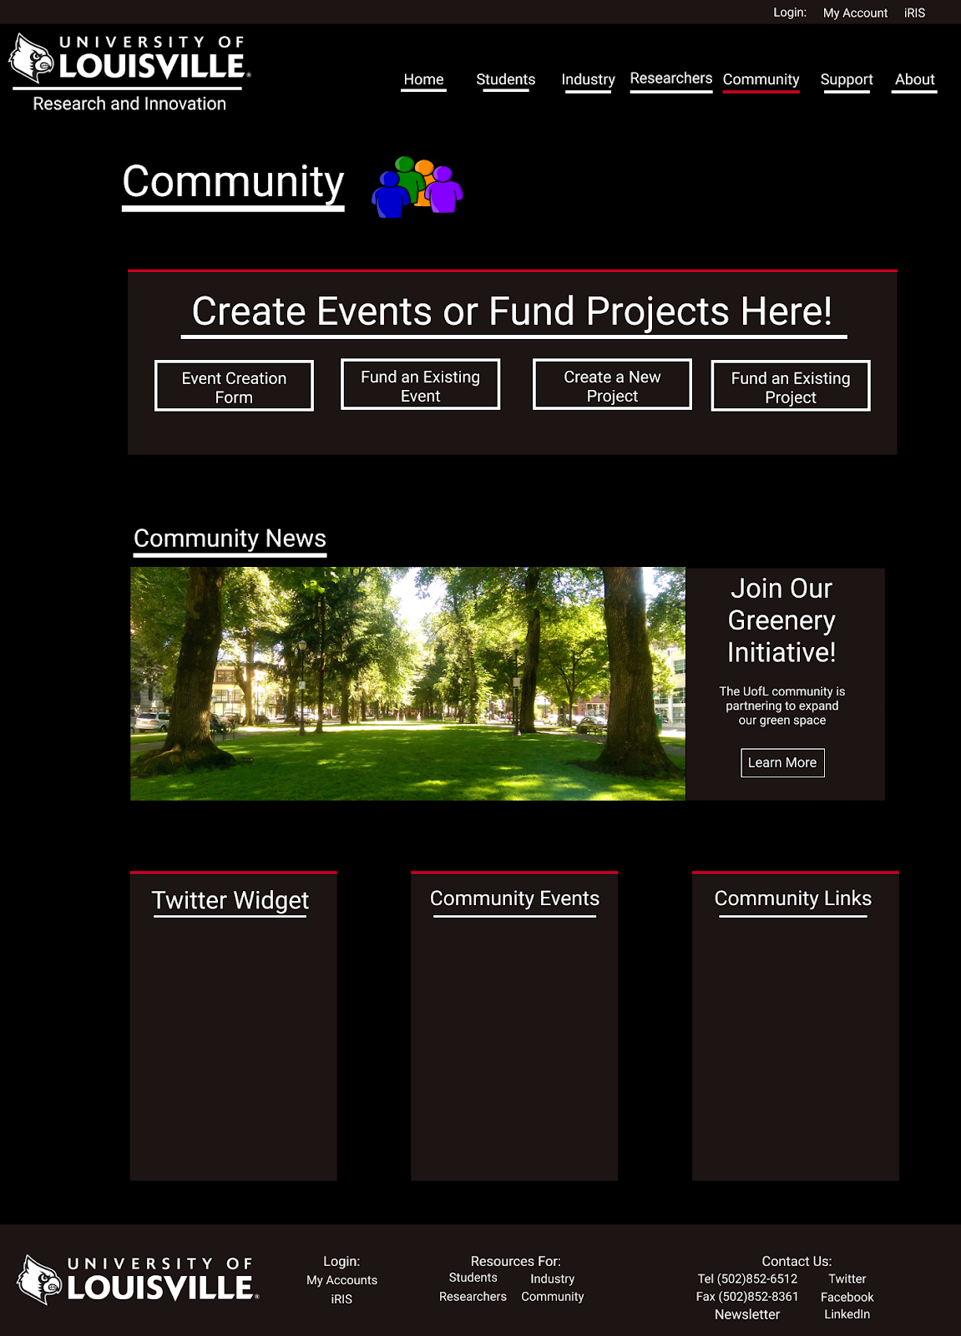

Upon arriving at the Community site, visitors are met with a distinctive icon indicating that they are on the community page. From there community members are met with the large text asking them to create events or fund projects. An event creating form is available, as well as fund existing events, create new projects and fund existing projects. Moving down there will be a large section for community news with an image to draw visitors in and text explaining with a Learn More link at the bottom. We have placed a demo event inside this area called The Community Greenery Initiative. The bottom of the page like the rest will contain a twitter news feed, community related events and links.

**Prototype**

**Researcher**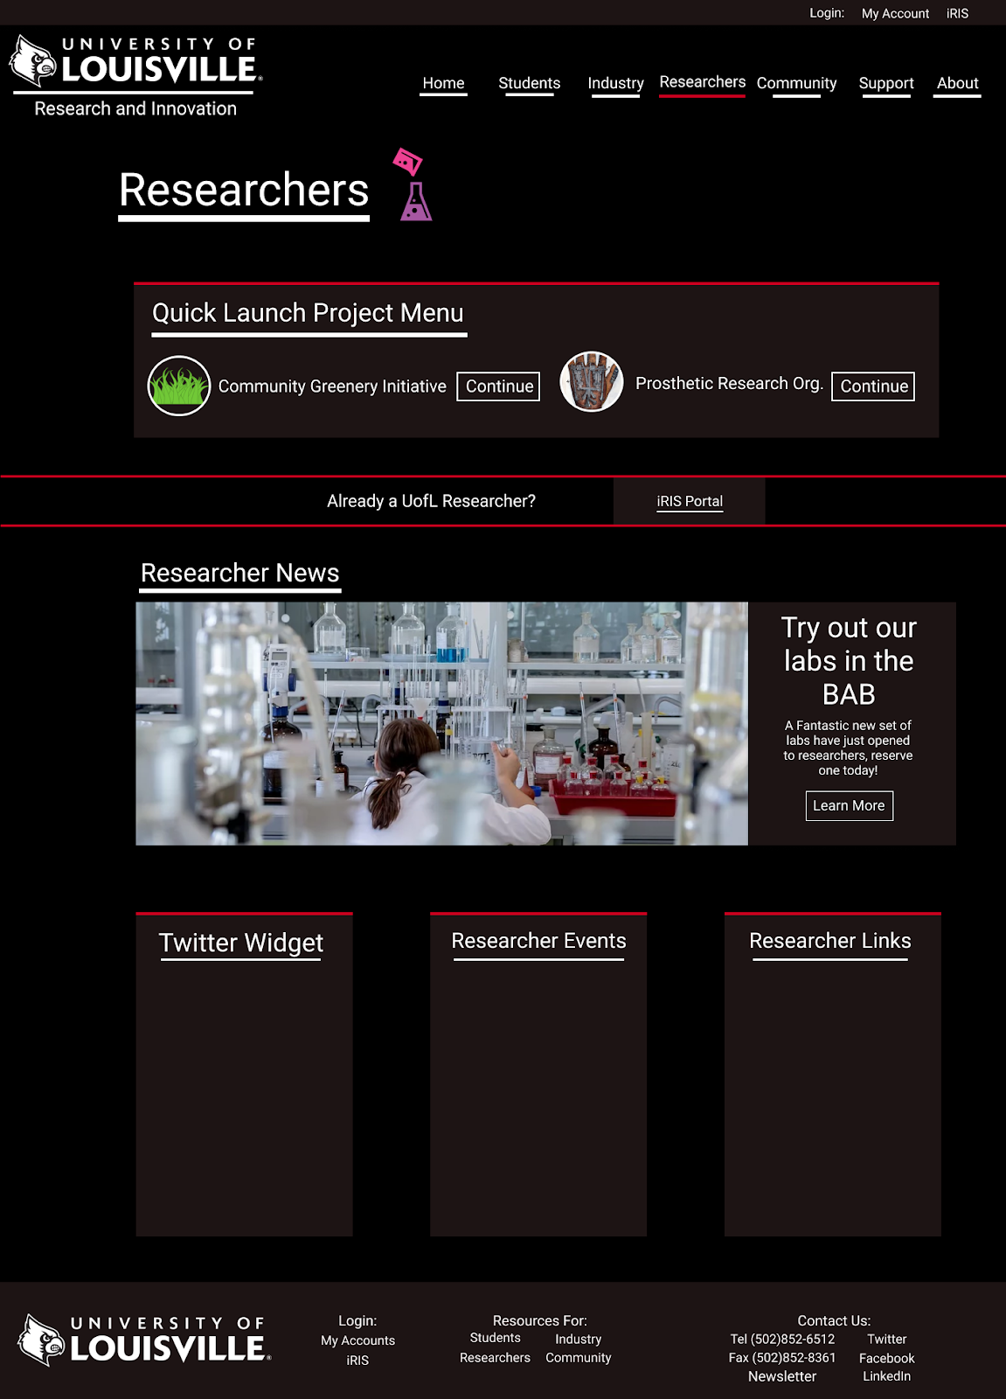

Upon arriving at the research page, visitors are met with a unique icon indicating which page they are on. From there we have a quick launch project menu so researchers can get back to their projects as fast as possible. This page uses the assumption that researchers will arrive here first before jumping to their project environment. Moving down we have a small section for the iRIS Portal which can be removed once it is phased out. Just like the community page we have also included a researcher news section with a text description and a learn more button. Example content has been inserted to demo what it would look like. Finally continuing with the uniform nature of the pages a twitter widget and Researcher links and events will also be added to the bottom section.

**Prototype**  
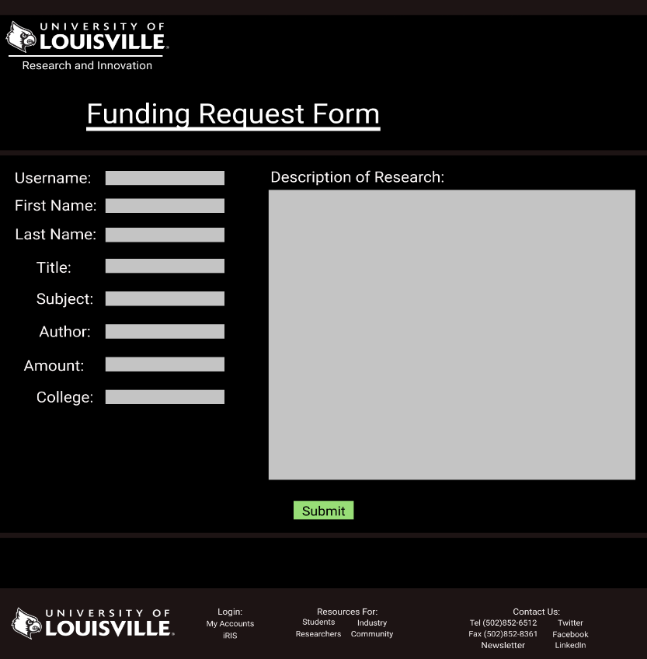

**Funding Request Form**

Once the user enters the funding request form they will be met with our logo & the heading funding request form. Below this the user will be prompted to enter information for username, first name, last name, title, subject, author, amount and college. The user will also be prompted for a description of research. Below these fields is a green submit button. And finally, at the very bottom is the universal footer

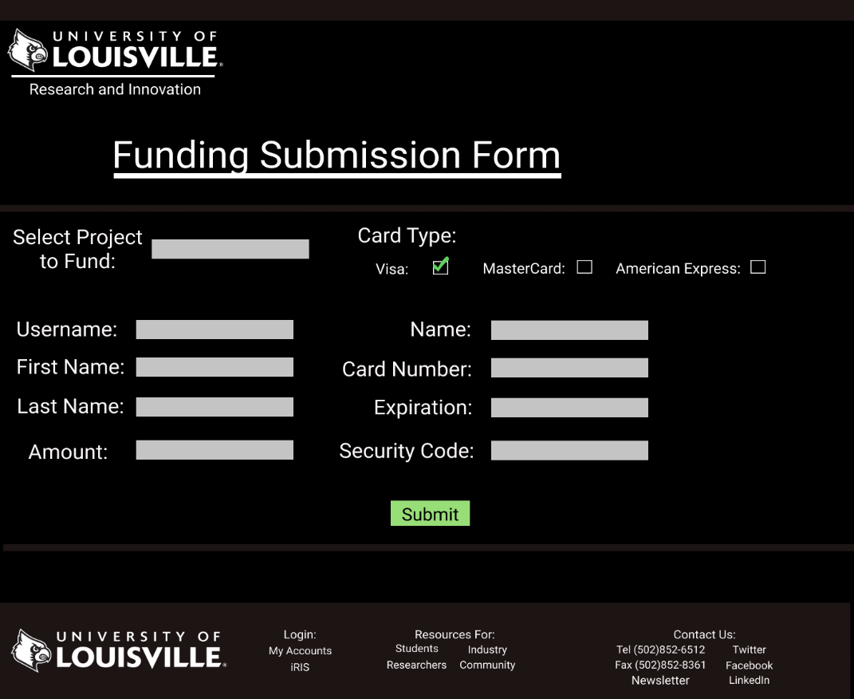

**Funding Submission Form**

Once the user enters the funding submission form, they will be met with our logo and the heading funding submission form. The user will be required to enter a variety of information, select project to fund, username, first name, last name, amount, cart type, name on card, card number, expiration & security code. Below these fields is the submission button. Finally, at the very bottom is the universal footer

**Prototype**

**Login Page**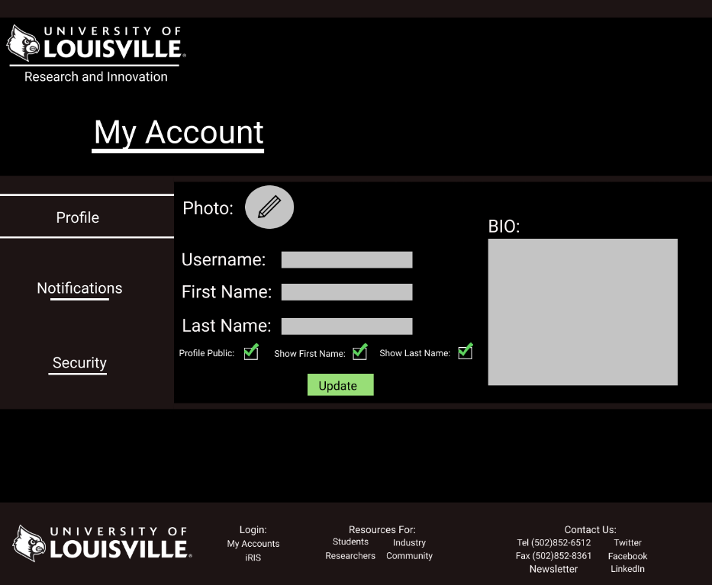

Once the user enters the My Account page they will be met with our logo and my account heading. Below this we have a number of tabs for profile settings, notification settings and security settings. The prototype for profile settings includes a field to upload a photo, set a username, first name, last name, BIO and settings to set your profile as “public”, to show your first name and to show your last name. A green update button solidifies the user’s settings and at the very bottom we have our universal header.

**Newsletter**

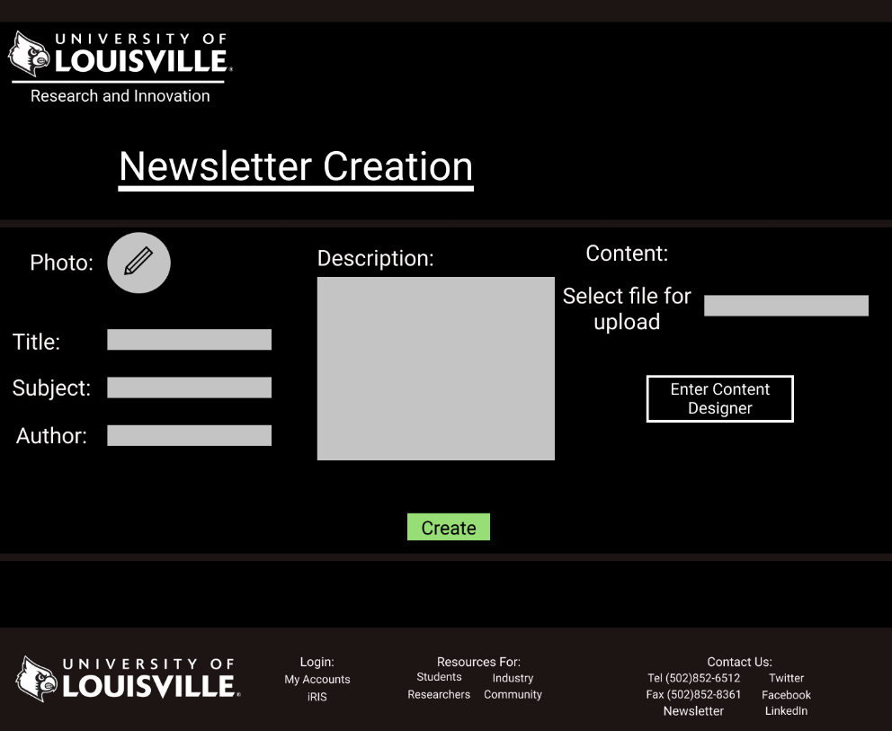

When the user arrives at the newsletter creation page they will be met with our logo and the newsletter creation header. The letter creator will be prompted to upload a photo, enter a title, subject, author, description, and upload a document containing the content of the newsletter. If the creator does not upload a document, they could also enter a basic content designer. Finalize the creations with the create button. Finally, our universal footer is present at the bottom of the page.

**Prototype**

**Project**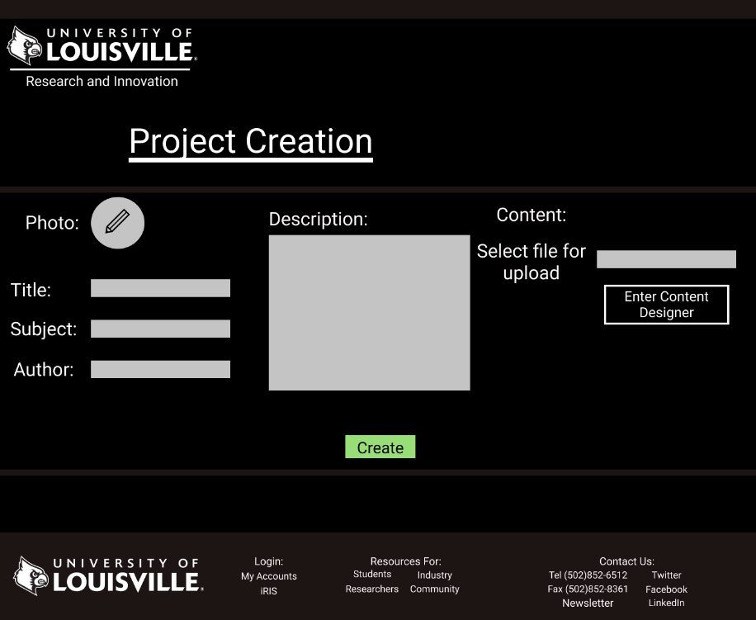

When the user arrives at the project creation page they are met with our logo and the project creation heading. The user can then upload a photo, enter a title, subject, author, description of the project and select or design a file containing the content of the project. The project creation is finalized with the create button. At the very bottom is our universal footer.

**Event**

When the user arrives at the event creation page they are met with our logo and the event creation header. The event creator can upload a photo, enter the event name, description and change a number of event permissions, set public, allow searchability, allow registration, moderators able to edit event, members able to comment, show share link, allow donations, allow sub-events(events within this event) and moderators able to remove members. To finalize the event there is a create button. At the very bottom of the page is our universal footer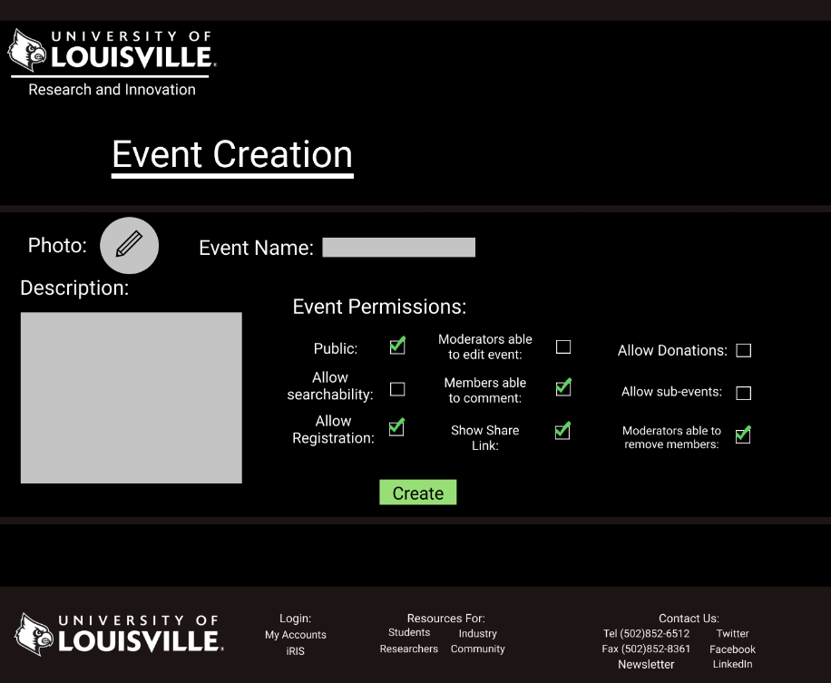

**Prototype**

Upon arriving at the front page in the top left the UofL logo and the text Research and innovation are displayed. A login, My Account and iRIS portal link are included at the very top. A simple NAV cluster is also included with a highlighted red bar indicating which page the user is on. Below this we have a slideshow of news images and text. The most important news will go here. Moving below this we have another small link to the iRIS portal which may be removed once it is phased out entirely. Below the portal link there is a section for statistics which will showcase UofL’s achievements in the latest year of research. This will serve as marketing to draw visitors in and make them more likely to work with us with funding. Below this we have 3 sections for a twitter news widget, events and quick links. This area can also be replaced with a plethora of other content ideas if need be, this is just an example of things that could potentially go here. Finally, in the footer of the doc we have the UofL logo, login links, resource links and contact us information. This footer will remain standard on all pages of the site and events could fit into the additional blocks.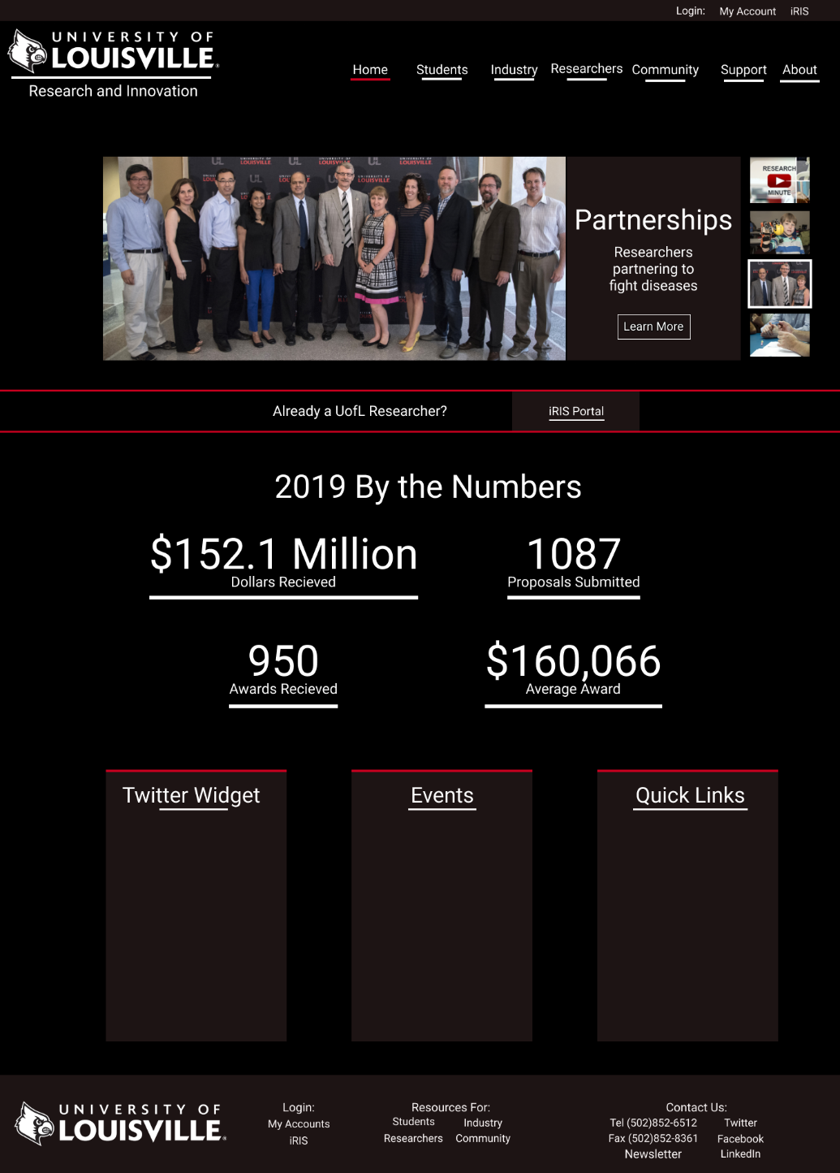

**Prototype**

**Newsletter Page**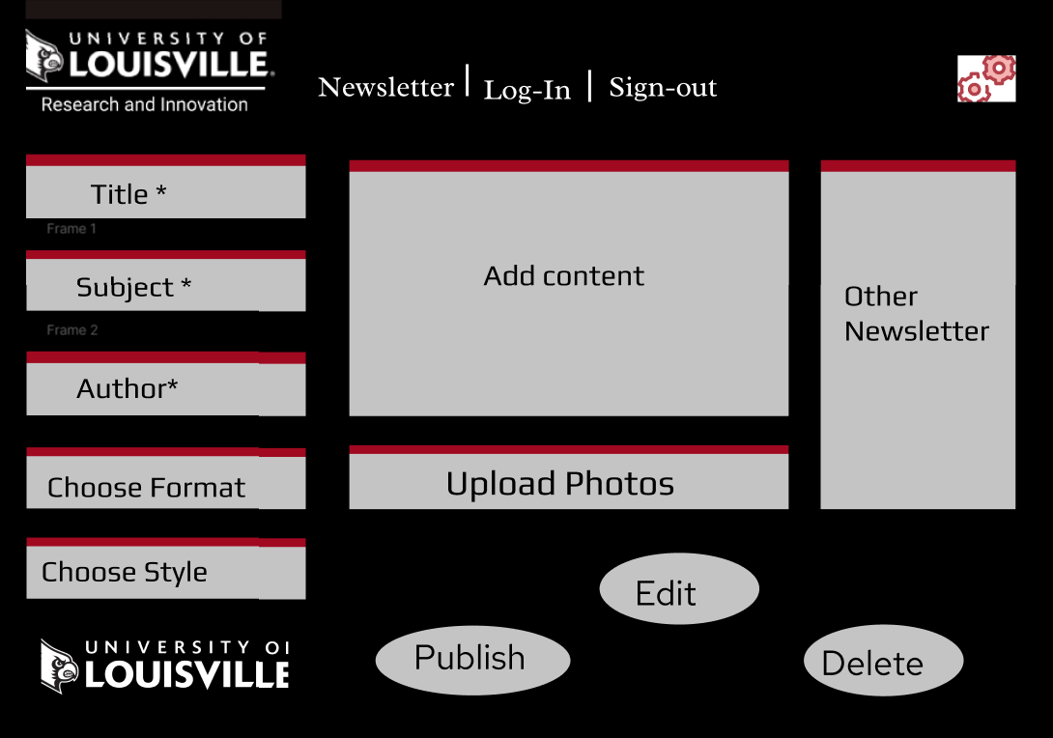

Upon arriving at this Newsletter page, the user must be logged in as administrator in order to obtain authority for creating and having access to Newsletter. After logging, the user must insert title, subject, author, and content of the article. It is given an option for the user to implement and chose different format and styles to produce a good visual. There will also be an option to upload photos and images. There is the University of Louisville for the Research and Innovation Office logo presented in the top of the page and the bottom of the page.

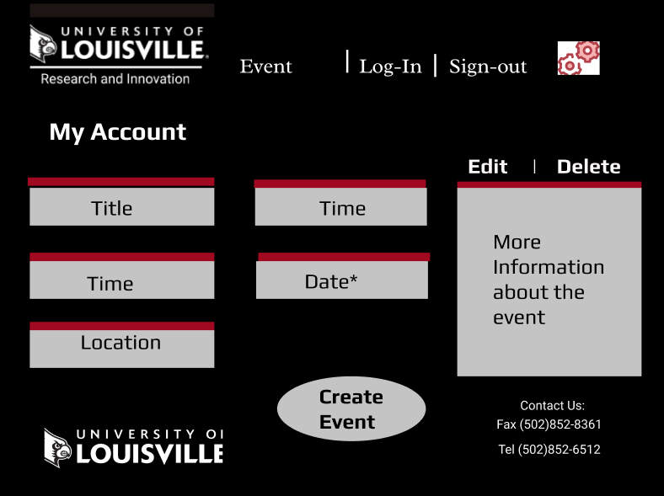

**My Account**

Upon arriving in the event page, the users ate presented to insert information to schedule an event on campus. It is required that the user login as an administrator to manages information that is given to them by another stakeholder. The user will need to insert information on title, time, date, location, and detail information of the event. After inserting all the necessary information, the user is then able to create and publish the event. There is given an edit and delete to give the user the option to modify the events.

**Prototype**

**Attendee Page**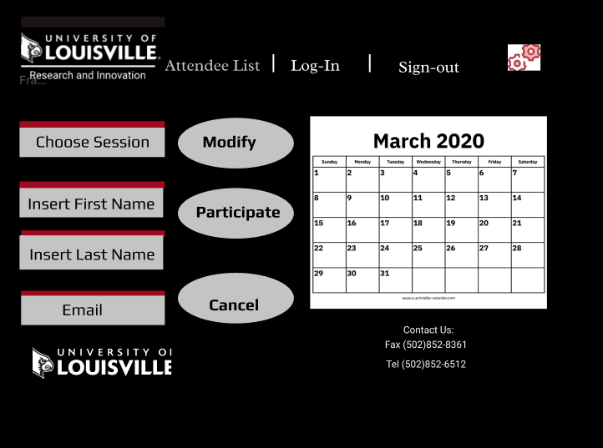

This attendee list prototype is meant to allow all the stakeholders to join and attend a particular event. The user must choose the session that they want to attend, insert their first name, last name, and email address. Once they insert their information, they are must select participate in order for their names to be joined in the attendee list. If the user changes their mind, there can also remove or change information by logging in to the page.

**Newsletter Landing**

We continue to use black, red, and white as the color theme of the prototype because that presents the University of Louisville. The Research and Innovation logo is present to should that this website is specific to their department. As the user prompt to subscribe to newsletter, they must insert information such as first name, last name, email, and phone number. 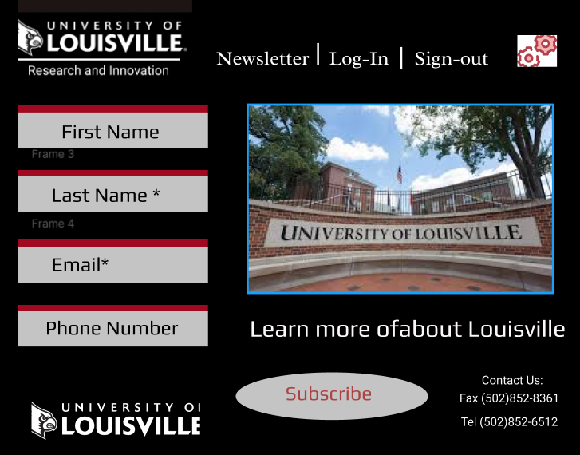

**Prototypes**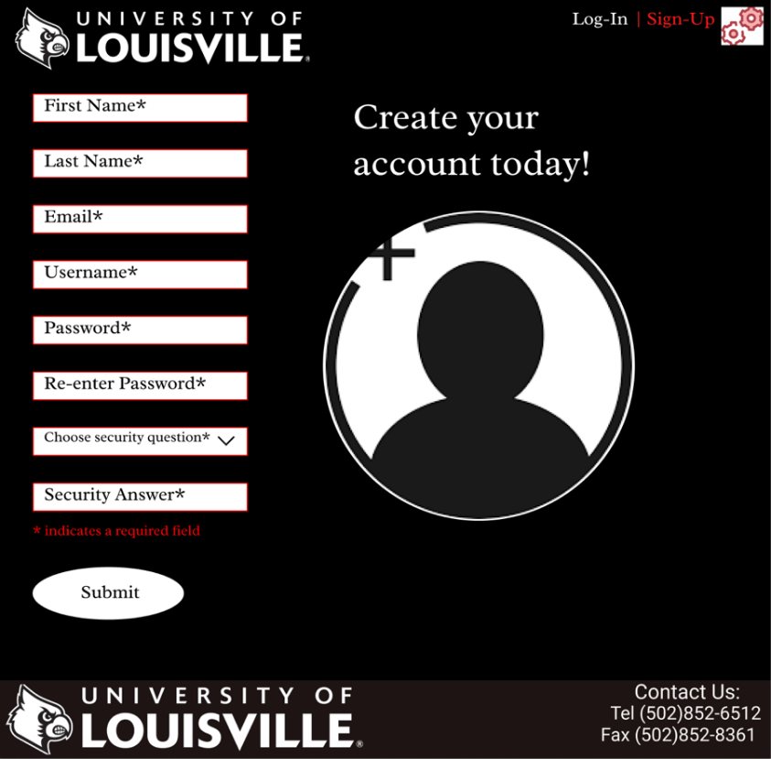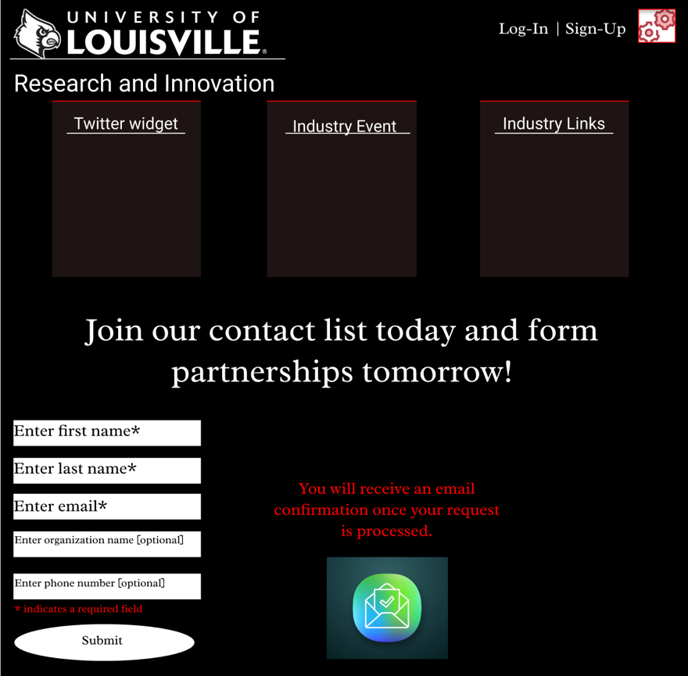

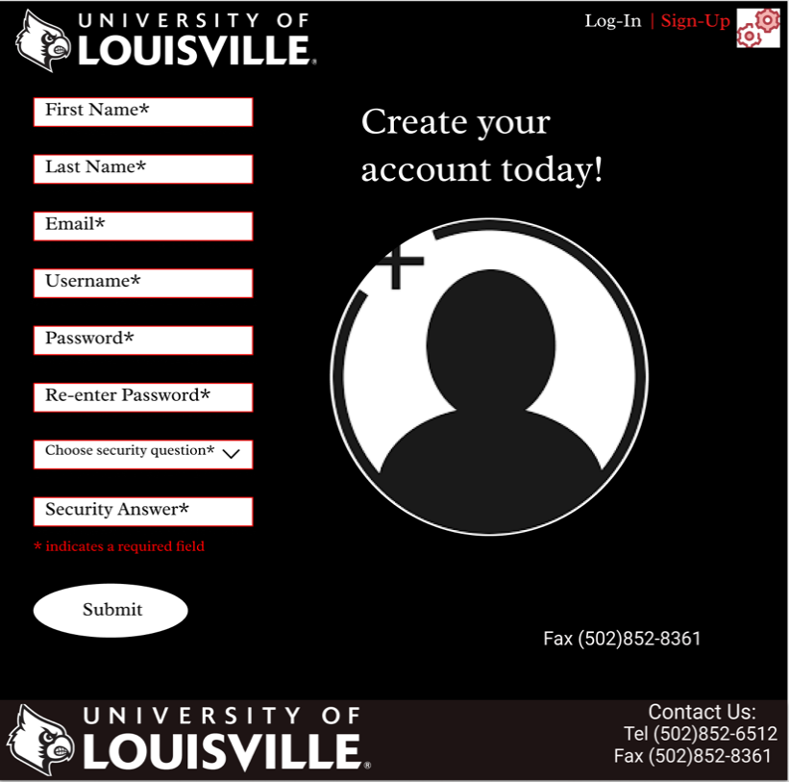

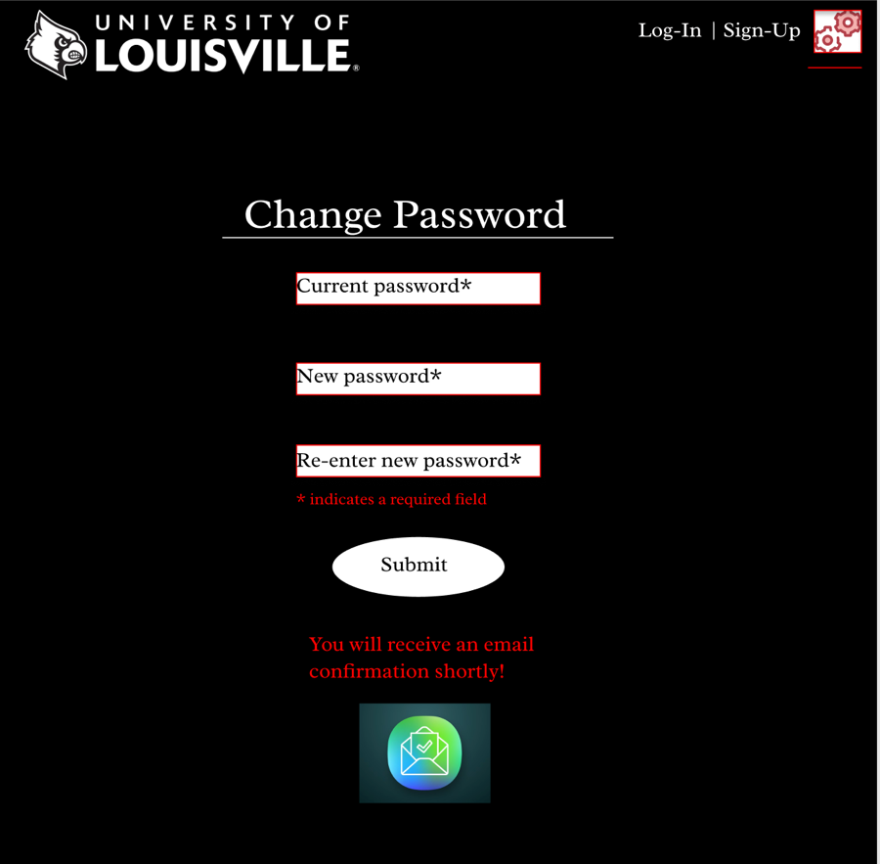

**Prototypes**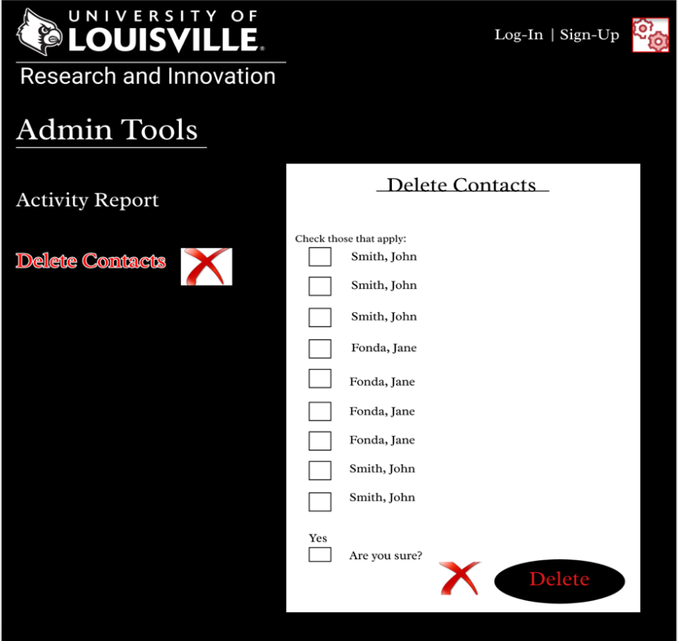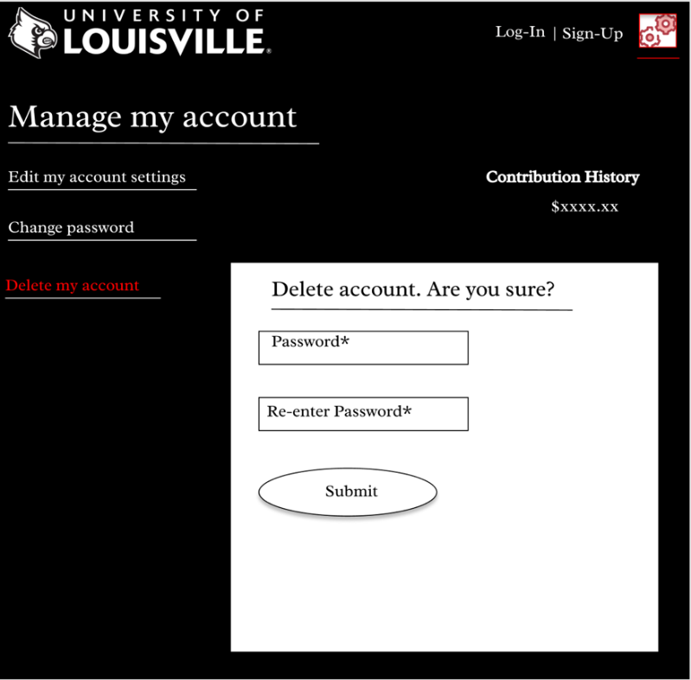

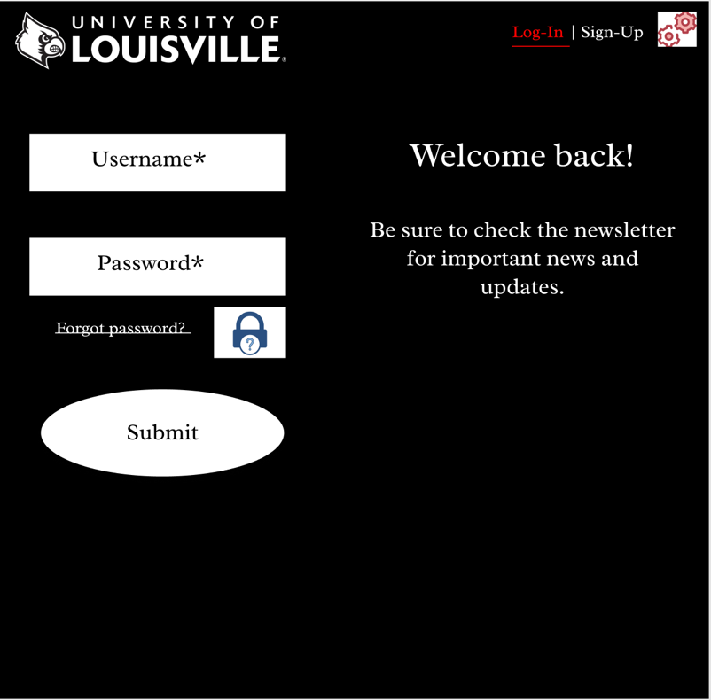

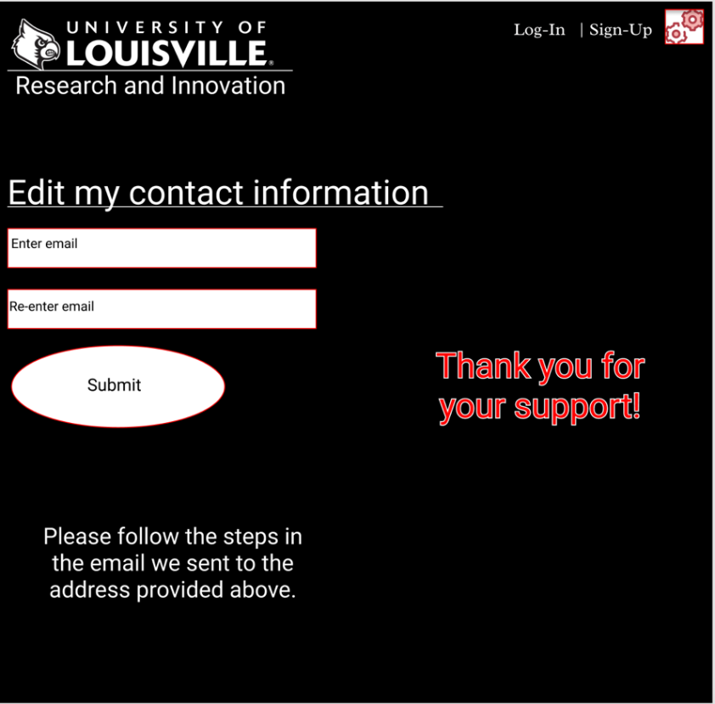

**Prototypes**

**Prototypes**